# Storybird

[Storybird](https://storybird.com)

is a digital tool for designing visual stories. Students can design picture books on their own or work in teams (e.g., author and artist) to create visually appealing representations of their knowledge. Teachers and parents can pay to have students’ books printed through the online shop. Storybird allows students to showcase their creative thoughts through storytelling and art online. Storybird also offers more than 700 lessons, quizzes, and writing prompts to support the development of writing skills. If you are looking for a tool to excite students about writing, this might be the one!

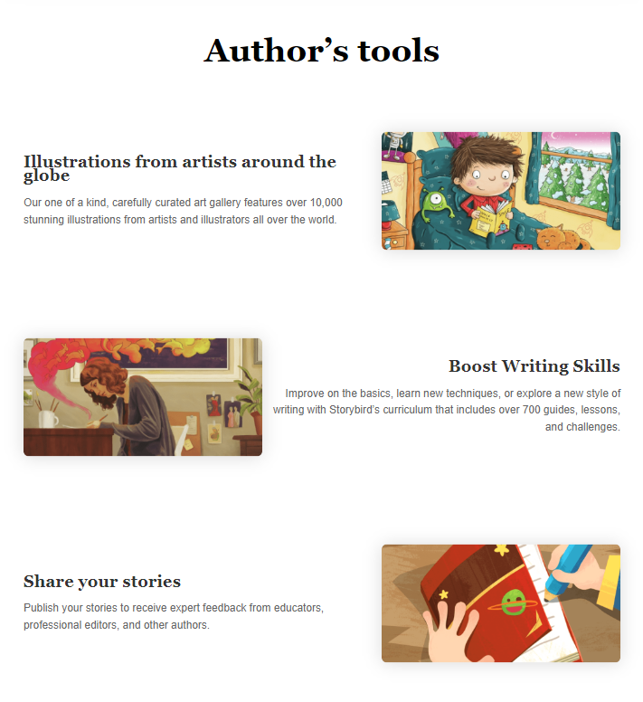

## Tool Snapshot

|  |  |
| --- | --- |
| **Price** | 7-day free trial; Upgraded plans: $8.99/month, $59.88/year, school, or district plan |
| **Learning** | [Constructionism](http://edutechwiki.unige.ch/en/Constructionism) |
| **Ease of Use** | ★★★★✩ |
| **Privacy** | ★★★★✩ |
| **Accessibility** | ★✩✩✩✩ |
| **Class Size** | Unlimited |
| **ISTE*S** | Knowledge Constructor, Creative Communicator, Global Collaborator |
| **COPPA/FERPA** | Yes |

### **Price**

Storybird has four options for payment: Individual $8.99/month, Individual $59.88/year, School Plan, or District Plan. There are plans for [educators](https://storybird.com/membership-educator) and plans for [families](https://storybird.com/member-family-plan).  Printing books and artwork also involves payment.

### **Ease of Use**

Storybird is ease to use for all ages.

### **Usability**

Mobile phones, desktop computers, and especially iPad/iPhone/tablets are great access for Storybird. iPad is one of the recommended ways for Storybird owing to smooth interaction for readers and writers.

### **Accessibility**

Storybird is unable to be used with a screen reader, and acoustic function, as well as sound effects, are not employed in completed artworks. There is no accessibility statement found on the site.

## Storybird Overview Video

## Storybird & the SAMR Model

Dr. Ruben Puentedura’s [SAMR model](http://www.emergingedtech.com/2015/04/examples-of-transforming-lessons-through-samr/) offers a lens for examining how technology is adopted in a classroom. As you strive to incorporate online tools into your classroom, we encourage you to use this model as an analytic tool.

* **Substitution:** Students read a book on Storybird rather than in print.
* **Augmentation:** Students read and interact with a multimodal book on Storybird.
* **Modification:** Students design their own books.
* **Redefinition:** Students collaboratively design their own books and publish them in print.

## Learning Activities

### **English Reading Task**

English language instructor conducts picture book read aloud in the 3rd grade classroom. Students are expected to pick one picture book from Storybird for independent reading, and then give comments after reading. Next, every student wraps up a thought to create their own picture book. Storybird involves students to work on draft based on individual’s creative ideas. Students are given feedback after peer review in the Storybird community, and further move to edit draft before finalized product.

### **STEM Artwork and Writing**

#### Science-Leaves, Stems, and Roots

Students are guided to create artworks inclusive of related vocabulary: leaves, stem, root, flat, provide, fruit, bury, soil, nutrient, and fix. Next, students brainstorm ideas with (1) what keeps leaves in the light? (2) what fixes the plants to the ground? Think and speak before working on writing through a picture book. Ultimately, writing a draft is produced with students’ creative thoughts and accompanied artwork. Students are given peer review respectively before the finalized product is done.

#### Poetry Writing Workshop

Emergent bilinguals in the ESL Pullout program are encouraged to create poetry for fun. First, choose one preferred art and employ imagination by implementing three or four English sentences. Users are able to arrange various narratives for poetry in Storybird, inspiring English language learners to explore focal elements of syntax, fluency, pragmatics, and vocabulary.

#### Longform Writing Fun within Collaboration

Instructor of English language arts prompts a reading and writing activity for 6th graders**.** Longform reading involves reading comprehension and shared feedback during either peer discussion or group activity. After the first phase of Longform reading is completed, students design artwork of individual Longform products in the subsequent classes. Collaboration is a focused discourse in Storybird. Students perceivably have a concept mapping on Longform draft, and cordially invite your collaborators to work on editing and adding texts for writing practice, which significantly help literacy construct based on integrated reading and writing process. Thus, students benefit from “thinking in English and collaboratively reproducing artwork of creativity” via Longform writing fun in Storybird wonderland.

## Resources

* [Visual storytelling for everyone](https://storybird.com/about/)
* [Storybird Blog](https://storybird.com/blog/)
* [Twitter @Storybird](https://twitter.com/Storybird)
* [Storybird Website Review](https://www.commonsensemedia.org/website-reviews/storybird)
* [Storybird for Educators](https://www.youtube.com/watch?v=PJ9ycfrCR44)
* [Super Storytelling with Storybird](https://www.youtube.com/watch?v=T00YjRBIcIw)
* [Storybird Crunchbase](https://www.crunchbase.com/organization/storybird#/entity)
* [How to: Write and Read using VoiceThread and Storybird](https://wp.voicethread.com/2015/02/18/how-to-write-and-read-using-voicethread-and-storybird/)
* [With 2 million members, Storybird is ‘reverse-engineering’ the picture book](https://gigaom.com/2013/01/24/with-2-million-members-storybird-is-reverse-engineering-the-picture-book/)
* [Storybird: The Ultimate Online Storytelling Tool](https://www.fractuslearning.com/2015/03/12/storybird-online-storytelling/)
* [Lark, by Storybird. Make and share art-inspired poetry](https://itunes.apple.com/us/app/lark-by-storybird.-make-share/id930495608?mt=8)
* [Storybird: Glen Lake Community Schools](http://www.glenlakeschools.org/academics/tech-tools-resources/storybird.html)
* [EDUTOPIA: New Teacher Boot Camp Week 3 – Using Storybird](https://www.edutopia.org/blog/storybird-new-teacher-boot-camp-lisa-dabbs)
* [Storybird Snippets](https://katswhiskers.wordpress.com/2016/10/16/storybird-snippets/)
* [Education World: Storybird](http://www.educationworld.com/a_curr/site-reviews/storybirds.shtml)
* [The Storybird has flown the nest](http://theliteraryplatform.com/magazine/2013/03/the-storybird-has-flown-the-nest/)
* [Storybird Launches Longform Format](http://www.publishersweekly.com/pw/by-topic/childrens/childrens-industry-news/article/61961-storybird-launches-longform-format.html)
* [Storybird Aims to Attack the Last Bastion of the Printed World, the Kids’ Bookshelf](https://techcrunch.com/2013/02/06/storybird-aims-to-attack-the-last-bastion-of-the-printed-word-the-kids-bookshelf/)
* [Storybird: Publishing as a 2 Million-strong “Breakdancing Circle”](http://publishingperspectives.com/2013/02/storybird-publishing-as-a-2-million-strong-breakdancing-circle/#.WBI6rPkrJPY)
* [Using “Storybird” in Young Learners’ Creative Writing Class](https://americanenglish.state.gov/files/ae/resource_files/etf_53_4_pg35-37_508.pdf)
* [Storybird: Writing for Kids (While Raising Them)](https://taralazar.com/tag/storybird/)
* [Exploring Social Justice with Storybird](http://when-tech-met-ed.blogspot.com/2013/05/exploring-social-justice-with-storybird.html)
* [More from the annals of micropublishing: Picture books from Storybird](https://pando.com/2013/01/30/more-from-the-annals-of-micropublishing-picture-books-from-storybird/)

## How to Use Storybird

1. Go to <https://storybird.com>
2. Two options for log in:
   1. You can choose “Sign Up with Google”
   2. Click “Sign up for Free”
3. Choose what best describes how you plan to use Storybird
   1. Regular user, educator/teacher, or student
4. Confirm your role
   1. Regular users need to input their age, username, email, and password
   2. Children under age 13 are required to include their parent’s email address
      1. Parents: Activate your child’s account via email
5. All Set. Welcome to Storybird.

## Research

Giacomini, L. (2015). [Teaching Techniques: Using" Storybird" in Young Learners' Creative Writing Class](https://eric.ed.gov/?id=EJ1084480). In English Teaching Forum (Vol. 53, No. 4, pp. 35-37). US Department of State. Bureau of Educational and Cultural Affairs, Office of English Language Programs, SA-5, 2200 C Street NW 4th Floor, Washington, DC 20037.

Nordin, Y. (2010) [Web 2.0 and Graduate Research: Storybird](http://edpsychbsustudentwork.pbworks.com/f/3-StoryBird-Web+2.0+and+Graduate+Research.pdf).

Wertz, J. (2014) Bitstrips and Storybird: Writing Development in a Blended Literacy Camp. National Council of Teachers of English, 24-32.

Read this online at <https://edtechbooks.org/onlinetools/storybird>