# StudyStack

[StudyStack](http://www.studystack.com/) is an online tool to help you and your students memorize information through playful activities such as flashcards and games. You can use pre-existing games or create your own “stack” of activities where you can design flashcards and other pedagogical activities to share with your students. You can print the flashcards you have created. StudyStack can be used on iOS and Android devices. It is available on the App and Google Stores.

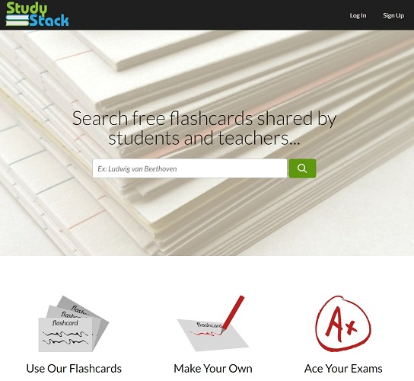

## **Tool Snapshot**

|  |  |
| --- | --- |
| **Price** | Free Basic. Pro: $10/year. Pro Teacher: $20/year. |
| **Learning** | [Behavorism](https://www.learning-theories.com/behaviorism.html)  &  [Connectivism](https://www.learning-theories.com/connectivism-siemens-downes.html) |
| **Ease of Use** | ★★★★✩ |
| **Privacy** | ★★★★✩ |
| **Accessibility** | ★★★✩✩ |
| **Class Size** | Unlimited |
| **ISTE*S** | Knowledge Constructor & Empowered Learner |
| **COPPA/**    **FERPA** | [Yes](https://www.houstonisd.org/cms/lib2/TX01001591/Centricity/domain/16245/pssfinal/StudyStack%20OnePager.pdf) |

### **Price**

On its homepage, StudyStack presents itself as being a “free advertiser-supported business”, which means that there are advertisements if you choose to use the tool for free. As stated in the [FAQ](http://www.studystack.com/FAQ), you can get rid of the advertisements and be a PRO user: “The basic PRO account is $10 per year or $1.50 per month.” There is also a “PRO Teacher” plan that you can use to remove ads for you and your students.”The PRO Teacher account costs $20 per year.  The Upgrade page is not accessible to account holders who are 12 or younger.

### **Privacy**

You can access pre-designed flashcards related to many topics without logging in. However, you need to be logged in to save game scores as well as the databases that you create. In “Settings,” you can choose the level of privacy you would like to have, whether your flashcards will be “private,” “hidden,” or “public.” Your students can view and use the flashcards you design without having to create an account. The information entered while subscribing to the PRO plan is not sent to studystack’s servers but is transmitted to stripe.com for payment processing.

## StudyStack Overview Video

***[Video transcript](https://docs.google.com/document/d/1gLXM_PLEahOvrwaSkHwvqAgZycAudB5fIqA1ceZEHCM/edit?usp=sharing)***

## StudyStack & the SAMR Model

Dr. Ruben Puentedura’s [SAMR model](http://www.emergingedtech.com/2015/04/examples-of-transforming-lessons-through-samr/) offers a lens for examining how technology is adopted in a classroom. As you strive to incorporate online tools into your classroom, we encourage you to use this model as an analytic tool.

Here is an example of how StudyStack might fit within the SAMR model:

* **Substitution:** Students review flashcards on Study Stack rather than printed flashcards from the teacher.
* **Augmentation:** All students could add some parts on the flashcards. For instance, you teach a Spanish class and want your students to focus on a lesson on food. Each student could add a phrase related to the topic.
* **Modification:** Students could design flashcards for a class located in a different country.
* **Redefinition:** Students can assess stacks that have already been created by individuals from all over the world.

## **Learning Activities**

### **Math**

Memorize math formulas.

### **Science**

Play games to build foundational human anatomy knowledge.

### **English/Language Arts**

Build vocabularly knowledge.

### **Geography and history**

Memorize major events and dates in history.

## **Resources**

* [Quizzlet versus StudyStack](https://prezi.com/jeifdns8cuo0/quizletcom-vs-studystackcom/)
* [Using StudyStack to Study Smart](http://www.nc.edu/using-study-stack-study-smart/)
* [How to Use the 5 Best Free Flashcard Creation Tools for Teachers](https://elearningindustry.com/the-5-best-free-flashcard-creation-tools-for-teachers)
* [Study Stack Instructional Manual](http://pdst.ie/sites/default/files/StudyStack%20Instructions.pdf)
* [The Five Best Free Flashcard Creation Tools for Teachers](https://elearningindustry.com/the-5-best-free-flashcard-creation-tools-for-teachers)
* [Example of How to Use Study Stack](http://sfltdu.blogspot.com/2011/09/flashcards-studystack.html)
* [Study Stack Review](https://dtm4260.edublogs.org/2015/08/06/studystack-study-tool/)

## **How to Use StudyStack**

1. Go to <http://www.studystack.com>
2. Click “Sign Up” and register for an account or use the activities without signing up.
3. Play around before deciding whether Study Stack is for you
4. Or if you sign up, use either your Facebook credentials or an email address. Be advised that if you use your Facebook credentials, your Facebook username will appear on Study Stack public forums.
5. Once you have created your account, click on “create a new stack” and enter the database of your choice.
6. Study Stack will automatically generate activities based on your “stack,” i.e. the database you created.

## **Research**

Chien, C. W. (2015). [Analysis the Effectiveness of Three Online Vocabulary Flashcard Websites on L2 Learners' Level of Lexical Knowledge](https://eric.ed.gov/?id=EJ1075255). English Language Teaching, 8(5), 111-121.

Grillo, K. J., & Dieker, L. A. (2013). A new twist on vocabulary instruction for students with learning disabilities in biology. The american biology Teacher, 75(4), 264-267.

Hung, H. T. (2015). [Intentional vocabulary learning using digital flashcards](https://eric.ed.gov/?id=EJ1079086). English Language Teaching, 8(10), 107-112.

Read this online at <https://edtechbooks.org/onlinetools/studystack>