# Tiki-Toki

[Tiki-Toki](http://www.tiki-toki.com/) is web-based software for creating interactive timelines that can be shared on the Internet. Tiki-Toki can be used in any browser and the basic account is free to sign up, which allows you to create one fully-functional timeline. Tiki-Toki provides integration with images and videos (from Youtube and Vimeo). Each timeline you create with Tiki-Toki has its own unique URL that you can share with your friends or colleagues. The upgraded version allows you to embed the timeline directly on your website or blog. This tool enables students to create interactive timelines in order to construct and present content knowledge. It also helps students easily understand events and dates in a visualized way as well as allowing them to actively participate in the learning process.

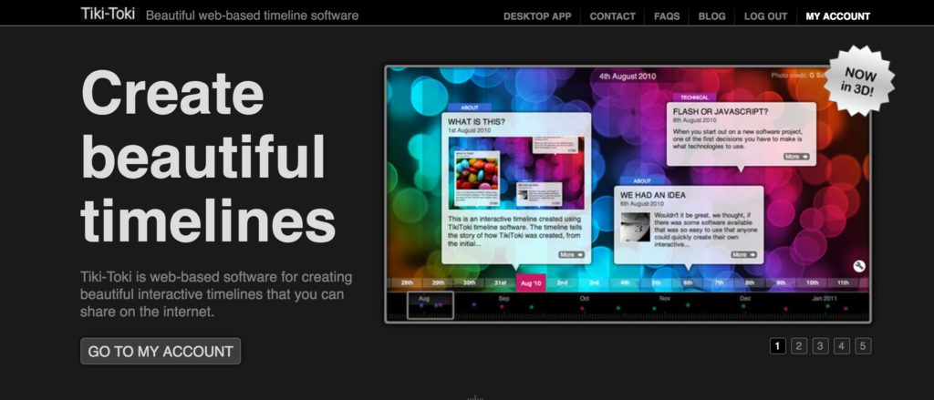

## Tool Snapshot

|  |  |
| --- | --- |
| **Price** | Basic Account: Free; Bronze Account: $9.50/month; Silver Account: $25/month; Teacher Account: $150/year |
| **Learning** | [Cognitive constructivism](http://gsi.berkeley.edu/gsi-guide-contents/learning-theory-research/cognitive-constructivism/)  &  [Constructionism](http://edutechwiki.unige.ch/en/Constructionism) |
| **Ease of Use** | ★★★★✩ |
| [**Privacy**](https://www.tiki-toki.com/privacy/) | ★★★★✩ |
| **Accessibility** | ★★✩✩✩ |
| **Class Size** | Free account: 1 per student; Teacher account: 50 students |
| **ISTE*S** | Knowledge Constructor, Creative Communicator, Global Collaborator |
| **FERPA/COPPA** | Parent consent required for children under 13.  [Read more](https://www.tiki-toki.com/parental-consent/)  about the tool's COPPA compliance. |

### **Ease of Use**

This tool is very easy to use. After signing up for your account, you can simply create a new timeline by filling out basic information, such as title, introduction, start date and end date. Then you can add content, including text, images and videos to your timeline. You are free to check out the [Tiki-Toki blogs](http://www.tiki-toki.com/blog/) to view some advance timeline examples and gather some best practices of how to using the timeline products. If you have any questions you can search for help articles or contact the Tiki-Toki team by emails.

### **Privacy**

The Tiki-Toki creation group don’t collect any information directly from general visitors to their website. However the users have to share some personal information (e.g., email address, name, location) to login. They state that they may disclose user’s personal information if they are approached by a potential buyer of their business or they are required to do so by law.

### **Accessibility**

It allows for multiple means of representation (eg. text, video, audio, images) which helps reach more learners. It also has a few features that help users who can not see very well to avoid clutter of the timelines, such as zoom out functions, adjustable 3D version, and equal spacing modes. There is no accessibility statement or VPAT for the tool.

## Tiki-Toki Overview Video

Transcript:

* Tiki-Toki is a web-based application for creating interactive timelines that you can  integrate images and videos.
* The basic account is free which allows you to create only one fully-functional timeline, you can embed video and share your timeline with others. With a paid teacher account, you can create up to 25 timelines, and access to new features, for example, 3D version, group editing, and embed timelines in your websites.
* This tool is very easy to use. After signing up for your account, you can simply create a new timeline by filling out some basic information, such as title, introduction, start date and end date. Then you can go ahead add content, including texts, images and videos to your timeline. You are free to check out the Tiki-Toki blogs to view some advance timeline examples and gather some practices of how to use the timeline products. If you have any questions you can search for help articles or contact the Tiki-Toki team by emails.
* Tiki-Toki supports students in acquiring content knowledge. For example, teachers can create a timeline that visually displays or highlights the important moments in a period of time. Students can also create a timeline to present the life of famous artists. By doing these, they will have the chance to do the research, and synthesis of information. Above all, Tiki-Toki is a great tool to be used in education field.

## Tiki-Toki & the SAMR Model

Here is an example of how Tiki-Toki might fit within the SAMR model:

* **Substitution:** Students can use Tiki-Toki to create a timeline through the Internet instead of drawing it on a piece of paper or on a white board.
* **Augmentation:** Students can use Tiki-Toki to create more interactive, multimodal timelines with the functionalities that enable them to integrate image and video.
* **Modification:** Students can use Tiki-Toki to create a timeline to manage a project or map out a plan in a more easy-to-digest and visual way.
* **Redefinition:** Students can share their work with a broad public audience to solicit feedback.

## Learning Activities

### History

Students can use Tiki-Toki create a timeline that visually displays or highlights the important moments in a period of history.

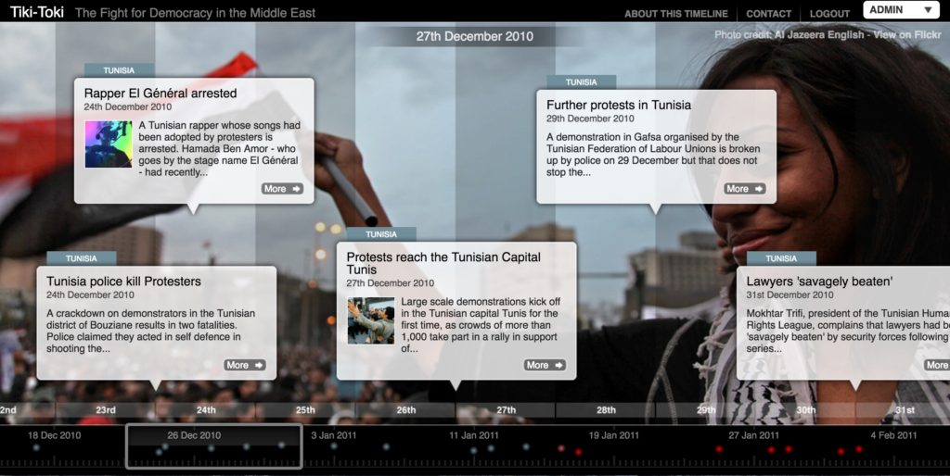

### Fine Arts or Music

Students can use Tiki-Toki to create an art gallery or a timeline to present the life of a famous artist or musician.

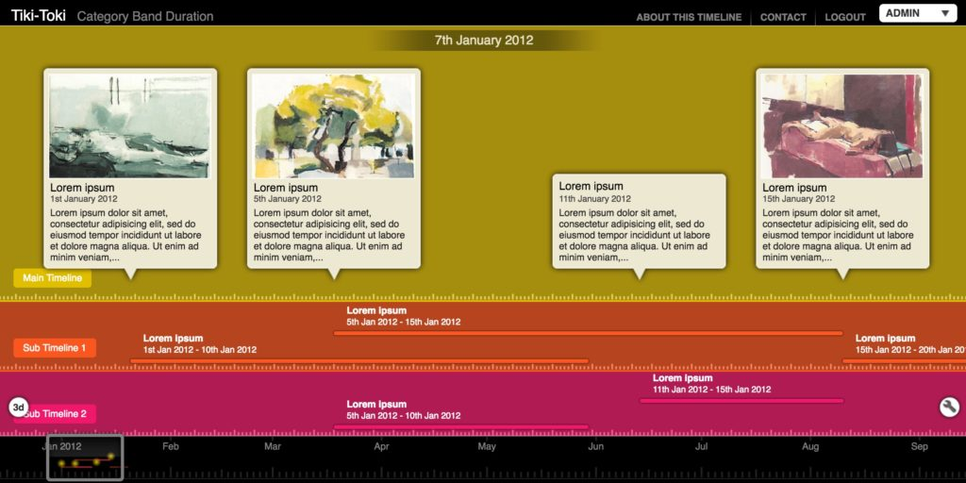

### Literacy/Language

Students can use Tiki-Toki to create a timeline of a history of their family, and include their photo albums and videos in the timeline.

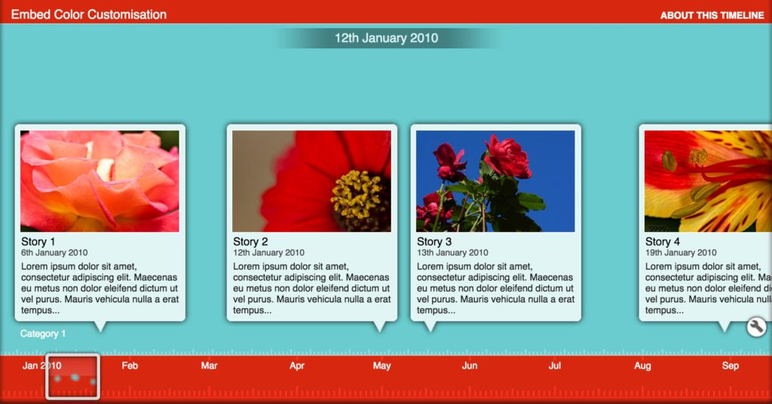

### Project Managing

Teachers and students can use Tiki-Toki to manage projects. It helps team members visually track projects and see how tasks relate to each other. In this way, it makes a complex projects easy to manage and organize.

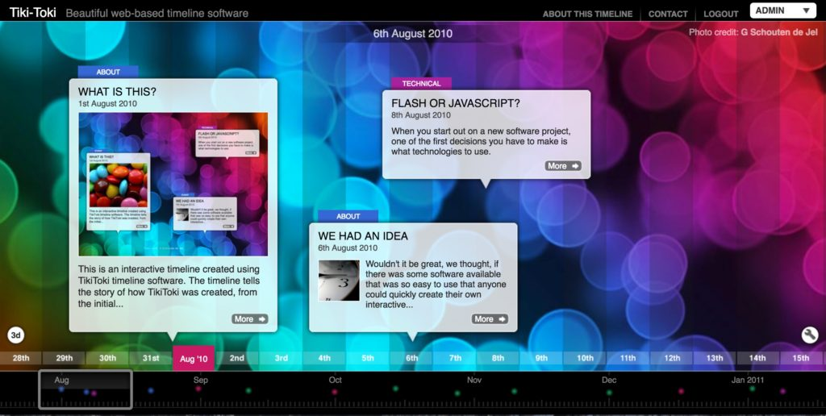

### Reflection/Assessment

Teachers can have their students create a timeline to reflect their progresses throughout a semester. They can include their digital media products, building a digital profile or illustrate the evolution of their ideas. Teachers can use the timelines their students created as a kind of summative assessment.

## Tiki-Toki – Timeline Creator

* Highlighted features
* Timeline examples

## Resources

* [10 Creative Ways To Use Free Timeline Makers in eLearning](https://elearningindustry.com/10-creative-ways-to-use-free-timeline-makers-in-elearning)
* [8 Excellent Free Timeline Creator Tools for Teachers](http://www.educatorstechnology.com/2012/08/8-excellent-free-timeline-creation.html)
* [Easy Timeline Creator App for Tablets & Computers](http://classtechtips.com/2015/01/04/easy-timeline-creator-for-tablets/)
* [Did you know how to: Use Tiki-Toki in the classroom](http://www.tiki-toki.com/blog/entry/classroom-use/)
* [Did you know how to: Avoid clutter on a timeline](http://www.tiki-toki.com/blog/entry/avoid-clutter/)
* [Tiki-Toki videos: Getting started with Tiki-Toki](http://www.tiki-toki.com/blog/entry/intro-video/)

## Introduction to Tiki-Toki Timelines Video (by Tiki-Toki Timeline Maker)

## Research

Figueiredo, M. P., Alves, V., Lourenço, C., Alves, V., Bernardo, M., & Carapito, N. (2021). [Project-based learning in design and multimedia in higher education: An interactive timeline developed in collaboration](https://repositorio.ipv.pt/handle/10400.19/6882).

Ivanova, A. (2021, June). [Online interactive timeline to improve learning of history in school education](https://dl.acm.org/doi/abs/10.1145/3472410.3472448). In International Conference on Computer Systems and Technologies' 21 (pp. 218-223).

Nutt, N., Salmistu, S., Meitl, C., & Karu, K. (2020, September). [Case Study in Experiential Learning-From Chaos to Order: Sensemaking with the Interactive Timeline Tool in Architecture and Civil Engineering Studies](https://link.springer.com/chapter/10.1007/978-3-030-68198-2_8). In International Conference on Interactive Collaborative Learning (pp. 91-102). Springer, Cham.

Read this online at <https://edtechbooks.org/onlinetools/tiki-toki>