# Pixton Comics

[Pixton](https://www.pixton.com/)

allows teachers and students to construct their own comic strips. There are a variety of comic strip layouts, numerous character and background choices, and a ton of creative options. This is a great learner-centered tool that allows students to construct their own knowledge and display it in a way that is meaningful to them by allowing them to create comics representing their concepts and ideas.

## Tool Snapshot

|  |  |
| --- | --- |
| **Price** | Free 14-day trial & paid plans |
| **Learning** | [Constructionism](http://edutechwiki.unige.ch/en/Constructionism) |
| **Ease of Use** | ★★★★✩ |
| **Privacy** | ★★★★✩ |
| [**Accessibility**](https://www.pixton.com/accessibility-level-aa) | ★★★★✩ |
| **Class Size** | Unlimited |
| **ISTE*S** | Knowledge Constructor & Creative Communicator |
| **COPPA/FERPA** | Yes |

### **Price**

The pricing for teachers is $24.99 monthly or $99 annually. Discounts are available if a plan is purchased for 11 teachers or more. There’s also the $9.99 plan but that doesn’t include full access, or you can buy individual packs for $14.99 each without the Monthly Pack. [Get a pricing quote here](https://help.pixton.com/how-to-request-a-quote).

### **Usability**

Pixton is accessible through any web browser and can be accessed on phones, tablets, and computers. Pixton offers a free app for smartphone or tablet use. The website does not specify if there is a preferred browser to use.

### **Ease of Use**

Pixton is very easy to use. It is relatively intuitive when constructing comics because all of the icons have images indicating what they do. For example, the icon with a face can be clicked to add a character. Similarly, click the icon with a picture on it to add a background image. The Pixton website has a tutorial that runs the first time you access the program. You can also access the tutorial through the help center by clicking on the question mark icon at the bottom.  In the help center, you will also find videos on how to do various things on the website and an FAQ section. You can also directly contact the owners of the help center.

For teachers, there are a ton of resources. You can create your assignments or borrow from pre-existing ones. There are a variety of layouts to suit your instructional needs including timelines, mind maps, and storyboards. Pixton also allows for a lot of creativity. You can upload your images for the background, you also have direct access to creative commons images.

### **Accessibility**

Pixton has made significant efforts to improve the digital accessibility of the tool over the last few years. It now offers speech-to-text, keyboard navigation, and screen reader integration ([learn more](https://www.pixton.com/accessibility-level-aa)). Pixton used the WCAG 2.0 guidelines to evaluate the accessibility of its tool.

### **Privacy**

Pixton Comics is COPPA and FERPA compliant by [iKeepSafe](https://ikeepsafe.org/content/uploads/2021/06/Please_DocuSign_iKeepProfile_FERPA_CSPC_COPP-2.pdf). Pixton is also a signatory of the [Student Privacy Pledge](https://studentprivacypledge.org/signatories/). However, they do still collect a lot of personal information. They use and share this information under a multitude of circumstances. They also use cookies.  Take a closer look at their privacy policy [here](https://www.pixton.com/privacy-policy/educators).

## Pixton Intro Video (by Pixton)

## Pixton & the SAMR Model

Here is an example of how Pixton might fit within the SAMR model:

* **Substitution:** Students can make comic strips digitally rather than by hand.
* **Augmentation:** Students can easily and quickly revise comic strips based on feedback.
* **Modification:** Students select diverse characters and media to create unique comics with ease. Students can customize backgrounds with their own images and change the color of skin, hair, and eyes of their characters.
* **Redefinition:** Students can easily share their comics with others via social media. Additionally, the digital aspect of this tool makes it easier for less artistically inclined students to be encouraged and inspired.

## Learning Activities

### Math

Have students create a comic strip outlining how to carry out certain mathematical processes, like long division, fractions, or order of operations. By adding in their own backgrounds they can include a visual and textual explanation.

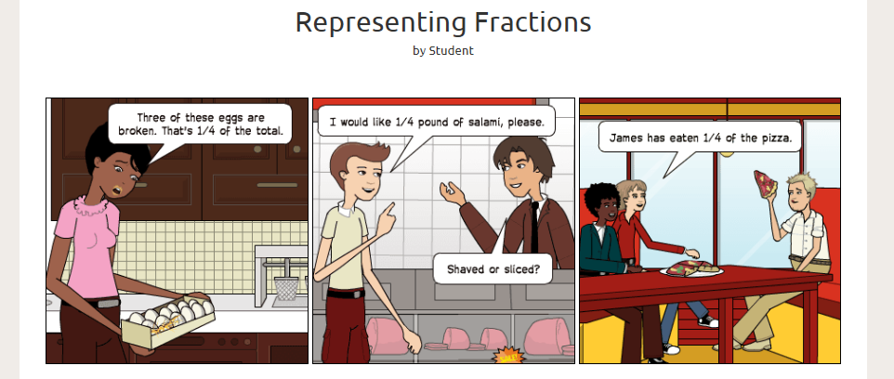

### Science

Have students summarize a scientific discovery or the evolution of a scientific concept in comic form. Or, have students construct a comic that illustrates a scientific process like photosynthesis.

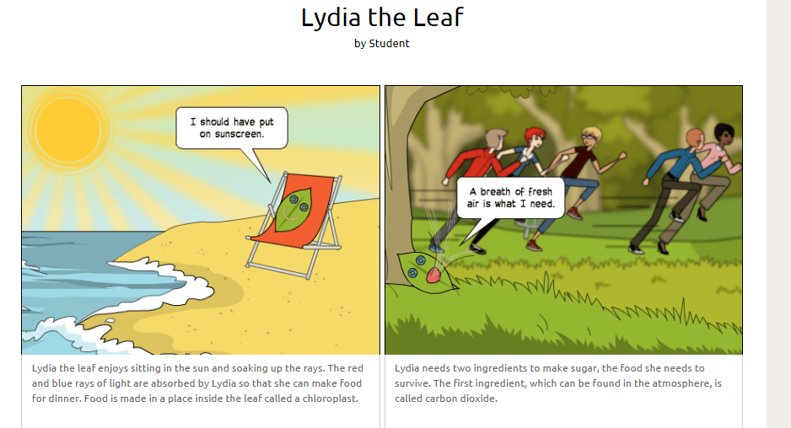

### English/Language Arts

Have students summarize a scene, book, or character by constructing a comic strip.  They could also construct a timeline for these developments.

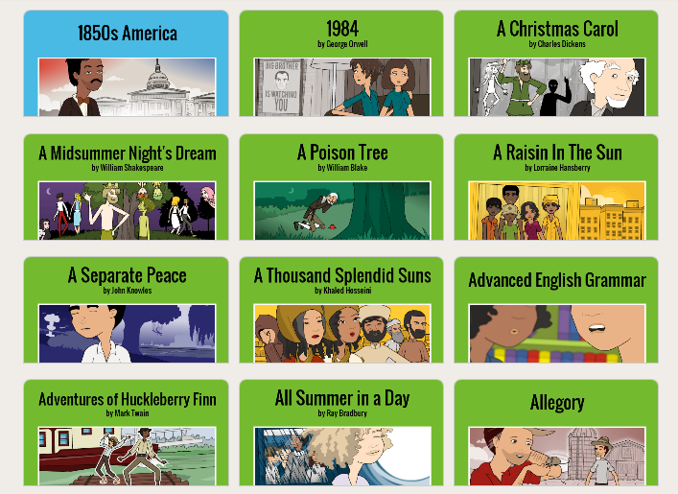

### **Art**

Comics strips can encourage creative expression and Pixton is a way to motivate students who are self-conscious about their drawing skills to still be creative and expressive.

### History

Students can break historical events down into digestible and relatable stories through the creation of a timeline.  Have them tell the story of the Boston Tea Party or Genghis Khan in a fun and creative new way.  Or, have them create their political cartoons to discuss current events.

## Resources

* [How to Teach with Comics](https://ideas.pixton.com/) (resource by Pixton)
* [Pixton- Comic Making Website for Creative Students](https://www.theteachingblog.com/post/pixton-comic-making-website-for-creative-students)

## How to Use Pixton

1. To setup a new account:
   1. Go to <https://www.pixton.com>.
   2. Click on the "For Educators" button.
   3. Choose from one of the SSO options: Clever, Microsoft, or Google.
   4. Add your personal info.
   5. Start exploring and creating!
2. If you already have an account go to <https://www.pixton.com> then click on the Login button at the top right.

## Research

Meyers, E. A. (2014). [Theory, technology, and creative practice: Using pixton comics to teach communication theory.](https://www.tandfonline.com/doi/full/10.1080/17404622.2013.839051?casa_token=pRefI5PKnX8AAAAA:6SvHroeefZW_JyXLfpiA693GYsyq1rzqbiEI1immmHrxzpti7PnYNwCM2uuoBaD0IoUmTlwUYEWiUg)Communication Teacher, 28(1), 32-38.

Cabrera, P., Castillo, L., González, P., Quiñónez, A., & Ochoa, C. (2018). [The Impact of Using” Pixton” for Teaching Grammar and Vocabulary in the EFL Ecuadorian Context.](https://eric.ed.gov/?id=EJ1170640)Teaching English with Technology, 18(1), 53-76.

### Other Related Articles

Azman, F. N., Zaibon, S. B., & Shiratuddin, N. (2015, November). Digital Storytelling Tool for Education: An Analysis of Comic Authoring Environments. In International Visual Informatics Conference (pp. 347-355). Springer International Publishing.

Maldonado, N., & Yuan, T. (2011). Technology in the classroom: from Ponyo to “My Garfield Story”: using digital comics as an alternative pathway to literary composition. Childhood Education, 87(4), 297-301.

Rogers, M. F., & Myles, B. S. (2001). Using social stories and comic strip conversations to interpret social situations for an adolescent with Asperger syndrome. Intervention in School and Clinic, 36(5), 310.

Tatalovic, M. (2009). Science comics as tools for science education and communication: a brief, exploratory study. Jcom, 8(4), A02.

Read this online at <https://edtechbooks.org/onlinetools/pixton-comics>