# Skype

[Skype](https://www.skype.com/) is a free web-based communication tool which allows people to video conference, make calls, and instant message. Skype has more than 300 million active users all around the world (see [24 Amazing Facts about Skype](http://expandedramblings.com/index.php/skype-statistics/)). 

Skype provides a variety of educational opportunities for classrooms. Students can connect with other students, increase their knowledge, and interact with other cultures. They can use Skype to share projects, polish their language skills, exchange information about particular books with students who read the same books or present their dissertation to their committee.  Skype also provides students and teachers with the opportunity to participate in virtual tours of historical places, communicate with authors and researchers, and engage in conversations with classrooms around the world. Skype provides a simple platform for student development and growth.

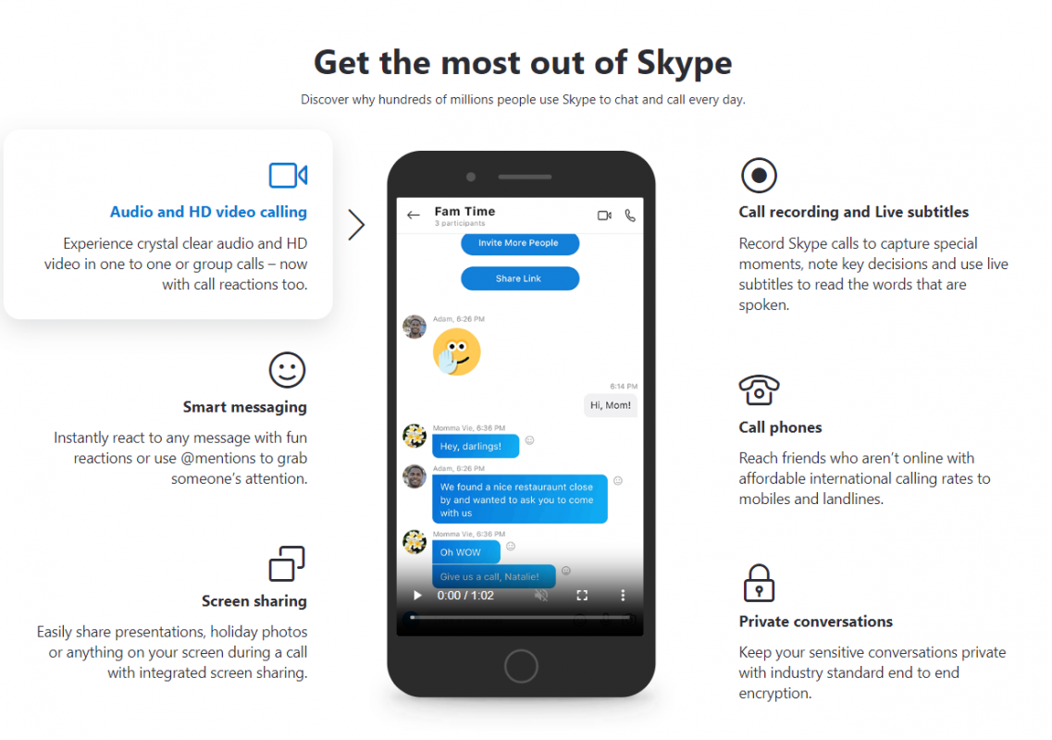

## Tool Snapshot

|  |  |
| --- | --- |
| Price | Free (basic);  [Paid international calls](https://www.skype.com/en/international-calls/) |
| Learning | [Social constructivism](http://gsi.berkeley.edu/gsi-guide-contents/learning-theory-research/social-constructivism/)  ,  [Connectivism](https://www.learning-theories.com/connectivism-siemens-downes.html) |
| Ease of Use | ★★★★★ |
| [Privacy](https://privacy.microsoft.com/en-us) | ★★★★☆ |
| [Accessibility](https://support.skype.com/en/faq/FA12371/what-accessibility-features-are-available-for-skype) | ★★★★☆ |
| Class Size | Up to  [50 people on one Skype call](https://www.skype.com/en/blogs/2019-04-group-video-calling/#:~:text=Call%20up%20to%2050%20people%20at%20once%20with%20Skype!&amp;text=You%20can%20now%20call%20and,get%20everyone%20in%20one%20place.) |
| [ISTE*S](http://www.iste.org/standards/standards/for-students-2016) | Knowledge Constructor, Creative Communicator, Global Collaborator |
| [COPPA/FERPA](https://docs.microsoft.com/en-us/microsoft-365/compliance/offering-ferpa?view=o365-worldwide) | Yes, FERPA |

### **Price**

Skype is technically a “free” community-based software. However, if you want to get a phone number with the country code in which you live, you have to pay a little amount of money.

### **Ease of Use**

Skype main page is very simple and does not comprise a lot of information. Skype has a seamless [help page](https://support.skype.com/en/skype/all/). They split the necessity information into the categories such as getting started, calling, video, account and payments, messaging, and everything else. It means you don’t have to think too much or spend a long time to get an assist. If you don’t know which category includes your question, you can use search icon and text keyword to find an answer. Furthermore, you can join the conversation and note previous discussion pertain to the topic.

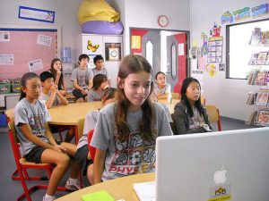

### **Designers**

Skype was created by Janus Friis (Denmark) and Niklas Zennstrom (Sweden) in 2003. Then, Microsoft bought Skype, paying $8.5 billion.

### **Accessibility**

Skype offers voiceover, narrated screen reader, high-contrast settings, magnifier, and speech recognition to convert speech to texts to support people with hearing or seeing disabilities.

### **Privacy**

Skype uses cookies to get some personal information about users. It benefits from the cookies to improve itself, recognize people’s preferences, and tailor Skype web content for individuals. You can disable cookies if you do not want Skype to use your information. Furthermore, you can change your privacy settings by clicking Skype> Preferences> Privacy.

## Skype Overview Video

 ***[View the Skype Video Transcript](https://docs.google.com/document/d/1hIP-f4tMh34Xz2ltHJZspfs4tlZIGGzKuWDX8ygDHKY/edit)***

## Skype & the SAMR Model

Dr. Ruben Puentedura’s [SAMR model](http://www.emergingedtech.com/2015/04/examples-of-transforming-lessons-through-samr/) offers a lens for examining how technology is adopted in a classroom. As you strive to incorporate online tools into your classroom, we encourage you to use this model as an analytic tool.

Here is an example of how Skype might fit within the SAMR model:

* **Substitution:**Students use a Skype to meet, communicate, and interact with other students online (instead of engaging in a face-to-face discussion).
* **Augmentation:** Students can communicate in multimodal ways with Skype.
* **Modification:** Students can join video conferencing, share their screens, and communicate with other students who live in the U.S or abroad and save their videos for future use.
* **Redefinition:**Subject matter experts, faculties, and famous people all around the world can be invited to join a class discussion and share their expertise.

## Learning Activities

Mystery Skype provides entertaining social learning experiences for students. Particularly, Geography, Language Arts, Science, and Math teachers can use it effectively. Mystery Skype allows students to recognize cultural awareness, speak with second language learners, and learn knowledge related to geographical features of the place. Remember, teachers should get permission students to show themselves on camera.

### Math

Many tutors use Skype to teach Math as online. They teach students who struggle to understand abstract concepts in Math as an individual or in the group.

### Science

There are many opportunities to use Skype for STEM. Students can follow along with scientists as they build a new rocket  or walk on a glacier in Iceland.

### English/Language Arts

Skype allows both educators and students to connect with one another on a global level. Learners can find a chance to speak the foreign language with native speakers. In addition, students can meet authors and lecturers on Skype to get more information about writing and reading their own language.

### Other

Interviews, after school help, virtual field trips, bringing busy parents into the classroom.Resources (see [50 Awesome Ways to Use Skype in the Classroom](http://www.teachingdegree.org/2009/06/30/50-awesome-ways-to-use-skype-in-the-classroom/) )

## Resources

* [5 Creative ways Use Skype in Classroom](https://elearningindustry.com/5-creative-ways-use-skype-in-the-classroom)
* [How Are You Connecting Your Students with the World? Skype in the Classroom](http://www.edutopia.org/blog/mock-elections-via-skype-suzie-boss)
* [12 Top Tips: How to Teach on Skype](http://www.lindsaydoeslanguages.com/12-top-tips-for-teaching-on-skype/)
* [A window on the world: Using Skype in the classroom](http://www.learnnc.org/lp/pages/6573)
* [6 Creative Ways to Use Skype in the Classroom](http://www.edudemic.com/skype-in-classroom/)
* [The complete Guide to the Use of Skype in Education](http://www.educatorstechnology.com/2012/06/complete-guide-to-use-of-skype-in.html)
* [Cool Ways to Use Skype in the Classroom](http://www.teachhub.com/using-skype-classroom)
* [Skype in the Elementary Classroom!](http://teachtrainlove.com/skype-in-the-elementary-classroom/)

## How to Use Skype

* 1. Go to [www.skype.com](https://www.skype.com/en/)
  2. Click “Download Skype” and get Skype for Windows or Skype for Mobile.
  3. Click “Sign Up” and register for account
  4. Setup your profile page
     1. Click on the silhouette icon in the top right corner
     2. Click on “My account.”
     3. Click on the silhouette icon and select “edit profile”
     4. Add a photo and/or short bio
  5. Search people’s either username or e-mail address to add them to your contact list
     1. Go to “Contacts”
     2. Select add “Contacts” or click directly in the search text box
     3. Type the “Contact name” or “Skype username”
     4. Click on “search Skype”
     5. After find right contact, click on “Add to Contacts”
  6. Make a free call
     1. Click the “Use Skype Online” button in the center of the page
     2. Go to your account and Click the “Contacts” next “ Search Skype” to find people you want to call
     3. Click the name you found and make a voice or video call or message

## Research

Hidayati, A. N., Ramalia, T., & Abdullah, F. (2021). [Leveraging Skype-based webinars as an English language learning platform](http://www.journal.staihubbulwathan.id/index.php/alishlah/article/view/420). Al-Ishlah: Jurnal Pendidikan, 13(1), 10-20.

Mustafa, E. N. E. (2018). [The impact of YouTube, Skype and WhatsApp in improving EFL learners’ speaking skill](http://www.ijcar.net/assets/pdf/Vol5-No5-May2018/02.pdf). International Journal of Contemporary Applied Researches, 5(5), 18-31.

Rock, M. L., Schoenfeld, N., Zigmond, N., Gable, R. A., Gregg, M., Ploessl, D. M., & Salter, A. (2013). [Can You Skype Me Now? Developing Teachers’ Classroom Management Practices through Virtual Coaching](https://journals.sagepub.com/doi/abs/10.1177/107429561302200303). Beyond Behavior, 22(3), 15-23.

Read this online at <https://edtechbooks.org/onlinetools/skype>