Classkick
Classkick is a free digital formative assessment tool that allows teachers to create lessons and assignments that students work through on their devices at their own pace. Teachers can observe student progress in real time and provide immediate feedback. In addition to receiving help and feedback from the teacher, Classkick allows students to anonymously request help from their peers. Text, images, video, and audio can be easily integrated into assignments. It is a great tool for synchronous and asynchronous communication, blended classrooms, personalized learning, and cooperative learning.
Classkick is now both web- and app-based, it can be used from a web-browser, Chromebook, or iPad.

Tool Snapshot
Price | Pricing Plan
Learning | Behaviorism  ,  Cognitivism  ,  Social constructivism  (peer support)
Privacy | Privacy Policy
Accessibility | Accessibility Statement
Class Size | Unlimited
ISTE*S | Empowered Learner
COPPA/FERPA

Classkick Overview Video
*** Classkick Video Transcript ***

Classkick & the SAMR Model
Dr. Ruben Puentedura’s SAMR model offers a lens for examining how technology is adopted in a classroom. As you strive to incorporate online tools into your classroom, we encourage you to use this model as an analytic tool.
Here is an example of how Classkick might fit within the SAMR model:
- Substitution: Students use Classkick to complete assignments (as opposed to completing assignments on paper).
- Augmentation: Teachers can also provide real-time feedback to students instead of waiting to have papers graded the next day, allowing students to move on and continue learning within a lesson/assignment rather than getting stuck at a certain place.
- Modification: Students can include an image, video, or audio recording in their response to an assignment question. This gives students an opportunity to synthesize their analysis and response in multiple modalities. Teachers embed video and text into lessons and assignments, providing information in multiple mediums and allowing students to learn by reading, listening, and/or watching.
- Redefinition: Students can anonymously request help from peers in real-time, and peers can switch roles from student to teacher to assist fellow students. This challenges more advanced students to achieve a level of understanding such that they can teach others, and provides additional students who are struggling more. The anonymity of requesting help makes it easier for students who need the additional support feel comfortable asking for it.

Learning Activities
Elementary School (Grades K-5): Make observations of plants and animals to compare the diversity of life in different habitats.
Middle School (Grades 6-8): Instruct students to read, listen to, or watch The Gift of The Magi and continue the story after its current ending point. Also require students to evaluate their continuation against a rubric.
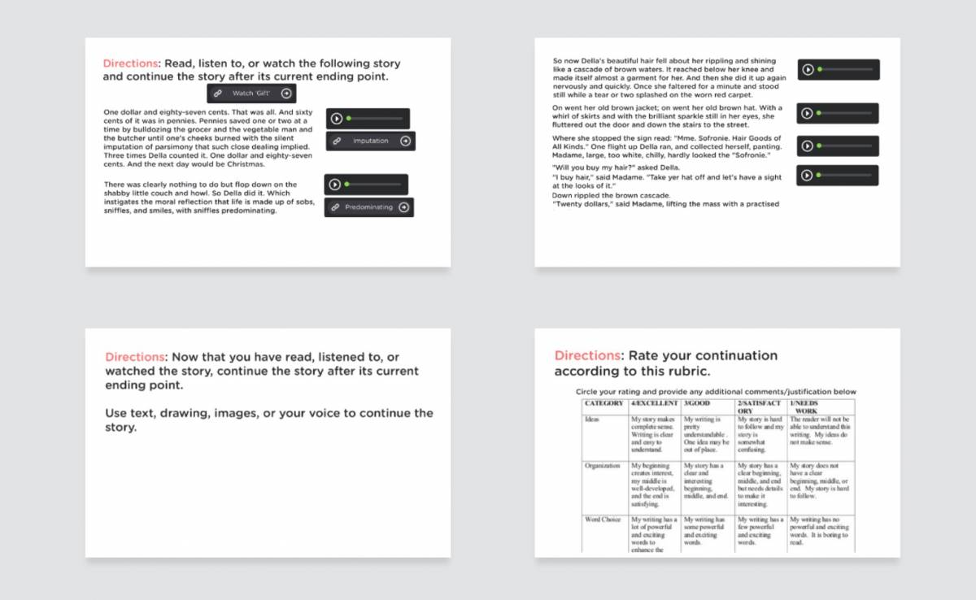
High School (Grades 9-12): Have students solve linear systems of equations using substitution. Use slides to walk students through the process. Have students who finish early answer peer questions.
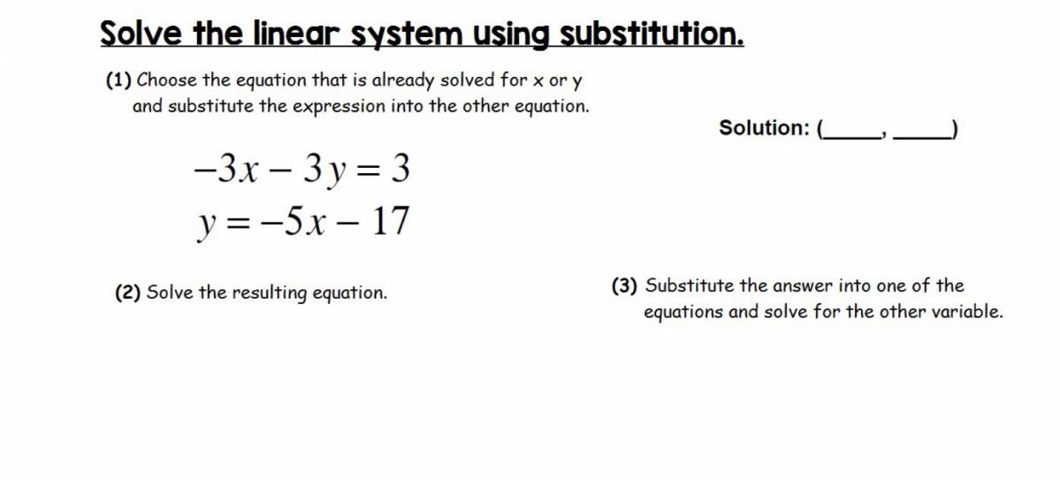
Higher Education (and all grade levels): Have students create a classkick presentation instead of a typical Powerpoint. Require that students incorporate questions into their presentation and have them monitor classmates progress and answer questions as they come up as they relate to their topic.

Resources
- Classkick Getting Started Guide – Official Guide from Classkick
- Classkick Teacher Resources– Official Classkick Teacher Resource List
- Classkick Teacher Guide – Guide Created by Duplin Schools
- Classkick Math Lessons – Rockstar Math Teacher Blog Post
- 5 Reasons to Use Classkick – Classroom Tested BlogPost
- Classkick Youtube Tutorials – Classkick’s Youtube Channel

How to Use Classkick

As a Teacher:
- Go to http://app.classkick.com/
- Click Teacher Login
- Enter email and password
- Click Sign Up
- To create a new assignment: click plus sign in the top right hand corner.
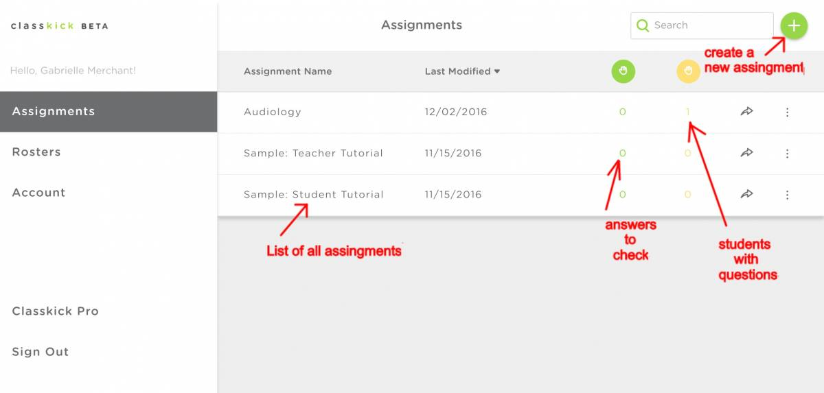
  - Give the assignment a name and a description
  - Create slides or upload a PDF.
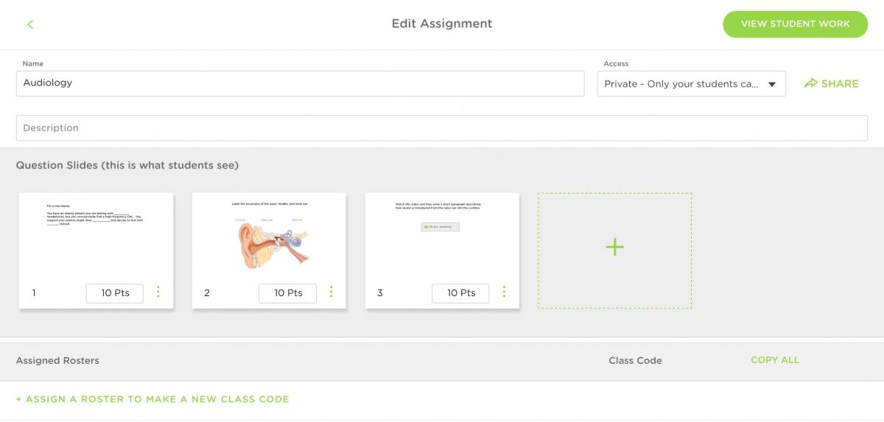
  - Slides can include text, audio, video, links, and drawings. If a slide contains a question, assign a point value to that slide.
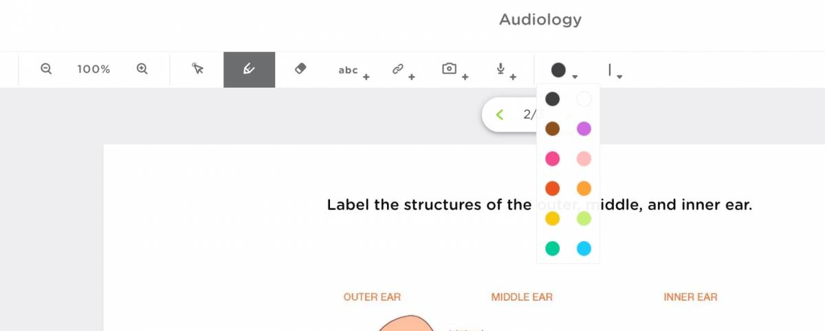
- Provide students with the class code or send them the class code hyperlink to join the class.
- Click View Student Work to look at student progress and provide feedback. This screenshot shows two students from Period 1: Joe and Susie. Clicking a white rectangle opens the student’s slide. There are 3 slides in the assignment (and thus 3 shown for each student). Each slide is worth 10 points. The yellow hand indicates that Susie is requesting help on slide two, which you can provide by clicking on the slide. The two green slides have been given feedback and scored.
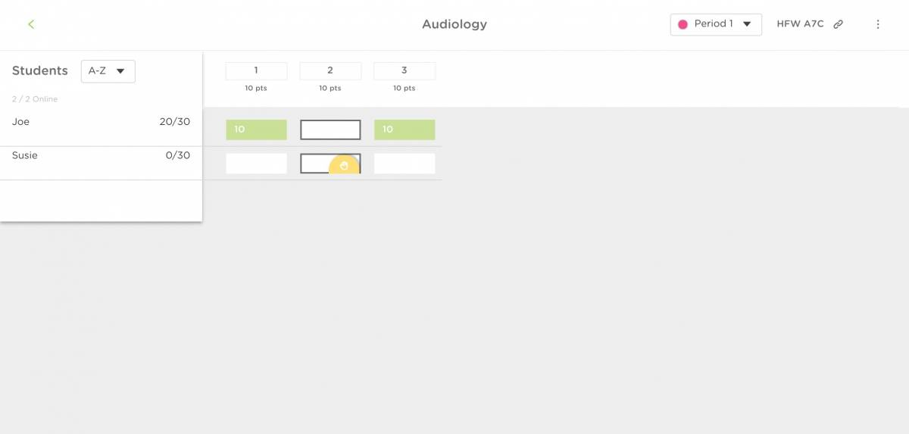

As a Student:
- Go to http://app.classkick.com/ or the hyperlink provided by your teacher.
- Type in your Class Code and your name
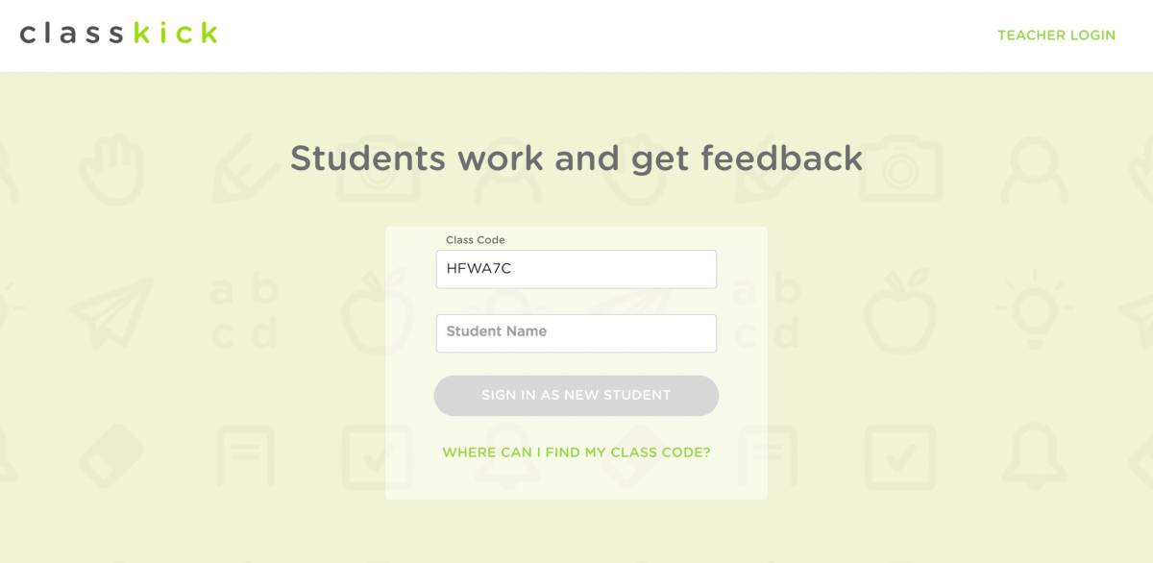
- Click on the first slide, and work through the lesson and assignment
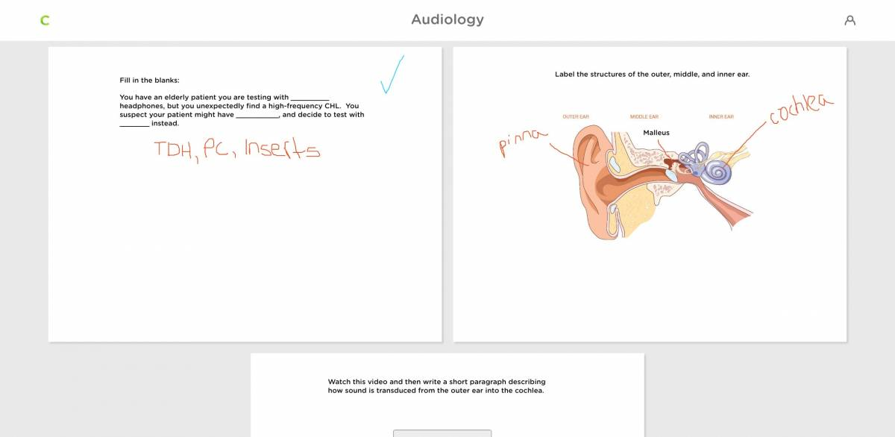
- You can write on the slides with a pen (drawing) or text. You can also add photos, video, and audio to your responses.
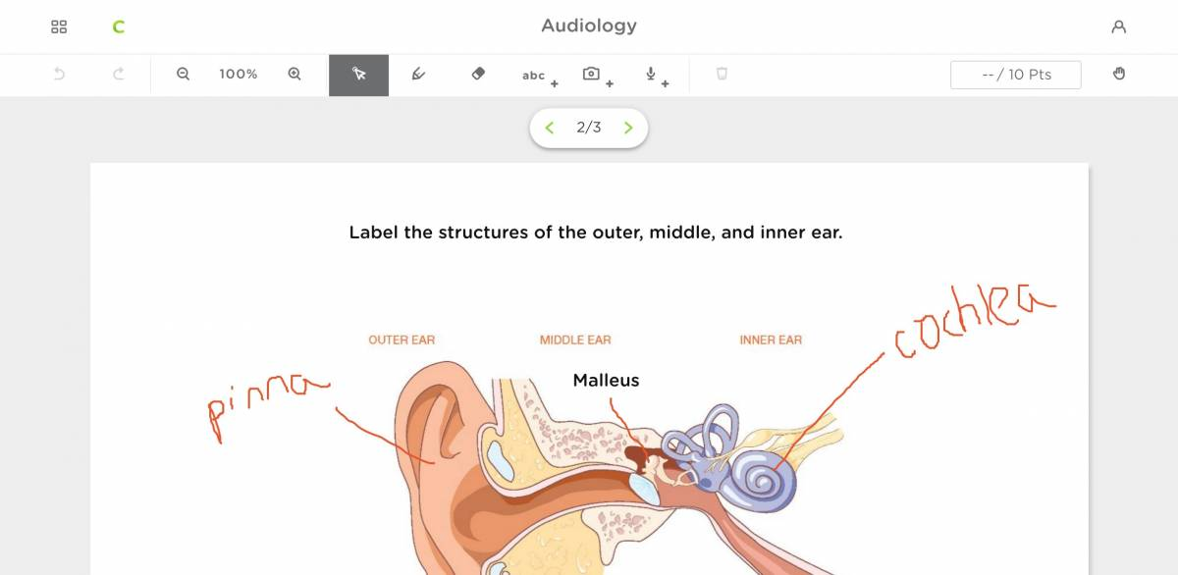
- If you need to get help or would your response checked, click the hand in the top right corner.
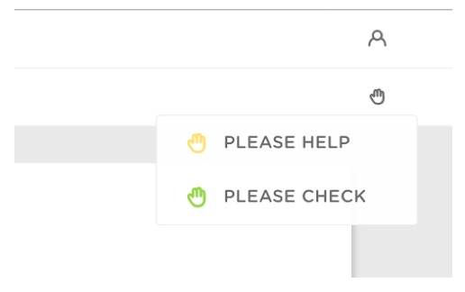

Author
This page was created by Gabrielle R. Merchant
Read this online at https://edtechbooks.org/onlinetools/classkick

