# EdPuzzle

[EdPuzzle](http://edpuzzle.com) is a free assessment-centered tool that allows teachers and students to create interactive online videos by embedding either open-ended or multiple-choice questions, audio notes, audio tracks, or comments on a video. Edpuzzle interactive videos can be made with videos from a number of websites, including [YouTube](http://www.youtube.com), [TED](https://www.ted.com/talks), [Vimeo](http://www.vimeo.com), and National Geographic.

## Tool Snapshot

|  |  |
| --- | --- |
| [Price](https://edpuzzle.com/pricing) | Free (Basic); Pro Teacher ($12.50/month); School & District Plans Available |
| Learning | Behaviorism |
| Ease of Use | ★★★★☆ |
| [Privacy](https://edpuzzle.com/privacy) | ★★★☆☆ |
| [Accessibility](https://support.edpuzzle.com/hc/en-us/articles/360034886311-Edpuzzle-Accessibility-VPAT-2-0) | ★★★★☆ |
| Class Size | Unlimited |
| [ISTE*S](http://www.iste.org/standards/standards/for-students-2016) | Empowered Learner |
| [COPPA/FERPA](https://edpuzzle.com/privacycenter) | Yes, certified from iKeepSafe |

EdPuzzle is a great [formative assessment](https://www.google.com/url?q=https://en.wikipedia.org/wiki/Formative_assessment&amp;sa=D&amp;ust=1481585237877000&amp;usg=AFQjCNEYeNeT77BVrLbXM5oYHo_N_njyyQ) tool for teachers who run a [flipped classroom](https://www.google.com/url?q=https://en.wikipedia.org/wiki/Flipped_classroom&amp;sa=D&amp;ust=1481585237879000&amp;usg=AFQjCNFi5gymxD_w3UtKrbWdx1VERFyTww), assign videos for homework, or want to encourage [asynchronous communication](https://www.google.com/url?q=http://etec.ctlt.ubc.ca/510wiki/Synchronous_and_Asynchronous_Communication:Tools_for_Collaboration&amp;sa=D&amp;ust=1481585237881000&amp;usg=AFQjCNGKQA-1u7BuWVkkIqmSBRkFmBCnJQ).  Teacher also can have students use EdPuzzle to show whether or not they achieved the goals at the end of the semester.

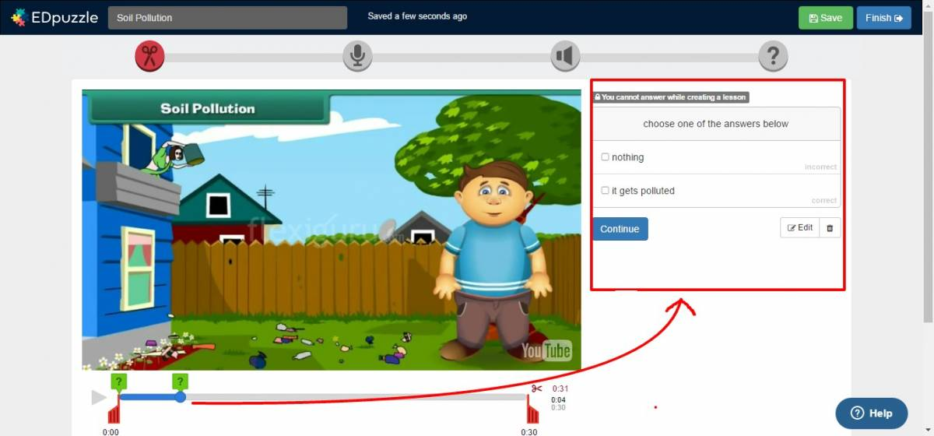

In EdPuzzle teachers can create online classes and upload original videos or select online videos, add interactive features, assign those videos to students, and send the video assignments to students’ email addresses by providing either access code or a link. EdPuzzle enables teachers to keep track of how many students watched the video, what percentage of the video students watched, when they watched it, what questions in the video students answered right or wrong.

## Sign up for EdPuzzle

[The video transcript](https://docs.google.com/document/d/1L3sHKeyZey3wgINEbOhy3GbeWR9ssg_43l2loxemF8k/edit?usp=sharing)

## EdPuzzle Tutorial

[The video transcript](https://docs.google.com/document/d/1E1Rubrz9TpXewC0ZBRnnQ9ObEE-cQXYVLTIQPXrErFY/edit?usp=sharing)

## EdPuzzle & the SAMR Model

Dr. Ruben Puentedura’s [SAMR model](https://www.google.com/url?q=http://www.emergingedtech.com/2015/04/examples-of-transforming-lessons-through-samr/&amp;sa=D&amp;ust=1481585237920000&amp;usg=AFQjCNEAY0F1UDFXb_nkJfdlCbYyglENJg) offers a lens for examining how technology is adopted in a classroom. As you strive to incorporate online tools into your classroom, we encourage you to use this model as an analytic tool.

Here is an example of how EdPuzzle might fit within the SAMR model:

* **Substitution:**Students answer questions on a video rather than on paper.
* **Augmentation:**Teachers can enhance the videos they show in class by adding their own narration into the video to clarify concepts or highlight key points.
* **Modification:** Students use EDPuzzle to add multiple choice and open-ended questions to a video from the teacher. Once they have created their own interactive videos, students can exchange their videos with classmates, complete classmates’ video quizzes, and provide feedback on the quality of their classmates’ interactive videos.
* **Redefinition:**Students and teachers can share their EdPuzzle interactive videos with people around the world, collect data from the individuals who respond to their questions, and analyze the data.

Far too often, technology is used as a direct substitute for other low-tech tools (e.g., pencil and paper). While substitution has some benefits (e.g., students develop their technology skills and knowledge), we encourage you to think about how you might use EdPuzzle to modify or redefine learning.

## Learning Activities

### Math

After covering the topic “slope,” go to EdPuzzle and search for a video (e.g., how to find slope on a line) by using Khan Academy, which is a tool that contains tons of math videos. Embed your own voice and questions in the video, add it to your online class on EdPuzzle and share it with your students via online class on EdPuzzle. After that, ask your students to answer the questions in the video and track their answers and progress. Provide immediate feedback to scaffold student learning.

### Science

In order to create awareness of climate change, each student finds a climate change-related video. They customize it by embedding their own voice and adding some questions in it. Then, students gather all the videos, synthesize them into one video in a meaningful way, and create a video gallery to present it in upcoming showcase in school.

### Biology

By using National Geographic Channel on EdPuzzle, find a cheetah video and share it with your students. Give it as assignment for them and tell them to watch it before they come to school. Once they come to school, have them discuss the video in groups.

### Social science

Students watch a video about the different types of government structures. They develop a list of questions about this topic and embed their questions directly into the video via EdPuzzle. They can share their EdPuzzle video with a teacher or expert (via social media) to solicit responses to their questions.

## Resources

* [EdPuzzle support](https://support.edpuzzle.com/hc/en-us)
* [EdPuzzle workshop by Edpuzzle](http://www.sps186.org/downloads/table/81425/Workshop_EDpuzzle_2014.pdf)
* [Getting data from EdPuzzle](http://www.sps186.org/downloads/table/84165/Getting%20Data%20from%20EDpuzzle.pdf)
* [Q & A site by EdPuzzle](https://sites.google.com/a/edpuzzle.com/edpuzzle/q-a)
* [Encouraging conversation with Edpuzzle](http://tiie.w3.uvm.edu/blog/encouraging-conversations-edpuzzle/)
* [Make videos more engaging with EdPuzzle](http://comeongetappy.com/2015/11/16/make-videos-more-engaging-with-edpuzzle/)

## How to Use EdPuzzle

1. Go to [EdPuzzle](http://edpuzzle.com).
2. Choose teacher account.
3. Click “Sign Up” and register for an account.
4. Return to EdPuzzle and login.
5. Go to my classes option on the top.
6. Click on “add class” option to create a class.
   1. Name your class.
   2. Invite your students to your class.
   3. Click on search button on the top.
7. Search for a video on the channels offered on the left side (e.g., EdPuzzle, YouTube, Vimeo).
   1. Choose the video that you want to edit and click on “use it” button.
   2. Edit your video by using features on the top of the video.
   3. Click on “Save” button and go to my content on the top middle on Homepage.
   4. Select your video that you just edited and assign it to your students in your class by clicking on “assign/share” button on the top. And then, assign it for your class on EdPuzzle.

## Image Sources

* EdPuzzle, (n.d.). EdPuzzle support by EdPuzzle. Retrieved from <https://edpuzzle.zendesk.com/hc/en-us/categories/201076232-For-Teachers>
* EdPuzzle, (n.d.). EdPuzzle teacher resources by EdPuzzle. Retrieved from <https://sites.google.com/a/edpuzzle.com/edpuzzle_teacher_resources/>
* EdPuzzle, (n.d.). EdPuzzle workshop by Edpuzzle. Retrieved from <http://www.sps186.org/downloads/table/81425/Workshop_EDpuzzle_2014.pdf>
* EdPuzzle, (n.d.). Getting data from EdPuzzle by EdPuzzle. Retrieved from <http://www.sps186.org/downloads/table/84165/Getting%20Data%20from%20EDpuzzle.pdf>
* EdPuzzle, (n.d.). How to create a video by EdPuzzle. Retrieved from <http://www.sps186.org/downloads/table/84171/Create%20a%20video%20in%20EDpuzzle.pdf>
* EdPuzzle, (n.d.). Q&A site by EdPuzzle. Retrieved from <https://sites.google.com/a/edpuzzle.com/edpuzzle/q-a>
* Green, J. (2016). Make videos more engaging with EdPuzzle. Retrieved from <http://comeongetappy.com/2015/11/16/make-videos-more-engaging-with-edpuzzle/>
* Hennesey, S. (2015,Marc 9). Encouraging conversation with EdPuzzle. [Blog post]. Retrieved from <http://tiie.w3.uvm.edu/blog/encouraging-conversations-edpuzzle/>
* Pixabay, (n.d.). Retrieved from [https://pixabay.com/en/photos/?q=instagram&image_type=&cat=&min_width=&min_height=](https://pixabay.com/en/photos/?q=instagram&amp;image_type=&amp;cat=&amp;min_width=&amp;min_height=)

## Research

Active Learning with Interactive Videos: [Creating Student-Guided Learning Materials](https://www.google.com/url?q=http://www.tandfonline.com/doi/abs/10.1080/1533290X.2016.1206776&amp;sa=D&amp;ust=1481585237959000&amp;usg=AFQjCNF8qeuxN71ZyV3soLwbZ_EoMnI0-w)

Baker, A. (2016). Active Learning with Interactive Videos: Creating Student-Guided Learning Materials. Journal of Library & Information Services in Distance Learning, 1-9.

## Author

This page was designed by Emrah Pektas.

Read this online at <https://edtechbooks.org/onlinetools/edpuzzle>