# Pencil Code

[Pencil Code](https://pencilcode.net/), which is built on top of MIT’s Scratch, is a programming site for drawing art, playing music, and creating games. It is also a place to experiment with mathematical functions, geometry, graphing, webpages, simulations, and algorithms (learn more here). Programs are open for all to see and copy. If you are trying to teach your students how to code in a creative engaging manner, then you should consider this tool.

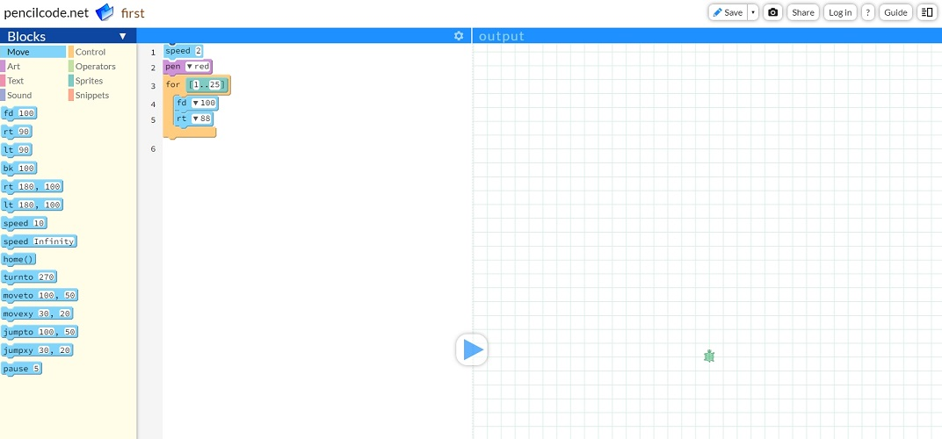

## Tool Snapshot

|  |  |
| --- | --- |
| **Price** | Free |
| **Learning** | [Constructionism](http://edutechwiki.unige.ch/en/Constructionism) |
| **Ease of Use** | ★★★  ✩  ✩ |
| **Privacy** | ★★★★★ |
| **Accessibility** | ★✩  ✩  ✩  ✩ |
| **Class Size** | Unlimited |
| **Login** | No |
| **ISTE*S** | Innovative Designer, Computational Thinker |
| **COPPA/FERPA** | Yes |

## Pencil Code Overview

Pencil Code is a great tool. Overall it is easy to learn, but if you’ve never seen this tool or similar tools such as Scratch, it has a decent learning curve to get over.

Privacy-wise, Pencil Code is great as it is clearly stated that all tools are public to all users and no real names are allowed on the platform.

However, since Pencil Code’s content is very dynamic, accessibility is an issue with the site since the output of the code is not supported by screen readers or similar tools.

## Pencil Code Overview Video

## Pencil Code & the SAMR Model

Here is an example of how Pencil Code might fit within the SAMR model:

* **Substitution:** Students engage in the coding aspect of drawing (instead of using typical means, such as pen and paper).
* **Augmentation:** Students are able to create stories with music and narratives which are not typically associated with coding.
* **Modification:** Students can gather code from multiple sections of code pencil (i.e., music animation, etc...) and mash them all together in one project.
* **Redefinition:** Students are able to view all projects created on Pencil Code and are encouraged to edit them and make modifications to make it their own.

Far too often, technology is used as a direct substitute for other low-tech tools (e.g., pencil and paper). While substitution has some benefits (e.g., students develop their technology skills and knowledge), we encourage you to think about how you might use Pencil Code to modify or redefine learning.

## Learning Activities

### **Math**

Students can learn about mathematical concepts such as angles and degrees using Pencil Code. In order to move around the plane, students must know about the unit circle.

### **Music**

Students can create their own music by writing code, they could choose individual instruments such as piano, or create their own by changing the pitch and frequency of provided sound effects.

### **English/Language Arts**

Students can create interactive adventures using code. Using Pencil Code, students can create interactive stories in which they can receive input from users and perform different actions based on the inputs.

### **Creative Arts**

Students can draw simple and complex objects using code. Ranging from a simple house using 8 lines of code, to an elaborate tree structure using 25 lines of code.

### **Other**

Students are able to combine any and all of the resources previously mentioned to create their own projects, such as creating an interactive story that has a custom background noise depending on the what is currently happening in the story.

## Resources

* [Pencil Code Online Guide](https://guide.pencilcode.net/)
* [Pencil Code Manual](https://manual.pencilcode.net/home/pdf/101-Chapter1.pdf)
* [Pencil Code Activities](http://activity.pencilcode.net/)
* [Pencil Code Music Example](https://gym.pencilcode.net/jam/#/jam/firstnote.html)
* [Pencil Code Story Writing Example](https://gym.pencilcode.net/imagine/#/imagine/first.html)
* [Pencil Code Drawing Example](https://gym.pencilcode.net/draw/#/draw/first.html)
* [Pencil Code Reference Guide](https://gym.pencilcode.net/ref/)
* [Pencil Code All User Projects](https://pencilcode.net/home/)

## How to Use Pencil Code

If you’ve ever used [Scratch](https://scratch.mit.edu/), pencil code will be very straightforward. If you’ve never used scratch or any drag and drop coding tool, a highly recommend you read the [get started guide](https://guide.pencilcode.net/).

In order to get started follow these steps:

1. Go to the Pencil Code website: <https://pencilcode.net/>
2. If you want to get started quickly:
   1. Click the “Let’s Play Button”
   2. Once in the code editor, drag and drop blocks to code!
3. If you want to simply create a new empty pencil code:
   1. Look at the bottom right corner under the “Get Creative” section
   2. Click “Start on a Blank Page”
   3. Once in the code editor, drag and drop blocks to code!
4. If you want to create an account:
   1. Click the “New Account” button on the top right
   2. Input your username and passwords, keep in mind that no real names are allowed on Pencil Code per the privacy policy
5. Once you’re done with your Pencil Code project, click the save button on the top right to save it to your account
6. Or once you’re done with your Pencil Code project, share it with peers or instructors by clicking “Share” on the right corner.

## Research

Deng, W., Pi, Z., Lei, W., Zhou, Q., & Zhang, W. (2020). [Pencil Code improves learners' computational thinking and computer learning attitude](https://onlinelibrary.wiley.com/doi/full/10.1002/cae.22177). Computer applications in engineering education, 28(1), 90-104.

## Author

This page was created by Brian Ramirez.

Read this online at <https://edtechbooks.org/onlinetools/pencil-code>