# Newsela

[Newsela](https://newsela.com) is an instructional content tool that allows teachers to find articles with appropriate reading levels for their students. Newsela articles also feature questions and writing prompts that align with common core standards. If you want to bring real life events into your classroom with engaging content and analytics to see how your students are doing, try Newsela.

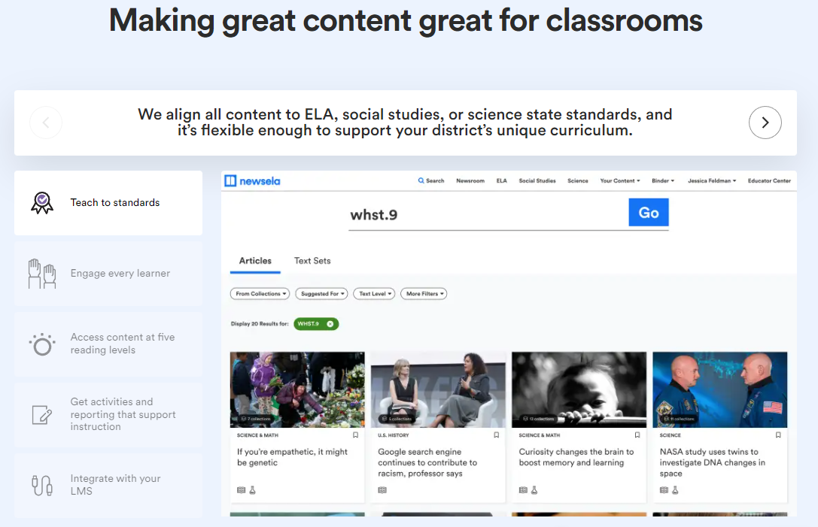

## Tool Snapshot

|  |  |
| --- | --- |
| **Price** | Free &  [Paid Plans](https://newsela.com/about/solutions/compare/) |
| **Learning** | [Cognitivism](https://www.learning-theories.com/cognitivism.html) |
| **Ease of Use** | ★★★✩✩ |
| **Privacy** | ★★✩✩✩ |
| **Accessibility** | ★★✩✩✩ |
| **Class Size** | Unlimited |
| **Login** | Yes |
| **ISTE*S** | Knowledge Constructor |
| **COPPA/**    **FERPA** | Yes |

## Newsela Overview Video

## **Newsela & the SAMR Model**

The SAMR model, developed by Dr. Ruben Puentedura, is a framework for examining the purpose and advantages of technology integration. It reminds us to think about the ways to use technology beyond just substituting low-tech alternatives, and aim for the redefinition of the task, adding functions that could not be done without the technology. Below are some ways Newsela can be used at each stage of the SAMR Model.

* **Substitution:** Teachers assign the same Newsela article at the same reading level for all students rather than assigning a printed newspaper article.
* **Augmentation:** Teachers use Newsela to assign relevant articles with **appropriate challenge level**and scaffolding for students.
* **Modification:** Teachers use Newsela to **integrate assessment** into engaging readings.
* **Redefinition:** Teachers use Newsela to **personalize learning** to each student’s reading level while still delivering the same content.

Far too often, technology is used as a direct substitute for other low-tech tools (e.g., pencil and paper). While substitution has some benefits (e.g., students develop their technology skills and knowledge), we encourage you to think about how you might use Newsela to modify or redefine learning.

## **Learning Activities**

### **Social Studies**

Keep up with current events. Use articles to support points in a debate.

### **Science**

Learn about hot topics (like robotics or climate change). Use articles as supplementary resources in curriculum.

### **Math**

Read about how math is used “in real life” like in finance and economics (use the “Math in the Real World” Text set).

### **ELA**

Use articles that connect to literary themes. Conduct research. Nonfiction genre study.

### **Other Topics**

Health, Sports, Arts/Culture

## **Resources**

* Creative ways to use Newsela:
  + Teacher Blog: [Navigating Newsela: Eight Weeks of Reading Instruction with Newsela.com](http://www.anthonyteacher.com/blog/navigating-newsela-eight-weeks-of-reading-instruction-with-newsela-com)
  + Teacher Blog: [“Level Up” Your Teaching with Newsela’s Free Features](http://kennycmckee.com/levelup1/)
* Policies:
  + [Newsela Terms of Use](https://newsela.com/pages/terms-of-use/)

## **How to Use Newsela**

1. Go to [www.newsela.com](http://www.newsela.com)
2. Click “Sign in”
   * Sign in with an existing Google, Microsoft, or Clever account or create a Newsela account
   * Choose your school
3. Create a class
   * Click “Settings” and “Classes”
   * Choose “Create a Class” or “Import a Class” from Google Classroom, Canvas, or Clever
4. Assign an article
   * Find an article you would like to assign by searching through the “Library” tab by topic (such as Art & Culture, Science & Math, Government & Economics, History, etc…) or the “News” tab by topic (such as War & Peace, Money, Law, Health, Sports, etc…) or the “Text Sets” tab by topic
   * Once you find an article, click the “Activities” button to review the prepared “Power Words” quiz, “Write” prompt (which you can edit), and 4 question “Quiz”
   * When you are ready to assign an article, click “Create Assignment”, name the assignment, choose the class to assign, adjust the level (if you would like), and add instructions
     + If the level is left at Newsela Recommended, Newsela will choose levels for each individual student based on their past performance
     + If the level is locked, students will not be able to change their reading level until after they initially submit the quiz
     + Instructions should be used to clarify what you want actions you want the student to take. (For example, highlighting in different colors)
   * Finally click “Assign Now”
5. [Here is a link to Newsela’s official YouTube page for additional help](https://www.youtube.com/channel/UCPWbr_l57rD-WN6913EYcQw)

## Using Newsela Like a Pro Video (by kdembroski)

## **Research**

Anderson, Nicole, “The Impact Of Newsela On Disciplinary Content Area Literacy To Improve Vocabulary Instruction” (2018). School of Education Student Capstone Projects. 147. <https://digitalcommons.hamline.edu/hse_cp/147>

Mcglynn, Kaitlyn, and Janey Kozlowski. “Literacy Engagement and its Role in the Science Classroom.” Science Scope 40.2 (2016): 62-4. ProQuest. Web. 15 Nov. 2018. <https://search.proquest.com/docview/1823839116?pq-origsite=gscholar>

Read this online at <https://edtechbooks.org/onlinetools/newsela>