# Marq (Formerly Lucidpress)

(formerly LucidPress*) is a web-based desktop application that can be **used to create brochures, flyers, newsletters, business cards, posters, magazines, and presentations.** Created in October 2013 by Lucid Software, it is an alternative to complex design applications like Adobe InDesign and Microsoft Publisher and can be used to produce all sorts of designs, from single-page to multi-page documents. To some, this tool may only sound like a useful one for businesses, but it can be a very engaging learning tool for K-12 teachers, as well. If you are struggling to get students motivated to create a presentation or a brochure with other common applications, like PowerPoint and Piktochart, this tool could heighten their interest and motivate them to engage in creating informative designs. It is also a useful tool for students that are interested in design. They learn how it’s done through **cloud-based** practice, **templates**, publishing, and **collaborating** in groups.

*Since LucidPress was extremely popular, the references to this tool will be kept as "LucidPress."

LucidPress offers three online design tools that allow the easy and quick creation of documents without advanced design skills:

* [Free Online Brochure Maker](https://www.lucidpress.com/pages/examples/free-brochure-maker-online)
* [Free Online Flyer Maker](https://www.lucidpress.com/pages/examples/free-flyer-maker-online)
* [Free Online Pamphlet Maker](https://www.lucidpress.com/pages/examples/free-pamphlet-maker-online)

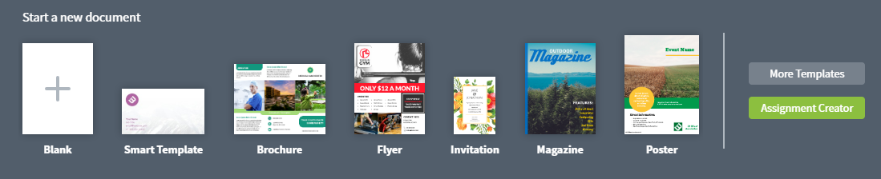

## Tool Snapshot

|  |  |
| --- | --- |
| Price | Free limited EDU version;  [**Pricing Plans for Upgraded Versions**](https://app.lucidpress.com/users/registerLevel#/pricing) |
| Learning | [Constructionism](http://edutechwiki.unige.ch/en/Constructionism) |
| Ease of Use | ★★★★✩ |
| [Privacy](https://www.lucidpress.com/pages/privacy) | ★★★★✩ |
| Accessibility | ★✩✩✩✩    No accessibility features beyond zoom features |
| Class Size | Unlimited with one account per user or limited to 3 documents on a single account |
| Login | Yes |
| [ISTE*S](http://www.iste.org/standards/standards/for-students-2016) | Knowledge Constructor, Creative Communicator |
| COPPA/    FERPA | No COPPA/FERPA policy found. Check with your school IT administrator. |

## Lucidpress Overview Video

## Lucidpress & the SAMR model

Dr. Ruben Puentedura’s [SAMR model](http://www.emergingedtech.com/2015/04/examples-of-transforming-lessons-through-samr/) offers a way to examine how technology has changed learning. As you strive to incorporate online tools into your classroom, we encourage you to use this model as an analytical tool to determine if the learning benefits of Lucidpress fit your needs.

Here is an example of how Lucidpress might fit within the SAMR model:

* **Substitution:** Students use Lucidpress in place of paper/pencil presentation methods.
* **Augmentation:** Students can enhance their projects with digital media materials.
* **Modification:** Projects can be shared with other students for improvement or feedback.
* **Redefinition:** Instead of physically creating a design or presentation, students learn digital design techniques and practice different methods of creating pleasing aesthetics.

Far too often, technology is used as a direct substitute for other low-tech tools (e.g., pencil and paper). While it has some benefits (e.g., students develop their technology skills), we encourage you to think about how you might use Lucidpress to modify or redefine learning in your class.

## Learning Activities

### **Media**

Distinguish the difference between print and digital forms of media with tools like Lucidpress versus a newspaper, as well as the **design principles** and applications of each.

### **Math**

With the ability to create all types of media on Lucidpress, students can create lessons and posts about mathematicians, math in the real world, and basic math skills tutorials, such as fractions.

### **Science**

Students can create science posters, brochures, and other informative science-based graphics.

### **English**

Students can create graphics to highlight grammar rules or step-by-step works cited lessons.

## Resources

* [How to make a brochure](https://www.lucidpress.com/pages/learn/how-to-make-a-brochure)
* [Learn how to make a newsletter](https://www.lucidpress.com/pages/learn/how-to-make-a-newsletter)
* [Educational teaching resources](https://www.lucidpress.com/pages/educational-teaching-resources)
* [Lucidpress Help Center](https://help.lucidpress.com/)

## How to use Lucidpress

1. Go to <https://www.lucidpress.com/>
2. Click “Sign up for free”
3. Click “Free – single user”
4. Create a nickname, username, and password
5. Click **“Log in”**
6. Select a new document or choose a template type
7. Click **“Create new”**
8. Customize your graphic by dragging and dropping it into the design area
   1. Text, images, color links, shapes, graphics, etc.
9. Click **“Share”** in the top right to share with collaborators or publish your graphic
10. Click “Download” to download the graphic for sharing on your computer

## Research

Henriksen, D., Creely, E., Henderson, M., & Mishra, P. (2021). [Creativity and technology in teaching and learning: a literature review of the uneasy space of implementation](https://link.springer.com/article/10.1007/s11423-020-09912-z). Educational Technology Research and Development, 69(4), 2091-2108.

Read this online at <https://edtechbooks.org/onlinetools/lucidpress>