Loom
Loom is a free screencasting tool that allows users to capture their computer's screen and record themselves with their camera.Loom can be used on both Mac and Windows computers. Once you are finished creating your screen recording video, you can edit it and share it on Twitter, Facebook, and Gmail, as a URL, or embed it on a website.
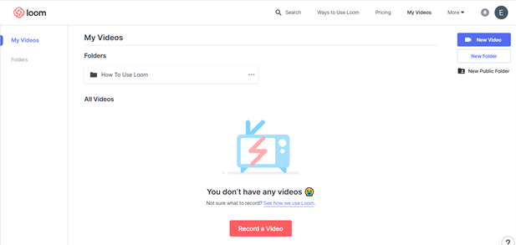

Tool Snapshot
Price | Pricing Plan
Learning | Social Learning  &  Constructionism
Privacy | Privacy Policy
Accessibility | No Accessibility Statement
Class Size | Unlimited
Login | Yes
ISTE*S | Empowered Learner, Creative Communicator, Global Collaborator
COPPA/  FERPA | COPPA: No (According to the Privacy Policy, Loom should not be used by children under 13). FERPA: No FERPA policy found. Check with your school IT administrator.

Price
The basic plan is free, but there are business and enterprise options for upgraded features.

Type of Learning
- Social Learning: Students can learn from each other’s screen recordings.
- Constructionism: Students can learn from designing their own screen recordings (e.g., evaluating a website, critiquing a YouTube video, annotating an online article, narrating presentation slides).

Ease of Use
Loom is user-friendly and intuitive and features a video series showing how to use the tool. There’s also a page showcasing possible uses for the tool.
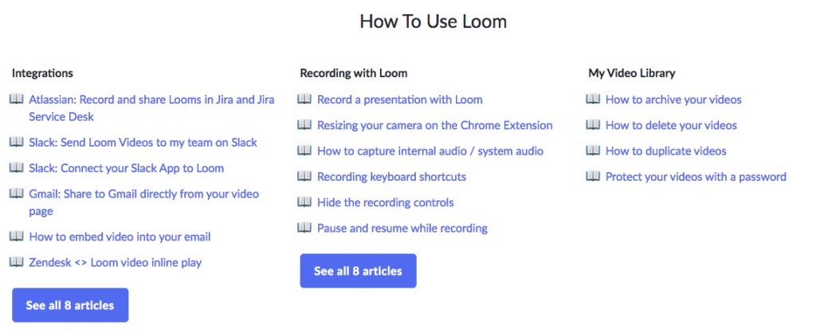

Accessibility
There is no accessibility statement released by Loom. Loom cannot be used without a mouse. It also cannot be used with voice control. However, creating videos that showcase visuals with added narration might make learning more accessible than traditional lectures (which can’t be paused or replayed) and text-heavy materials.

Privacy Policy
The Loom privacy policy outlines exactly what data is collected, how and why the data is used, and who has access to the data. Students under 13 years old are not able to use this tool due to COPPA. The policy also outlines GDPR compliance and the Chrome Extension Agreement.

ISTE Standards
- Empowered Learner: Students are able to demonstrate their learning with technology by creating screen recordings.
- Creative Communicator: Students can create screen recordings to express their ideas and communicate with others.
- Global Collaborator: Students can share their screen recordings with the online global community through social media and YouTube.

Loom Overview Tutorial

Transcript

Loom & the SAMR Model
Dr. Ruben Puentedura’s SAMR model offers a lens for examining how technology is adopted in a classroom. As you strive to incorporate online tools into your classroom, we encourage you to use this model as an analytic tool. Here is an example of how Loom might fit within the SAMR model:
- Substitution: Teachers can create a screen recording of their lecture for students to watch rather than presenting live in class.
- Augmentation: Students are able to extend learning beyond class time by accessing, watching, pausing, and replaying teacher-created videos at home.
- Modification: Students can record themselves reading, writing, or solving a math problem, while they brainstorm or think aloud. This allows teachers to better understand the thought processes of their students, as well as correct errors at specific steps.
- Redefinition: Students can create and share their Loom videos on Facebook, Twitter, Gmail, on the website, or through a URL so that they can get feedback from individuals around the world.
Far too often, technology is used as a direct substitute for other low-tech tools (e.g., pencil and paper). While substitution has some benefits (e.g., students develop their technical skills and knowledge), we encourage you to think about how you might use Loom to modify or redefine learning.

Learning Activities

Math
Teachers can create a screen recording to walk students through certain steps needed to take in order to solve a problem. Students can access this video outside of class to assist with their homework.
From a student perspective, students can record their problem-solving process to share with peers and teachers for feedback. Students can also record brief videos to teach their peers how to solve specific math problems.

Science
Students can record a video of an experiment with their phone or tablet, put the video on their computer, and then do their own narration over the video to explain the science behind what is happening.

English/Language Arts
Students can choose a scene from a book and recreate it with a modern twist by reenacting a scene to record via their camera (not their screen) or screen recording narration for a digital comic.

Social Studies
Students can record their screens as they showcase and discuss an interactive timeline, map, or virtual tour.

Other
Students who are English Language Learners can use Loom to capture live virtual presentations done in English and then watch, re-watch, pause, or slow down the video to aid their understanding of the material. For example, they could pause the video to look up the words that they don’t know.

Resources
- How to use Loom folder with tutorials about how to use the different functions of Loom
- How to Use Loom Video Recorder YouTube video
- How to Use Loom Screen Recorder YouTube video featuring the Loom Chrome Extension
- Loom Privacy Policy
- Loom GDPR Compliance
- Chrome Extension Policy
- Is there a Loom mobile app?
- 10 Ways Screencasting Can Transform Learning
- Loom 2.0 – Create and Edit Screencasts

How to Use Loom
- Go to: https://www.loom.com.
- Click on “Get Loom for Free.”
- You will need to download the desktop app or the Google Chrome extension for your web browser.
- When starting a recording, you will need to choose what to record: screen and camera, the screen only, or camera only.
- Choose the source of the microphone and the camera.
- When you are done setting up the screen capture recording features, select “start recording.”
- The screen recording will count down from 3 before it begins to record.
- There will be a stop button that appears on the left side of the screen to stop the screen recording.
- Once you stop the recording, it will be saved.
  - You have the option to invite people to see your video or add a password for the video. You will also be given a link that you can copy and share with others.
  - There is also the option to edit your video.
- There are many different editing tools/effects you can use to modify your video. For example, you can cut out certain parts of the recording or add emojis for emphasis.
- Once you are done editing your video, you can download, duplicate, delete, or share the video.
- The video will appear in your Loom account and you can go back to the video anytime you want to view, edit, or share it.

Research
Snyder, C., Paska, L. M., & Besozzi, D. (2014). Cast from the past: Using screencasting in the social studies classroom. The Social Studies, 105(6), 310-314.
Waltemeyer, S. & Cranmore, J. (2018). Screencasting technology to increase engagement in online higher education courses. eLearn Magazine. Retrieved from https://elearnmag.acm.org/archive.cfm?aid=3236693

Authors
This page was created by Elisabeth Ng, Isabelle Wang, and Tyler Volpe-Knock.
Read this online at https://edtechbooks.org/onlinetools/loom

