# Knight Lab Online Storytelling Tools

The Northwestern University [Knight Lab](https://knightlab.northwestern.edu/projects/) features a collection of projects that “help make information meaningful and promote quality journalism, storytelling and content on the internet” ([Knight Lab, 2020, para. 1](https://knightlab.northwestern.edu/projects/)). Currently (in 2020), the list of working projects includes six storytelling tools: [Juxtapose](https://juxtapose.knightlab.com/), [SceneVR](https://scene.knightlab.com/), [SoundCite](http://soundcite.knightlab.com/), [Storyline](http://storyline.knightlab.com/), [StoryMap](https://storymap.knightlab.com/), and [Timeline](http://timeline.knightlab.com/). There are also two projects in beta testing ([Learn](https://learn.knightlab.com/) and [Sensor Grid](https://sensorgrid.knightlab.com/)) and a number of prototypes, experimental, and past projects. The current storytelling tools can be used to incite curiosity and engage students in critical thinking and exploration of information.

**Storytelling Tools**

* [Juxtapose](https://juxtapose.knightlab.com/) helps storytellers compare two pieces of similar media (e.g., a historical and present-day photo) and is helpful for exploring changes over time, like the development of a building or a city skyline or the destruction of rainforest.
* [SoundCite](http://soundcite.knightlab.com/) lets you add inline soundbites into your story to create multimodal text.
* [Timeline](http://timeline.knightlab.com/) can be used to create interactive timelines with a Google spreadsheet.
* [StoryMap](https://storymap.knightlab.com/) allows you to create interactive, multimodal stories with maps.
* [Storyline](http://storyline.knightlab.com/) allows anyone to build an interactive line chart. This includes charts, axis labels, and cards.
* [SceneVR](https://scene.knightlab.com/) turns panoramic and VR-ready photos into a visual story line.

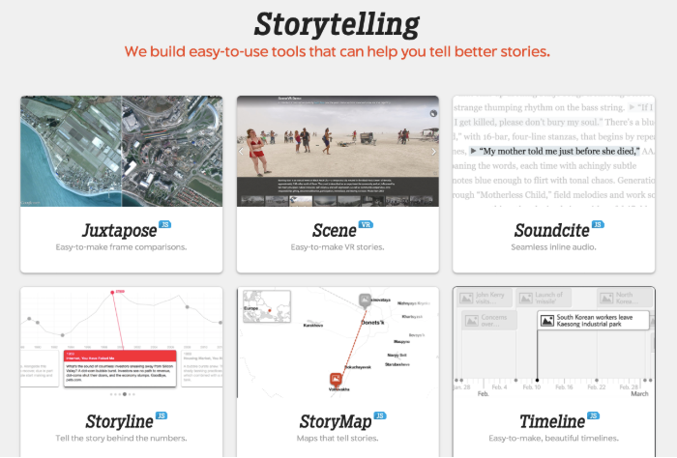

## Tool Snapshot

|  |  |
| --- | --- |
| Price | Free |
| Learning | [Cognitive Constructivism](https://gsi.berkeley.edu/gsi-guide-contents/learning-theory-research/cognitive-constructivism/)   &  [Constructionism](https://en.wikipedia.org/wiki/Constructionism_(learning_theory)) |
| Ease of Use | ★★★★☆ |
| [Privacy](https://timeline.knightlab.com/docs/faq.html#data) | ★★★☆☆ |
| Accessibility | ★★☆☆☆ |
| Class Size | Unlimited |
| Login | For some tools |
| [ISTE*S](http://www.iste.org/standards/standards/for-students-2016) | Knowledge Constructor & Creative Communicator |
| COPPA/    FERPA | No COPPA/FERPA policy found. Check with your school IT administrator. |

## Knight Labs Overview Video

[Transcript](https://imgur.com/rLUh9I1)

## Knight Lab Storytelling Tools & the SAMR Model

Dr. Ruben Puentedura’s [SAMR model](http://www.emergingedtech.com/2015/04/examples-of-transforming-lessons-through-samr/) offers a lens for examining how technology is adopted in a classroom. As you strive to incorporate online tools into your classroom, we encourage you to use this model as an analytic tool.  Here is an example of how the Knight Lab Storytelling Tools might fit within the SAMR model:

* **Substitution**: Students use StoryMap to pin locations on a map (instead of highlighting these locations on a paper map).
* **Augmentation**: Students create a multimodal map by adding descriptions, images, and videos to pinned locations.
* **Modification**: Students use their StoryMap to tell an interactive, multimodal story of a historical event or present-day situation.
* **Redefinition**: Students use StoryMap to tell an interactive, multimodal story of a famous painting by zooming in to focus on specific parts of the piece (see [Bosch Garden](https://storymap.knightlab.com/examples/bosch-garden/) example).

## Learning Activities

### Geography

Using the [Knight Lab StoryMap](http://storymap.knightlab.com) tool, students can create a multimodal, interactive map of a country, state, or other location.

### Science

Using the [Knight Lab Juxtapose](https://juxtapose.knightlab.com) tool, students can compare photos of forests and glaciers from 100 years ago versus today.

### English/Language Arts

Using the [Knight Lab Soundcite](http://soundcite.knightlab.com) tool, students can enrich the reading experience of a text by inputting sound effects, music, interview audio files, and spoken word.

### History

Using the [Knight Lab Timeline](http://timeline.knightlab.com) tool, students can create an interactive historical timeline by embedding photos, text, maps, audio, and videos.

### Math

Using the [Knight Lab Storyline tool](http://storyline.knightlab.com), students can create a graph showing the average cost of housing in a city throughout the years of 2009 to 2019 and annotate what may have contributed to an increase, or decrease, in the average cost each year.

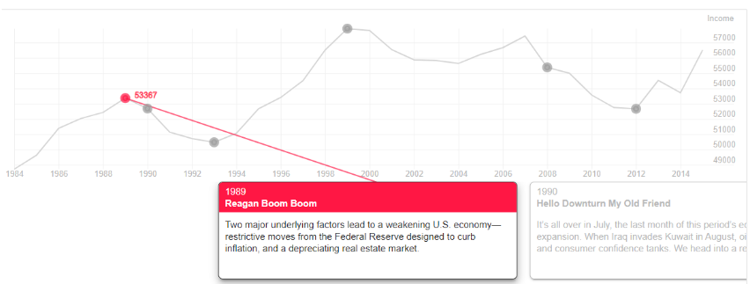

## Resources

* [How to create a timeline using Knightlab JS](https://www.journalism.co.uk/tip-of-the-day/tip-here-s-how-to-create-a-timeline-using-knightlab-s-timelinejs/s419/a712343/)
* [Storymap by Knightlab](https://libguides.hope.edu/storymap) Hope College Research Guide
* [Six Good Digital Storytelling Tools In One Place](http://blog.stcloudstate.edu/ims/2018/04/23/digital-storytelling-tools/)

## How to Use Knightlabs

1. Go to the [Knightlab Projects Page](https://knightlab.northwestern.edu/projects/).
2. Click on any of the 6 tools.
3. Each tool provides its own unique step-by-step instructions to use the respective tool. They may require you to sign in using a Google account.

## Research

What is Digital Storytelling? (n.d.). Retrieved March 30, 2020, from [https://digitalstorytelling.coe.uh.edu/page.cfm?id=27&cid=27](https://digitalstorytelling.coe.uh.edu/page.cfm?id=27&amp;cid=27) Robin, B. R. (2008).

[Digital storytelling: A powerful technology tool for the 21st century classroom](https://www.tandfonline.com/doi/full/10.1080/00405840802153916?casa_token=G6uUNUN0mTIAAAAA%3AaS-M34OIiiRPWzJqxyLR261qz7PrWy391Ix6bsKWMiHFuIfuMwq-s2LC2eBknFXcpoC7pVh2reEp). Theory into Practice, 47(3), 220-228. Robin, B. (2006, March).

[The educational uses of digital storytelling](https://www.learntechlib.org/p/22129/). In Society for Information Technology & Teacher Education International Conference (pp. 709-716). Association for the Advancement of Computing in Education (AACE).

## Authors

Page created by Mason Peng, Aviahna Austin, and Joey Ice.

Read this online at <https://edtechbooks.org/onlinetools/knight-lab-online-storytelling-tools>