# Wolfram Alpha

[Wolfram|Alpha](https://www.wolframalpha.com/) is an online tool that strives to make all knowledge computable and accessible (). This tool can provide the answer to numerous questions, such as “how many calories are in a potato?” and “how many planes are flying overhead?” and “how much money do you need to retire? (see [20 Ways Everyday Life is Easier with Wolfram Alpha](https://www.makeuseof.com/tag/20-ways-everyday-life-easier-wolfram-alpha/)). Wolfram|Alpha can also compute and present extensive data on everything from shoe sizes, to lottery odds, to dinosaur comparisons (explore [10 More Fun Questions Kids Can Answer with Wolfram|Alpha](http://blog.wolframalpha.com/2012/11/20/10-more-fun-questions-kids-can-answer-with-wolframalpha/) and [23 Cool Non-Math Things You Can Do With Wolfram Alpha](https://www.pcmag.com/news/23-cool-non-math-things-you-can-do-with-wolfram-alpha)). It allows anyone with access to the Internet to have the answers to their questions at their fingertips at a moment’s notice.

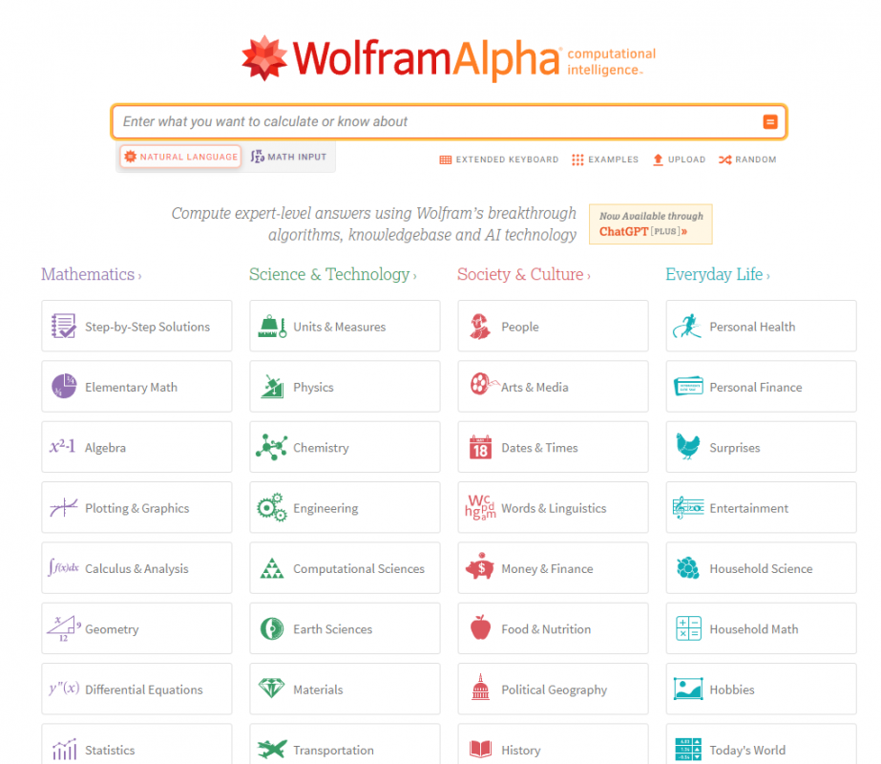

## Tool Snapshot

|  |  |
| --- | --- |
| Price | Free with paid options available. Pro for  [Students](https://www.wolframalpha.com/pro/pricing/students/)  (  [features](https://www.wolframalpha.com/pro-for-students/)  ) ($5/mo.). Pro Premium for Students ($8.25/mo.). Pro for  [Educators](https://www.wolframalpha.com/pro/pricing/educators/)  (  [features](https://www.wolframalpha.com/pro-for-educators/)  ) ($5/mo.). Pro Premium for Educators ($8.25/mo.) |
| Learning | [Cognitivism](https://www.learning-theories.com/cognitivism.html) |
| Ease of Use | ★★★★★ |
| [Privacy](https://www.wolfram.com/legal/privacy/wolfram/) | ★★✩✩✩ |
| [Accessibility](https://www.wolfram.com/legal/accessibility/wolfram-mathematica/) | ★★★★✩ |
| Class Size | Unlimited |
| Login Required | Free version: No    Paid version: Yes |
| [ISTE*S](http://www.iste.org/standards/standards/for-students-2016) | Knowledge Constructor, Computational Thinker |
| COPPA/    FERPA | No COPPA/FERPA policy found. Check with your school IT administrator. |

### **Ease of Use**

We gave Wolfram|Alpha 5 stars for ease of use because the website has a clean, simple user interface. The main page features a search box and a list of subjects to explore. As you start to type in what you want to calculate, it will offer suggestions for you. The website provides a helpful [tour page](https://www.wolframalpha.com/tour/) that explains how to use the tool at home, at work, or for fun!

### **Privacy**

Wolfram|Alpha collects information such as “real name, alias, postal address, unique personal identifier, online identifier, Internet Protocol address, email address, account name, Social Security number, driver’s license number, passport number or other similar identifiers” ([Wolfram|Alpha, 2020. Para 3](https://www.wolfram.com/legal/privacy/wolfram/)) They use this information for themselves and they say in their privacy policy that they do not sell the information to third parties.

## Wolfram|Alpha Overview Video

## Wolfram|Alpha & the SAMR Model

Dr. Ruben Puentedura’s [SAMR model](http://www.emergingedtech.com/2015/04/examples-of-transforming-lessons-through-samr/) offers a lens for examining how technology is adopted in a classroom. As you strive to incorporate online tools into your classroom, we encourage you to use this model as an analytic tool.

Here is an example of how **Wolfram|Alpha** might fit within the SAMR model:

* **Substitution:** Students use Wolfram|Alpha to find the answer to questions instead of using their textbook.
* **Augmentation:** Wolfram|Alpha provides real time data that allows students to see what is happening in the world at that moment, such as what planes are flying overhead right now!
* **Modification:** Students may discover information serendipitously (i.e., that they didn’t set out to learn specifically) by exploring the many topics below the search bar or reviewing all the information, charts, and data provided in the search results.
* **Redefinition:** With the pro/paid options students can customize and manipulate their learning experience.

Far too often, technology is used as a direct substitute for other low-tech tools (e.g., pencil and paper). While substitution has some benefits (e.g., students develop their technology skills and knowledge), we encourage you to think about how you might use **Wolfram|Alpha** to modify or redefine learning.

## Learning Activities

### [Math](https://www.wolframalpha.com/examples/mathematics/)

The free version of Wolfram|Alpha allows students to see the answer to complex mathematical equations. In the paid versions of Wolfram|Alpha students are able to see step-by-step solutions for questions. Students could compare and contrast their step-by-step problem solving process with the one provided by Wolfram|Alpha to extend their mathematical knowledge.

#### How to Do Unit Conversions with Wolfram|Alpha Video (by WolframAlpha)

### [Science](https://www.wolframalpha.com/examples/science-and-technology/)

Wolfram|Alpha is known for its ability to solve very complex equations in mathematics and physics. However it is capable of much more. For example, students can compare different elements in the periodic table, explore computations for engineering problems, and discover information about living organisms.

#### How to Balance a Chemical Equation with Wolfram|Alpha Video (by WolframAlpha)

### [History](https://www.wolframalpha.com/examples/society-and-culture/history/)

“With comprehensive data about people, places and events throughout history,” Wolfram|Alpha streamlines the research process for students ([Wolfram|Alpha, 2020, para. 1](https://www.wolframalpha.com/examples/society-and-culture/history/)). With the free version of Wolfram|Alpha, students can compare and contrast two different time periods or explore historical timelines or learn more about famous inventions.

### [Language](https://www.wolframalpha.com/examples/society-and-culture/words-and-linguistics/)

Wolfram|Alpha allows students to not only find the definition of words, but also learn complex grammar of the English language. It can also be used as an interactive dictionary! And, it can translate words to any other language!

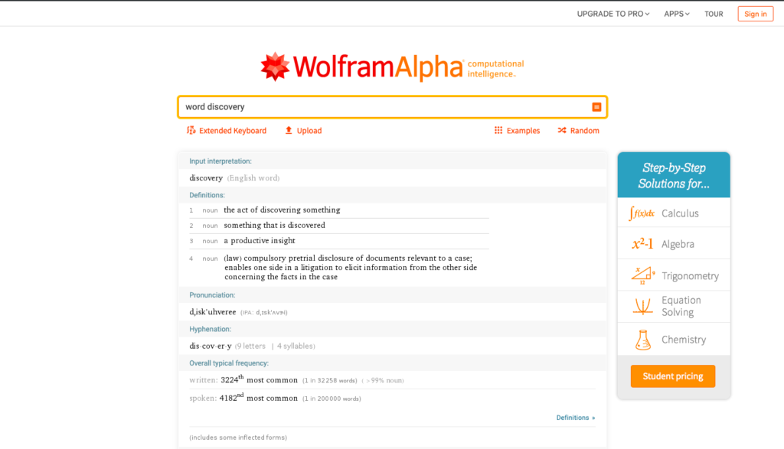

## How to Use Wolfram|Alpha

Go to [www.wolframalpha.com](http://www.wolframalpha.com). If you want to use the free version, begin typing your question into the search area or tap on one of the topics below the search bar to learn more.

### Part 1: Original Intro to Wolfram|Alpha (by Stephen Wolfram)

## Research

Dimiceli, V. E., Lang, A. S., & Locke, L. (2010). [Teaching calculus with Wolfram| Alpha](https://www.researchgate.net/publication/251423135_Teaching_calculus_with_WolframAlpha). International Journal of Mathematical Education in Science and Technology, 41(8), 1061-1071.

The Educational Purposes of Wolfram|Alpha: <https://www.wolfram.com/wolfram-u/catalog/edu011/>

Read this online at <https://edtechbooks.org/onlinetools/wolfram-alpha>