Blooket
Blooket is a trivia and review tool that allows educators to “level up classroom engagement” (Blooket, 2021, para. 1). Blooket is a gamified learning platform where teachers host games through question sets and students answer on their own devices. This is an assessment-centered tool, specifically formative assessment. When students get correct answers, they receive points, which allow them to buy and sell ‘Blooks’. On Blooket there are hundreds of premade question sets for you to use or you have the option to make your own set unique to your class. This new take on reviewing or practicing material can increase student engagement and excitement.

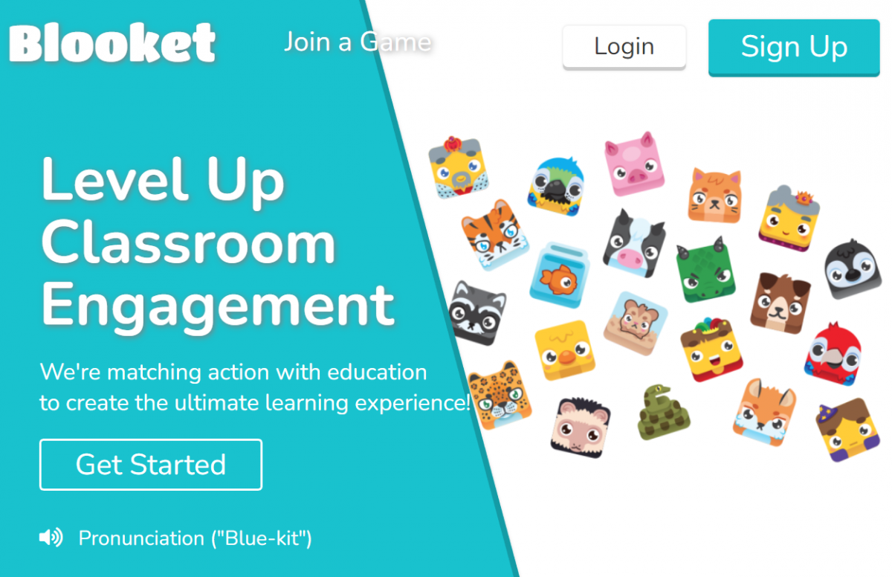

Tool Snapshot
Price | Pricing Plan
Learning | Behaviorism
Privacy | Privacy Policy
Accessibility | No Accessibility Statement Provided on Website
Login | Yes
ISTE*S | Empowered Learner
COPPA/FERPA | Yes as long as “parental consent” or “school consent” is provided

Types of Learning
Behaviorism is about learning through interactions within an environment. The most prominent example is positive reinforcement. When students get a correct answer on Blooket, they receive points. This shapes their behavior by encouraging them to learn more in order to get more points.

Ease of Use
We gave this tool a rating of 5 stars for ease of use. There is minimal instruction needed and the website navigation is straight forward. After signing up with your email, you can get started right away by creating a game or question sets. Unfortunately, there is not a FAQ page on the website however, there is a getting started tutorial for teachers.

Privacy
We gave this tool a rating of 3 stars for privacy. The user (who must be older than 13) does have to share personally identifiable information such as first and last name and email address when registering to use the tool. Other information, such as Internet use, device type, and location when using the tool, are also collected. The privacy policy clearly states what information is collected and what they do with the information. It seems as though you can not necessarily choose what information is collected, but schools and parents can request that student data is removed. Blooket’s privacy policy states that “Blooket collects the minimal amount of information from students necessary to utilize our Service: we ask student who are invited to play the games or participate in homework to only create a username. Students who join as users with parental consent or who are above specified ages only provide names, email addresses and usernames” (para. 24).

Accessibility
We gave this tool a rating of 2 stars for accessibility. There does not seem to be an accessibility statement provided by Blooket. You are not able to use Blooket solely through a keyboard – a computer mouse or computer pad must be used. Accessibility could be improved by supporting screen readers, alternative methods of navigation, and text-to-speech and speech-to-text features when asking or answering the questions.

ISTE Standards for Students
- Empowered Learner
  - Students can use this tool to seek immediate feedback via correct or incorrect answers.
  - Students use the tool to demonstrate their learning, what they know and do not know (pre or post-assessment) through the different types of game modes and question sets.
  - Students can customize their “Blook” and learning environment to support their learning.
  - Students and teacher can track their progress over the course of the year.
- Global Collaborator
  - Students can utilize this tool to collaborate with fellow classmates and peers by working in pairs or on teams.
  - Students only need a join code to join the game so students from around the world are able to connect and play in real time.

Blooket Overview Video

Blooket & the SAMR Model
Dr. Ruben Puentedura’s SAMR model offers a lens for examining how technology is adopted in a classroom. As you strive to incorporate online tools into your classroom, we encourage you to use this model as an analytic tool.
Here is an example of how Blooket might fit within the SAMR model:
- Substitution: Students use Blooket to answer quiz questions virtually (instead of using a pencil and paper).
- Augmentation: Students can complete Blooket games from home, the library, or anywhere in the world and receive immediate feedback.
- Modification: Students can engage in a variety of different games to advance their understanding of the content.
- Redefinition: Students can compete in games with other classes around the world.
With technology developing quicker than ever, it is crucial we implement it into education. We hope you can consider Blooket as one example of how technology can enhance students’ knowledge and understanding of material.

Learning Activities
- Math
  - Speedy Math races among AI ghosts or other students encourages more studying of basic arithmetic.
  - Students can test their knowledge of fractions through looking at the image of a pie chart, then selecting the correct proportion value for the correlated image.
- Science
  - Students can engage in a game where they must list the correct parts of the cell on a visual example, list the elements of the periodic table, or even identify compounds based on pop culture or two-word descriptions.
  - Leveling Up: Students could design their own “Blooks” on pencil and paper to represent each element in the periodic table or collaboratively generate a bank of quiz questions and host the game for a younger class or family members.
- English/Language Arts
  - Students can be challenged to list different pieces of a sentence structure (subject/predicate/etc…).
- Social Studies
  - Students can practice memorizing states, capitals, and countries.

Using Blooket for Formative Assessment
All of the games discussed above allow for direct feedback for both the student and the teacher. For the student, they can see which question(s) they got wrong in real time. This will allow the student to identify what material to look at in more detail. For the teacher, you are able to see whether your students are fully comprehending and understanding the information you are teaching during a session. By analyzing student responses after each session, you can see what topic areas students did not fully understand and discuss them further before moving on to the next topic.

Resources
- Assessment-Based Feedback Tool: Blooket
- Blooket: A New Take on Trivia and Review Games
- “Blooket Review for Teachers – Common Sense Education”
- Getting Started with Blooket – Teacher Edition
- Using Blooket to Increase Student Engagement

How to Use Blooket
- Go to www.blooket.com.
- Click “Sign Up” and register for an account using your email.
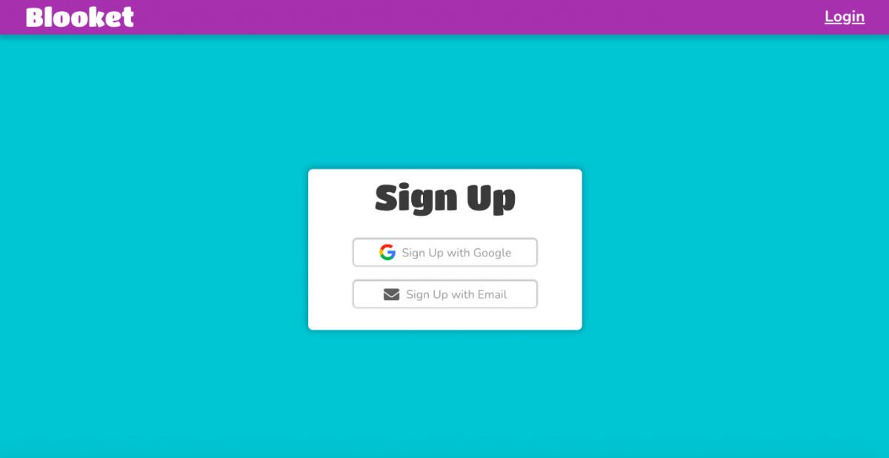
- You can choose to register as a teacher or a student (Note: Students under 13 should only register with parental or school consent).
  - Once you sign up, you have the option to switch your account to student or teacher if needed.
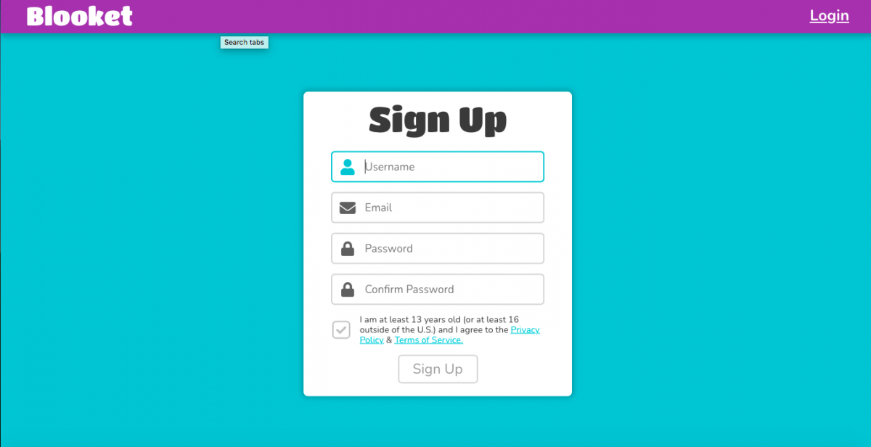
- Return to Blooket and login.
- Click on the dashboard icon at the top of the page (shaped like a house).
  - On the left of the dashboard you can see recent news, question sets, favorited question sets, quests, and recently hosted games.
- Create a new study set or discover sets made by others.
  - Use the search bar to discover new sets.
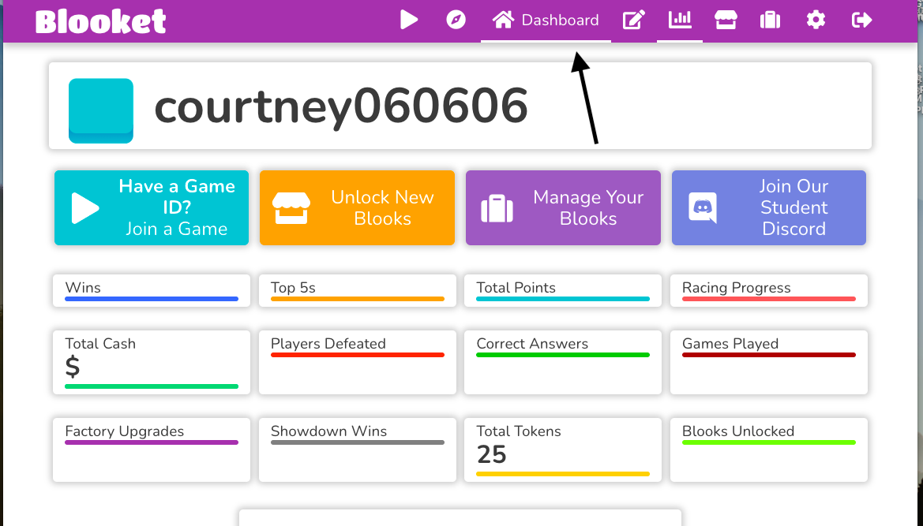
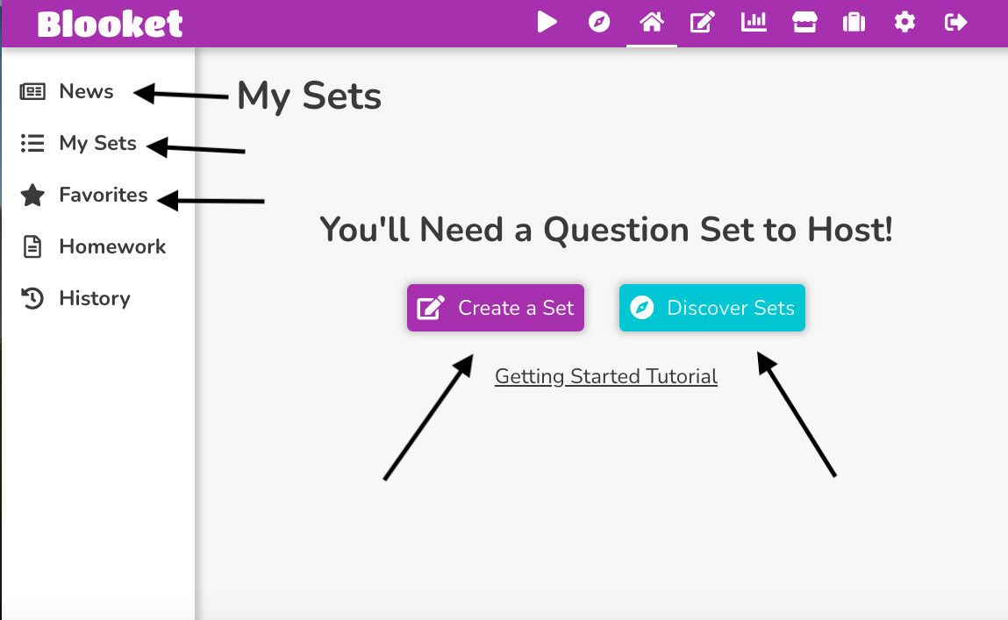
- (If teacher) Select a set that you are looking for.
  - Click the host button.
  - Assign homework.
  - Host live games.
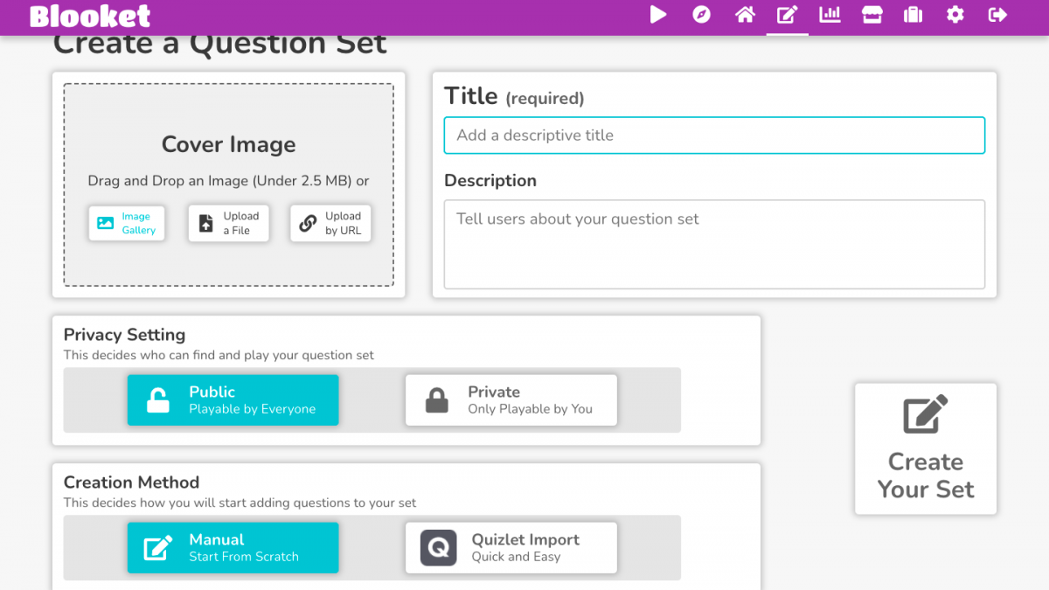
- (If student) Select the play button on your Blooket dashboard in order to join a live game.
  - Enter the game ID given by the host in order to join the game.
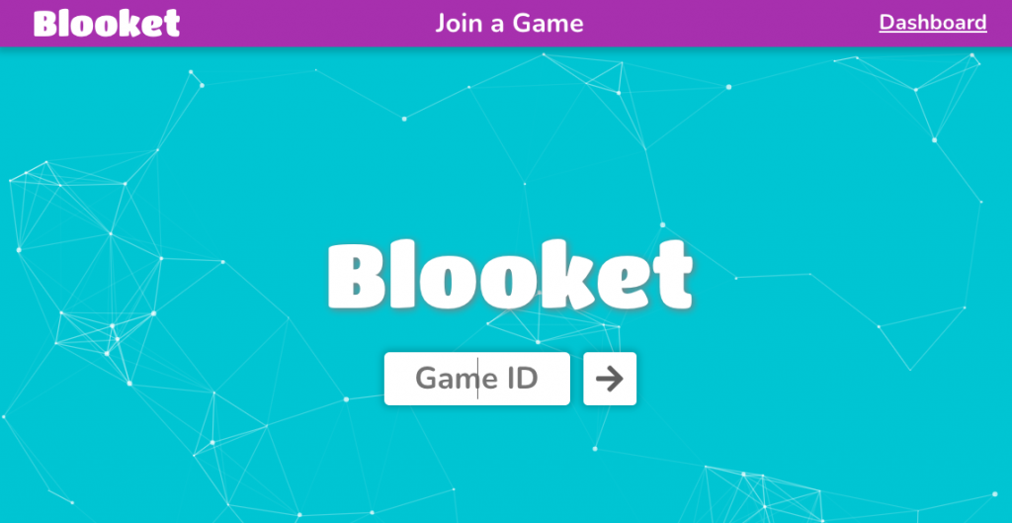

BLOOKET TUTORIAL for Teachers | Blooket Review Game Beginner Tutorial | EdTech Classroom

Related Research
- “Learning with quizzes, simulations, and adventures: Students’ attitudes, perceptions and intentions to learn with different types of serious games”
- “Technology: Learning Can Be Fun and Games”
- “Gamification in the Classroom: Examining the impact of gamified quizzes on student learning”

Authors
This page was created by Bridget Lombardi, Courtney Masse, and Connor Power.
Read this online at https://edtechbooks.org/onlinetools/blooket

