# Macro Level: The Situation at the National or Federal Level

[1]

The macro level refers to the national and province/state level. Depending on the political structure of each country, it could be that national or province/state levels are more or less relevant in order to understand better the different elements in this level per each aspect: infrastructure (I, central-decentral), quality (Q, national standards), policy (P, national policies) and change (C, national planning, funding).

The research questions posed at the macro level are the following:

* I: How can a national or statewide (technical) infrastructure for the dissemination of (O)ER be described (repositories, hubs…)? What is the technological and technical set-up behind it (meta data standards, host servers etc.) and how is it maintained? What is the relation between public and commercial entities involved (if there are)?
* Q: Do national standards exist with regard to (O)ER and their creation, dissemination and quality assurance? Who are the actors involved in setting and assuring them? How do they relate and adhere to international elearning standards and specifications?
* P: What national or state-wide policies are currently being discussed or are in place with regard to digital infrastructures and their implementation? Which actors are involved?
* C: How is change (in terms of funding, managing and promoting the infrastructure) promoted on the national level? Who drives change on this level (universities, governments, commercial entities…)?

## 1.1 Infrastructure

(O)ER infrastructures according to degree of centralization of HE systems

In order to understand the HEI (O)ER infrastructure (or their lack thereof), the level of political structure centralization can be examined, as this also influences the structure of the HEIs (see Figure 1)[2].

Figure 1

Spectrum Centralized HE system-Decentralized HE system.

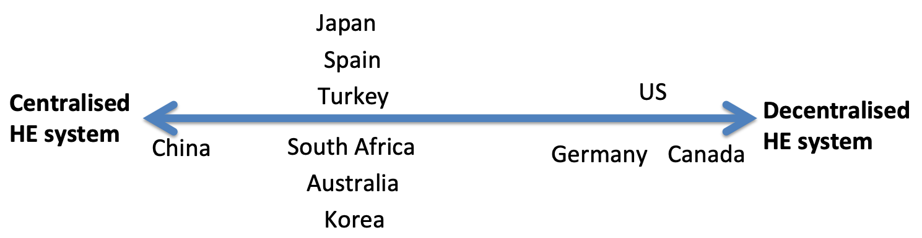

At the national or state level, countries with a highly decentralized HE system do not have (O)ER infrastructures or have underdeveloped infrastructures at the macro level, as is the case in Germany and Canada, as education is a mandate of the provinces and not of the national government of the country.

For example, the province of British Columbia (Canada), has developed the [BCCampus](https://bccampus.ca/), which supports numerous educational technology and open learning initiatives and innovations, and [BCNET](https://www.bc.net/), which facilitates the use of shared services across the post-secondary education sector (e.g., access to Kaltura, Moodle, etc.). The Canadian province of Ontario has as meta-infrastructure ORION as provincial research and education network, and counts with the e-Campus Ontario with 90% of its institutions offering e-Learning.

In the case of the US, initiatives are also highly decentralized and collaboration between provinces about infrastructure happens, but without a national coordination. Examples include the Utah Open [Courseware](https://digitalcommons.usu.edu/ocw/), the Galileo Open Learning [Materials](https://oer.galileo.usg.edu/) or the North Carolina Open Learning Object [Repository](https://explorethelor.org/). [Open Syllabus](https://opensyllabus.org/) is an interesting initiative hosted by American Assembly (a non-profit public policy institute at Columbia University in New York) and funded by the Hewlett Foundation and other groups that is harvesting data regarding the syllabus of university courses. Platforms arising from individual or company initiatives are used nation-wide (and worldwide). This strategy does not correspond to initiatives from provinces, but rather from individuals or companies, and allows copyright for hosted (O)ER to be maintained as a private good in the US. Examples are[iTunes U](https://www.apple.com/de/education/itunes-u/), [Coursera](https://www.coursera.org/) and [edX](https://www.edx.org/) for MOOCs.

In Germany, where many provinces have developed or are developing their own repositories, the creation of parallel structures and the potentially lack of interoperability have become evident. A possible solution is the one proposed by EduArc of creating a hub for all of them (see Figure 2), which is also mentioned in the OER Feasibility Study (Blees et al., 2016). In this study it is highlighted that a national repository is unlikely to happen, but rather a disseminated system exchanging OER information. The White Paper on OER (Deimann et al., 2015) follows along the same lines with some hypotheses that may have high impact possibilities: a (government supported) OER infrastructure is highly unlikely to happen as well as a joint platform for materials, but province or national level OER platforms is highly likely to happen (in fact, it is already under development). Other hypotheses are that Learning Management Systems (LMS) will have interfaces with the OER repository (medium-term likelihood) and that there will be an agreement and timely implementation of OER metadata standards (low likelihood).

Figure 2

Proposed hub of repositories in EduArc (Kerres, Hölterhof, Scharnberg & Schröder, 2019).

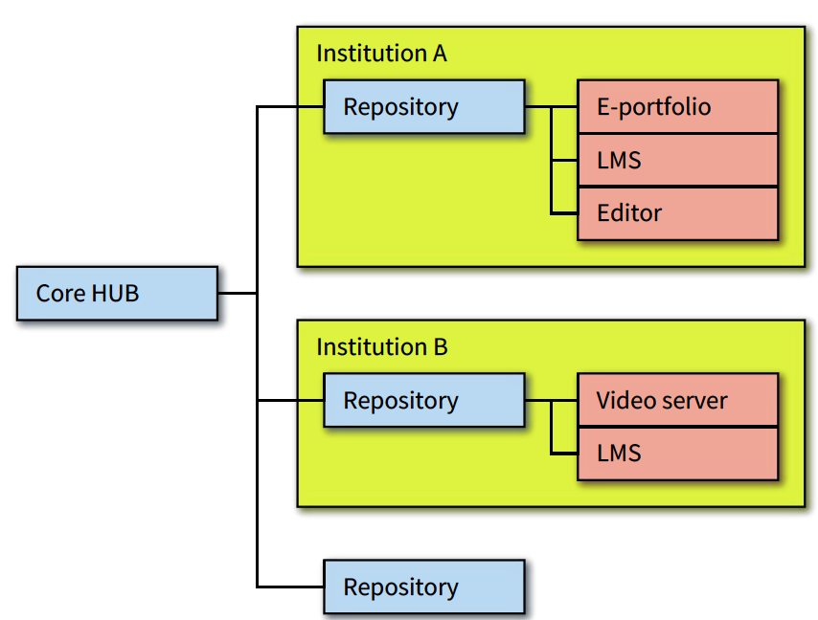

Other countries, such as South Africa, state that there is no plan for such national infrastructure, even though they manifest interest on having one due to its potential value in raising the awareness of OER is noted. This potential value of OER, but at the same time lack of awareness, also is observable in Turkey (Kursun, 2011).

Many countries with a rather centralized HE system have national infrastructures, but most of them are not specifically targeted at HE or (O)ER. In the case of Turkey, an unified government system has been developed, which includes the Higher Education Quality Council, the Higher Education Atlas, the Degree Recognition Digital Platform, the Higher Education Information Management System, the National Thesis Center and the Journal Park Project, but it is not directly connected to (O)ER. In 2019-20, Australia is further developing the Unique Student Identifier Service for all HE students, including a tertiary learning repository, but it is not available yet.

There are some exceptions in the countries with a more HE centralized system, where meta-infrastructures can also be found (provision of connectivity services, eduroam, private networks, databases, etc.). For instance, in Spain, RedIRIS provides advanced communication services to the national scientific community and universities (meta-infrastructure). In addition, the Foundation for Science and Technology (FECYT), which is a public agency managed by the Ministry of Economic Affairs and Competition, has developed a national infrastructure to harvest institutional repositories, thematic repositories, journal portals and open access journals ([RECOLECTA](https://buscador.recolecta.fecyt.es/)), which will be described later.

Similarly, South Korea and Japan have their own national providers for meta-infrastructure: the Korea Education Network (KREN), which uses since 2011 a commercial service but receives funds from the government and the universities, and the National Institute of Informatics, respectively. Both countries have also their own national MOOCs and OCWs. In addition, South Korea universities across ten regions have Centers for Teaching and Learning to develop and disseminate educational resources and support the faculty and students since 2000.

The China Education and Research Network (CERNET) is the meta-infrastructure of Chinese HEIs. Chinas has the National e-Learning Resources [Center](http://www.nerc.edu.cn/FrontEnd/default.html) operated by the Open University of China, and the Chinese University MOOC ([CUM](https://www.icourse163.org/)) that curates and provides MOOCs developed by Chinese universities, and it is operated by the NetEase-Internet technology company and Higher Education Press.

AARNet is a not-for-profit National Research and Education Network that provides the meta-infrastructure of universities and schools in Australia.

As in the report of Germany is noted, whilst the quantity of OER and the discourse surrounding them has proliferated over the past decade, metadata and interoperability still constitute challenges. This is not only a situation of countries where no national (O)ER infrastructures exist or where (O)ER infrastructures do exist but are underdeveloped; it also applies to the countries where there is some kind of national infrastructure. For instance, in a study on the status of digital repositories in Spain and the quality of its metadata, the need for improving this situation is asserted (Medrano, Figuerola & Berrocal, 2012). In this case, national quality standards in adherence to international standards (addressed in the section Quality) and the development of a hub (RECOLECTA) have been developed as a possible solution.

RECOLECTA (Figure 3) is aimed at creating a nationwide infrastructure of Spanish Open Access scientific repositories, which also include educational resources. The RECOLECTA-DRIVER Criteria includes two levels of interoperability: one is the syntactic use of OAI-PMH (Open Archives Initiative-Protocol Metadata Harvesting), which ensures the resource to be harvested correctly, and the second one, the semantic use of OAI_DC vocabularies.

Figure 4

Joining for harvesting process in [RECOLECTA](https://www.recolecta.fecyt.es/steps-to-follow?language=en).

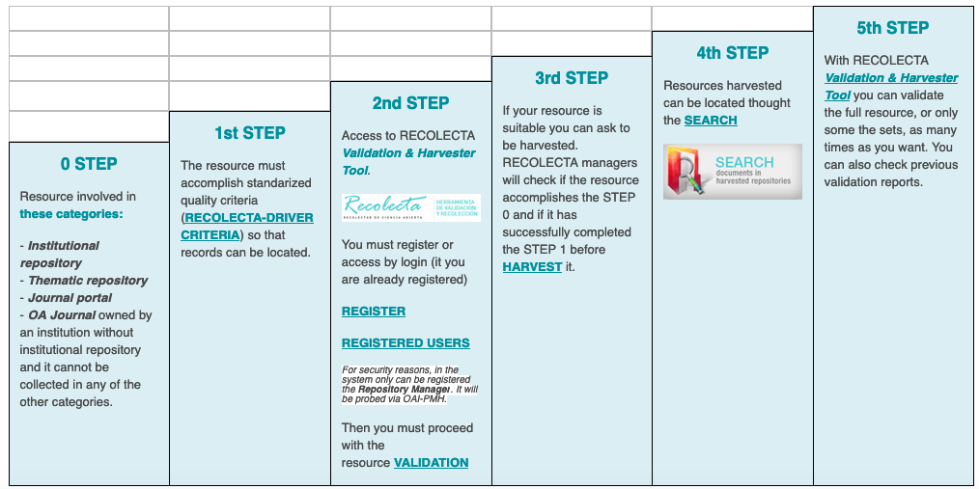

Public and private infrastructures for production of (O)ER

In terms of (O)ER production, which involves (O)ER initiatives and repositories available (see Figure 5), most countries have embraced OCW and MOOCs, which are considered two of the most popular OER initiatives in HE. The US, South Korea and China are high producers of OER, whereas countries such as Japan and Germany are producing less OER at the national level. Furthermore, Canada and the US are considered the OER pioneers, and many of their initiatives have been popularised and replicated in other countries. Examples are the Canadian Connectivism and Connective Knowledge MOOC (2008) and the popular US [MIT Open Courseware](https://ocw.mit.edu/index.htm) (2001) or the Stanford Coursera MOOCs (2011). MIT's EdX and Stanford University's private spinoff company Coursera are by far the largest providers of MOOCs in the US. Some other initiatives have been already mentioned before.

Figure 5

Spectrum Low production of (O)ERs - High production of (O)ERs.

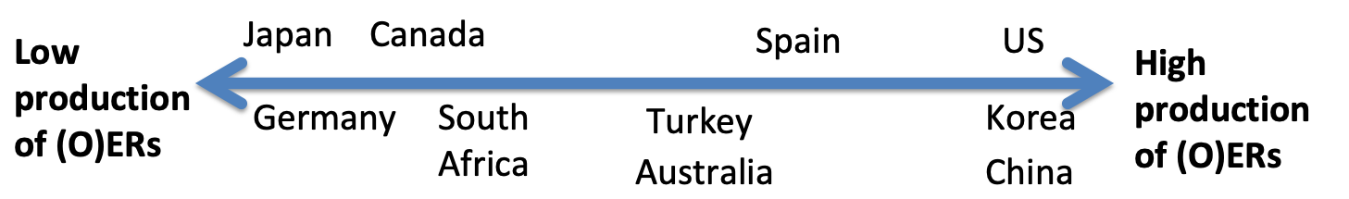

In South Korea and Japan, MOOCs and OCW have been/are being developed; however, OER production in South Korea is much higher than in Japan. The Japan OCW and JMOOC are two membership-based consortia (79 members with 140 courses, 4 private companies as providers) without governmental support. This could explain the differences in OER development and sharing compared to South Korea, where the main actors in OER infrastructure are two organizations funded by the Ministry of Education: the Korea Education and Research Information Service (KERIS), which is in charge of developing, managing and evaluating research products and OER for HEI; and the National Institute for Lifelong Education (NILE), which is hosting and developing K-MOOCs. KERIS has developed and managed 13,000 KOCW and 2,300 videos since [2007](https://www.keris.or.kr/eng/main.do), and [NILE](http://eng.nile.or.kr/eng/) manages K-MOOCs since 2015 (with over 80 universities and 500 courses in 2018).

China is very much focused on the development of MOOCs (often called "top or high quality open courses" or "State-benchmarking Open Courses") through its own national repository of educational resources for all educational [levels](http://www.jingpinke.com) and other centralized platforms, for example, the national repository mostly focused on MOOCs ([iCourse](http://www.icourses.cn/home/)) or the CUM. China Open Resources for Education (CORE) was the initiative that replicated the MIT Open Courseware in China in 2003. All the repositories are operated (to a lesser or greater degree) by organisations that are affiliated with the Ministry of Education.

In Spain, OCW-Universia[3] unified different Spanish university OCW under the same infrastructure and, 44 Spanish universities published 1,331 OCW courses on their institutional sites between 2007 and 2011, many of them now not available any more or gone for MOOCs (Aranzadi, 2011; Frías-Navarro, Monterde-i-Bort, Pascual-Soler, Badenes-Ribera & Pascual-Mengual, 2014; Martín, González, & Ruiz, 2015; Oliver, Hernández-Leo, Daza, Martín, & Albó, 2014). Many Spanish universities use [MiríadaX](https://miriadax.net/), a platform for Iberoamerican MOOCs, supported by the private telecommunications company Telefónica Learning Services (Oliver et al., 2014; Oliver Riera, Hernández Leo, & Albó Pérez, 2015), for developing and hosting them. A private and for profit platform to offer courses is [Tutellus](https://www.tutellus.com).

Along the same lines, in the context of the Turkish Academy of Sciences (TUBA) OCW Project a total of 80 courses were developed between 2010 and 2011 in [Turkey](http://www.tuba.gov.tr/en/activity-projects/academy-projects/open-course-materials-project). Despite the large-scale implementations, it is noted that OER movement is still in awareness stage in Turkey.

Even though innovative digital practices permeate the HE sector in Canada (e.g., MOOCs and Desire2Learn are Canadian innovations), there is a general belief that the sector must engage in radical transformation to remain relevant and successfully respond to the needs and pressures of a digital society (Bates, 2019b). Furthermore, the lack of national oversight could be a major reason why this country seems to be rather an exception in the full adoption of these OER initiatives, and especially of OCWs. Across the Pacific Ocean, Australia has made some move toward national repositories. Although not a national (O)ER repository as such, the [Learning & Teaching repository](https://ltr.edu.au/) houses OER materials from projects funded by the Australian Government between 1994 and 2018 and is run by the consortium [Open Universities Australia](https://www.open.edu.au/) (7 public universities and 14 other HE providers) that offers online degrees on a fee-paying basis. The Learning & Teaching repository currently has 694 projects and 1,119 resources with CC BY-SA licenses. Derived from the Open Education Licensing (OEL) research project[4], housed in the repository, the [OEL Toolkit](http://www.oel.edu.au/) is a decision tree system that was developed to support the use and development of OER in the Australian HE sector.

A final remark in this section is that, when developing (O)ER, the issue regarding (O)ER licenses arises as a topic of discussion, especially in countries like South Africa, US and South Korea. In Turkey, a big majority of the educators hesitate to digitize and share due to intellectual copyrights.

## 1.2 Quality

### National quality frameworks for (O)ER infrastructure

Most of the ten countries under investigation do not have any official national standards or quality frameworks specifically for (O)ER and their infrastructure (creation, dissemination, quality assurance); this has been predominantly an issue left to institutions or even to individual faculty members.

For instance, South Africa highlights that individual institutions where OER are placed in a repository have their own quality assurance and these institutions rely on authors’ own pride of publication. Similarly, in Japan the quality of OER is left to the hands of the individual universities, although some researchers have developed a quality checklist for OER at the individual level.

Remarkable is the Open Learning Policy Framework (DHET, 2017) of South Africa that refers to funding for infrastructure support and quality measure for sustainable OER, but there is no quality assurance measure in place at this stage.

Despite not existing national quality frameworks for (O)ER and their infrastructure, some of the countries highlight:

* Quality assurance procedures in HE in general (system and program accreditation, not related to OER). For example, the Australian Quality Framework, the Ontario Universities Council on Quality Assurance (Canada), the Higher Education Quality Council (Turkey), the six US Council for Higher Education Accreditation (CHEA)- recognized regional accrediting organizations, or the German Accreditation Council.
* Checklists, guidelines or evaluation guides related to OER:

In Spain, for example, the working group on repositories of the Network of Spanish University Libraries (REBIUN) is currently developing a guide for the evaluation of educational repositories, and it has produced multiple studies and reports on the status of the Spanish digital university repositories.

Likewise, Australia has developed different guidelines related to (O)ER such as the Feasibility [Protocol](https://ltr.edu.au/resources/CG10_1687_Bossu_Feasibility%20Protocol_2014.pdf), to assist HEI to make informed decisions on the adoption of OER and OEP at various levels; alongside Supporting OER engagement at Australian [Universities](https://ltr.edu.au/resources/CG10_1687_Bossu_OER%20engagement_2014.pdf), which provides advice on intellectual property rights, copyright and policy; the F.A.I.R. Policy Statement based on international metadata [standards](https://www.force11.org/group/fairgroup/fairprinciples), which stresses the need to ensure the Australian research output data remains Findable, Accessible, Interoperable and Reusable; and the Benchmarks for Technology Enhanced Learning ([TEL](https://www.acode.edu.au/pluginfile.php/550/mod_resource/content/8/TEL_Benchmarks.pdf)), to assist institutions to improve TEL quality.

In South Korea, KERIS has developed "A Guidebook for Digital Content Development and Management" (2017) to ensure the acceptable quality of online resources and OCW that are shared among the universities or open to the public, evaluate open digital content and online courses developed under the projects funded by the Ministry of Education, and to provide best practices. There are also official documents such as the "Guidelines for K-MOOC Development and Management" by NILE for edX (the MOOC platform for K-MOOCs) (NILE, 2016), which help guide KOCW and K-MOOC development.

Derived from the (scientific) discussion, Mayrberger, Zawacki-Richter and Müskens (2018), and Zawacki-Richter and Mayrberger (2017) made a first attempt for the German case to first outline existing approaches to quality of OER and to then develop tentative projections on how an institution-specific quality assurance approach could potentially look like in the context of the Hamburg Open Online University (HOOU). Although arguing that this institutional endeavor most likely does not or cannot result in a German quality model of OER, Zawacki-Richter and Mayrberger (2017) proposed derived quality dimensions of OER.

### Quality actors

The actors involved in OER quality are diverse, depending on the country, however governments, agencies, librarians and other working groups are usually involved.

For example, in the case of Australia, the following actors are mentioned: the Tertiary education quality and Standards Agency, the Australian Government Office for Learning and Teaching (no longer in existence), Universities Australia, the Council of Australian University Librarians, the F.A.I.R. Statement Working Group, and the Australasian Council on Open, Distance and e-Learning.

The case of the US is unique, since many digital education organizations are involved in defining quality for (O)ER, such as [Quality Matters](https://www.qualitymatters.org/) or the Online Learning Consortium ([OLC](https://onlinelearningconsortium.org/)), [Educause](https://www.educause.edu/), the Association for the Advancement of Computing in Education ([AACE](https://www.aace.org/)) and the Association for Educational Communications and Technology ([AECT](https://www.aect.org/)).

On the other hand, in Spain an Association for [Standardization](https://www.en.une.org/) (public entity with business representation) exists, but the working group on repositories of REBIUN (librarians) and the working group on trends in educational resources and quality criteria in new learning environments of CRUE (universities) are also relevant actors in the quality of (O)ER.

Alternatively, public agencies are deeply involved in OER quality in South Korea and China.

### National quality standards for (O)ER

South Korea, Japan, China and Spain highlight own technical standards for (O)ER metadata quality.

The JPCOAR [schema](https://jpcoar.repo.nii.ac.jp/index.php?action=pages_view_main&amp;active_action=repository_action_common_download&amp;item_id=42&amp;item_no=1&amp;attribute_id=16&amp;file_no=1&amp;page_id=46&amp;block_id=79) is a new metadata standard developed by the Japan Consortium for Open Access Repository (JPCOAR) and has been applied to the content creation of the institutional repositories and focuses on interoperability with established international metadata standards (OpenAIRE, Dublin Core, etc.).

Considering educational metadata schemes and components such as Dublin Core or DC Education and IEEE LTSC LOM, KERIS has introduced the Korea Education Metadata (KEM) standards with nine categories (general, life cycle, metaMetadata, technical, educational, rights, relations, annotation, classification) since 2005 and applied them to the development of educational resources. KOCW applies all categories of KEM3.0 but one (annotation). The Centers for Teaching and Learning collect and manage e-Learning courses and other digital materials following KEM3.0.

In China, in 1999, the Ministry of Education decided to establish the Modern Distance Education Resources Committee (MDERC) and its Expert Panel with the aim to drive the construction of modern distance education resources and assure their quality. In May 2000, MDERC issued Technical Specifications for Modern Distance Education Resources Construction (TSMDERC) (trial version) (MDERC, 2000). This standard focuses on the guidelines for resource developers, production requirements, and functions of the management system, rather than on the data structure of the software system. Parts of the specifications draw on Learning Object Metadata (LOM) model by IEEE LTSC (Learning Technology Standards Committee). However, TSMDERC is not mandatory, nor is it a national standard in the proper sense of the term; rather, it is an association standard. Similar to TSMDERC are the Technical Specifications for State-benchmarking Shared Courses Construction (TSSSCC). In addition to these association standards, there are also national standards in relation to educational digitalization in China. Chinese E-Learning Technology Standardization Committee (CELTSC) has developed dozens of national standards ranging from general guidelines to learning resource, learner, learning environment, education management information, multimedia instruction environment, virtual experiment, learning tool as well as e-textbook and e-schoolbag. Up to December 2018, CELTSC has developed 46 national standards and 12 association standards on educational digitalization (Xin, 2018) (still not compulsory).

In the case of Spain, the Spanish Association for Standardization has developed the UNE 71361:2010 for standardized labeling of digital educational resources based on LOM of LTSC. As in China, it is rather an association standard than a national standard. It includes a list of categories for this labeling and a descriptive table with the different elements of the aggregated and simple data that belong to each category with its corresponding definition. Based on the international validated and accepted standardization initiative LOM of the LTSC created within IEEE, LOM-ES was developed as a metadata schema that considers and satisfies the specific needs of the Spanish educational community. The basic structure of LOM-ES is based on the nine original categories of LOM v1.0 and has being modified in some of the elements (INTEF et a., 2010).

On the other hand, there is a case of development of standard for (O)ER content quality, though not specific for HE: the Spanish (non-binding) UNE 71362:2017 for the quality of digital educational materials. Through this standard different dimensions of the quality of (O)ER are defined; in other words, (O)ER should be evaluated considering their didactic effectiveness, technological effectiveness, and their effectiveness regarding accessibility (Table 1).

Table 1

Quality criteria for digital educational materials (Standard UNE 71632). Sources: adapted from Fernández-Pampillón Cesteros (2017, p.2).

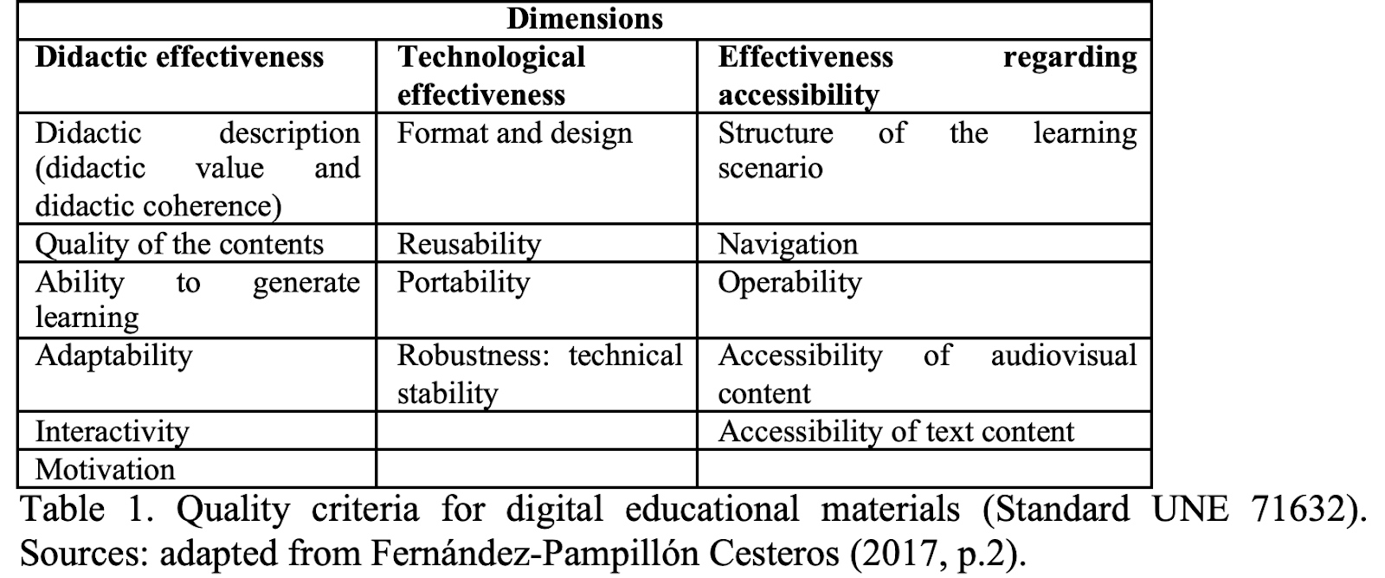

In the creation of the Standard UNE 71632, teaching and learning, technology, accessibility and educational experts from the academic sector, the business sector and the public administration were involved. It provides guidelines to define and assess the quality of digital educational materials quantitatively and qualitatively (Fernández-Pampillón Cesteros, 2017). Fifty-six national and international quality models formed the basis for the first version of the quality model of the standard. The standard defines a digital educational material of quality as being effective from the didactic perspective -good academic results are obtained when the materials are used with reasonable teacher or student effort or dedication-, technological view -simple, reliable, and transparent use-, and accessibility point of view -ease of access and use by any individual, with or without disabilities- (Fernández-Pampillón Cesteros, 2017, p.1). The UNE 71632 norm offers quality indicators to be scored and a rubric to guide this score and guidelines to help the assessment.

We would like to refer here also to the quality criteria of RECOLECTA (Figure 4), as part of national quality standards related to open access resources. The guide for the evaluation of institutional repositories of research is based on international criteria, being the main reference OpenAIRE (Open Access Infrastructure for Research in Europe), and aims at ensuring interoperability of all the open access resources and a quality access to their contents (FECYT, RECOLECTA, CRUE, & REBIUN, 2014). Though this guide is focused on institutional repositories of research, some guidelines may be also applicable to digital educational materials deposited sometimes in those institutional repositories.

It defines 53 evaluation criteria of the repositories, regarding visibility -through its presence in national and international directories and of a normalized name-, policies, legal aspects -regarding intellectual property of the contents distributed-, metadata - metadata characteristics and format that the documents should have-, interoperability, logs and statistics, and security, authenticity and data integrity (FECYT et al., 2014).

While some of those criteria are basic and should be performed, others are just recommended. All have closed answers with values Yes or No to evaluate if the repository complies them or not.

Concerning metadata evaluation criteria, there are some rules that should be applied in order to be harvested in RECOLECTA (FECYT et al., 2014):

* Using the metadata format OAI-DC.
* All the items have the field title (dc:title), description (dc:description) and type of publication (dc:type). This latter has to be assigned according to the type of documents and vocabulary OpenAIRE (European directive) with the document version.
* All the items have the field publication date (dc:date) and it is presented in the established format (norm ISO 8601 -AAAA-MM-DD).
* All the items have the field authors' rights (dc:rights) and information of the level of access, according to vocabulary of types OpenAire.
* All the items have the field author (dc:creator), a field of format (dc:format) according to the registered list of IANA (types of media of Internet- types MIME).
* All the items have the field language (dc:language) according to the established vocabulary (ISO 639-3).
* All the items have the field identification (dc:identifier).
* There exists an indexation policy known by the authors where it is established: language used, keywords, etc.
* Some system of normalized classification is applied (e.g. CDU, UNESCO).
* The metadata exportation is allowed in other format than Dublin Core Simple.
* Some format of technical and/or conservation metadata is used.

## 1.3 Policy

### National and province policies, working papers

As previously mentioned, a country's political structure strongly influences the (lack of) (O)ER infrastructure development. In the case of decentralized countries, there are rather non-binding recommendations published by different actors (e.g. US, Germany), whereas in centralized countries (e.g. South Africa, China) laws and regulations define policies regarding (O)ER infrastructures.

Therefore, in this section we should consider again the Figure 2 (centralized/decentralized HE system), to understand the existence of national/provinces policies or just working papers as recommendations for policy.

The case of China seems to be the clearest example of having developed national policies on digital transformation with its roots in the law of education (Action Plan for invigorating Education towards the 21st Century, 1998), coinciding with the high degree of centralization of its HE system. The Action Plan, Decision, 2019 Outline o China's National Plan for Medium and Long-term Education Reform and Development (2010-2020) devotes a full chapter to the acceleration of digital transformation, including developing and using high quality educational resources on a greater scale. The Ten-Year development plan for educational digitalization (2011-2020) aims at implementing the outline of that overall strategy with action plans and guarantee measures. The current action plans, the Action Plan for Educational Digitalization 2.0, and the Education Modernization 2035 Initiative, point towards the acceleration of digitalization in education, including the development of digital educational resources, and especially, MOOCs, with digital transformation being one of the 10 strategic priorities for education modernization.

On the other hand, an action plan has rarely been developed or provided the necessary follow-through or funding in Japan. For example, the e-Japan Strategy is the foremost official policy concerning the national-level ICT strategies, which also includes HE, that concretely promotes policy and financial support for the creation of faculties for training of high-level data scientists and financial support for university reform, but promotion of digital content creation and distribution is kept for K-12. Whilst the Grand Plan for Japanese Higher Education 2040 highlights the importance of using ICT to improve teaching and learning in HE, it does not establish follow-up plans or support.

In South Korea, the e-Campus Vision for Higher Education (2002) is the HE specific comprehensive digital transformation strategy at the national level to promote the use of ICT. This policy has derived in the Korean government support in the establishment and implementation of 1) e-Learning support centers in the universities across 10 different regions of the country, as well as funded collaborative content development among the universities located within the same region (Centers for Teaching and Learning), 2) the Integrated Administration and Finance System for Universities, and 3) the Crowd-based Integrated Academic Affairs’ System, which will be linked to the Universities’ Resources Management System in 2020.

In Turkey, Vision 2023 Framework is regarded as the national roadmap with six macro themes, of which one of them is Education, Science and Technology, which has the ability to affect the educational policies. The services provided by the Council of HE as national level regulatory organization of HE are one of the affected by the political regulation; e.g., integration of student support services to eGovernment platform or the HEC Digital Transformation Project. One of the actions taken within this Framework was the HE Council’s (HEC) Digital Transformation Project that intended to support and assist the Turkish HE institutions to complete their digital transformation processes. As the first step in this project, MOOCs-like courses that focused on improvement of digital skills of the faculty members and students were developed and piloted in nine Turkish universities.

In the case of some mid- and all highly-decentralised countries, mostly working papers that aim to influence national/province policy exist; there is no national educational policy. For instance, in Spain, which is organized in a centralized political way, and has national education and HE laws, universities are given a degree of autonomy to organize themselves by creating and proposing study programs according to the established rules. However, most of the working papers come from national actors. To highlight are "Towards an open university. Recommendations for the Spanish University System", which deals with open government, open data and open access of the universities and poses some best practices from different Spanish universities (CRUE, 2014); and "ICT 360º, Digital Transformation at the University" (Cabrero et al., 2017) and "UniversiTIC 2017. The Analysis of ICT in Spanish Universities" (Gómez Ortega, 2017) outline the trends regarding digital transformation at the universities and propose strategic lines of action.

In the case of Australia, provinces have the power to legislate on education, but the national government dominates HE policy. Nevertheless, the Australian Government currently has no explicit OER or OEP policies, framework or regulation for use in HE (Bossu & Stagg, 2018; Stagg et al., 2018), which has affected widespread ongoing adoption, aside from a few project-based initiatives, most of which have since been discontinued. At the province level, the Tasmanian Adult Learning Strategy 2019-2022 focuses on lifelong learning and improving literacy, numeracy and digital literacy, with Phase 2 exploring the development of an online portal/repository. The Western Australian government undertook the first audit of regional telecommunications infrastructure in 2017, and the Northern Territory government has funded The Centre for Appropriate Technology to install 27 mobile hotspots.

On the other hand, the national government of South Africa has developed several policies where OER are referred to (Open Learning Policy and Framework in 2017, White Paper on Post School Education and Training in 2014, Policy for the Provision of distance education in South African universities in 2014, Copyright amendment bill in 2017, E-education policy in 2014 and Operation Phakisa in 2015), but there is no overarching digital infrastructure policy with regard to OER in HE.

Interestingly enough, (O)ER are a featured part of the country HE strategy for enabling and broadening access to HE in Turkey, where the number of university students number has been increasing in recent years, and in South Africa, where access is a matter of discussion (DHET, 2014a; 2014b; 2017). Especially in the case of South Africa, education is considered as part of freedom and a political tool for change. In fact, it has been during many years a tool used to sustain and perpetuate inequality as part of the influence of colonialism and apartheid, which has to be considered carefully when taking into account (O)ER. The White Paper on Post School Education and Training (2014) in South Africa has as its main focus the transformation of the HE system to address those inequalities.

Given the lack of a central educational agency, the Council of Ministers of Education in Canada (CMEC) serves as an overarching body for the discussion of common interests and provides a forum to discuss policy issues, a mechanism through which to undertake activities, projects and initiatives in areas of mutual interest, a means by which to consult and cooperate with national education organizations and the national government, and an instrument to represent the education interests of the provinces internationally. Among the CMEC's priorities in HE, there are HE and the labor market, access and affordability, student transition, sustainability and accountability, and postsecondary learning outcomes (2016). The province of British Columbia (BC) includes education as a major focus in its 2018/19- 2021/22 strategic plan, describing “investment in education” as “investment in our future.” With regard to post K-12 education, the government of BC notes that students should be provided with “the tools and information they need to find the right career path”. Important to this endeavor is the effort to make education more affordable.

Similarly, in Germany, the Standing Conference of Ministers of Education and Cultural Affairs (KMK) and the German national government elaborate recommendations that aim at the development of policies in the field of digital transformation; for instance and respectively, the strategy papers "Education in the Digital World" (KMK, 2016) and "Shaping digitalization" (Bundesregierung, 2018). In the first recommendation, the provinces promulgate, from their perspective, a joint understanding on the role, challenges and measures to be taken in order to ensure appropriate education on all levels in the context of digital transformation and mention 10 areas of action and development. The first one refers to OER to mention the need of clarifying legislation and providing basic financial means, and the need for inter-institutional cooperation by developing joint infrastructure; it is remarked that digital transformation is a national endeavor. When talking about HE, the latter German policy document mentions enabling digitalization and the development of digital research infrastructures. Apart from this, 13 of 15 German provinces currently have digital agendas that include HE and the prominence of ideas is to strengthen the province HE system and foster inter-institutional cooperation, infrastructures are still addressed at the province-level.

The federal government in the US has developed the National Education Technology Plan (2017) and the initiative GoOpen, which aims to use OER to transform teaching and learning, but leaves the participation up to individual states and institutions. However, other actors/bodies are more relevant in terms of policy (see Actors and bodies). Decision-makers in the US are not only decentralized by states, but also by markets.

In the other countries, some general laws and regulations regarding open access and government, especially related to scientific dissemination works, are available (e.g., "Open Access Dissemination" in Spain, since 2011; "Declaration of Open Government" in Australia in 2010 and "Australian Government Open Access and Licensing Framework" -no longer in existence), which could also be connected to (O)ER and their infrastructures.

### Actors and bodies

Actors at this macro level are mainly national and/or province governments and funding bodies. In the case of countries with highly centralized HE systems, main actors are the national government (e.g., China, South Africa, Turkey), whereas in countries with the lowest degree of centralized HE systems, provinces are usually more relevant (e.g., Canada, US, Germany). In any case, we can find other institutions and groups involved with the policy for (O)ER and its infrastructures.

For instance, Australia includes as policy actors: the Office of the Australian Information Commissioner, Innovation and Science Australia, the National Copyright Unit, Infrastructure Australia, Australian Digital Council, Australian Technology Network of Universities and the Business Council of Australia.

In the case of Spain, the CRUE (universities), the REBIUN (librarians), the FECYT (public agency for the promotion of science) and the CEOE (business sector) are involved.

South Korea has as main actors the two public agencies that were mentioned in previous sections (KERIS and NILE). In Japan, policy support for private sector donations is currently being discussed.

In the US, apart from the province level policies (for online education and digital education resources), the education organizations (regional and digital organizations), the individual faculty members, the ICT start-up models, and foundations (Hewlett, Gates, Open Society Foundation) are the real actors (for policy and change).

In Germany, apart from the top-to-bottom province level policies too, there are also diverse bodies that influence policy bottom-to-top. Apart from the Hochschulforum Digitalisierung (HFD) as independent national platform and driver of the discourse and policy on HE in the digital age, there are province networks that influence each province policy. For example, ELAN e.V. in Lower Saxony, or the DH-NRW in North Rhine-Westphalia.

## 1.4 Change

### Initiatives to promote change

The most relevant action for the promotion of (O)ER and their infrastructures at the macro level consists of national digital strategies (involving investment/budget from respective Ministries or Departments of Education) or national funding initiatives, which were mentioned for all countries except Japan[5], whether they have a rather centralized or decentralized structure. These are not usually just focused on (O)ER and their infrastructure, but digital education aspects are highlighted. In the case of the US, the federal government does have funding bodies for academic research, and special educational funding initiatives, but it does not provide operational funding for education at any level.

For example, the Canadian national funding agency SSHRC (the Social Science and Humanities Research Council) provides generous funding for projects in national competitions, and digital educational initiatives are especially considered. National government spearheads these kinds of initiatives and provides national support for some aspects in the provinces. For instance, this support is mentioned to be available in Ontario for some university research, student assistance, and some programs (Canadian studies, literacy training, and international education).

In Spain, the Ministry of Science, Innovation and Universities announces annually calls for R&D projects oriented to the society challenges focused on contributing to the solution to social, economical and technological problems in mainstream way; one of its main topics is "Digital economy, society and culture".

In Germany, there are large-scale tenders promoted by the national government (Federal Ministry of Education and Research, the BMBF) as part of the cluster Research in digital higher education. The 2016 tender funded 20 projects related to OER (Mayrberger, 2018). Current tenders have rather a broader focus within digital higher education such as trends and new paradigms, innovation and discipline-based use of technology.

South Korea has several funding schemes for HEI digital transformation, which is also an evaluation criterion of HEI, and budget from the Ministry of Education includes special funds for blended learning universities, entrepreneurship efforts by universities and globalization of HE.

The national government of Australia is investing in Australia's National Research Infrastructure to 2028-29.

In South Africa, the National Treasury dedicates and channels public funding for OER. Another measure includes Teaching Development Grants (funded by the South African Department of Higher Education and Training) will be used to encourage collaborative development and use of OER, and the Policy allows for the sharing of OER with other countries especially when these are released under an open license that permits adaptation.

China includes in its digital transformation strategies investment for OER initiatives, and especially for the creation, development and sharing of MOOCs. Though China's highly centralized HE system and funds coming from the State Council, enterprises, institutions, public organizations and individuals are encouraged to invest in HE.

Some of the countries under investigation also have private funding initiatives, with private institutions particularly involved in (O)ER initiatives in specific countries (see Figure 5).

Figure 5

Spectrum Private funding - public funding.

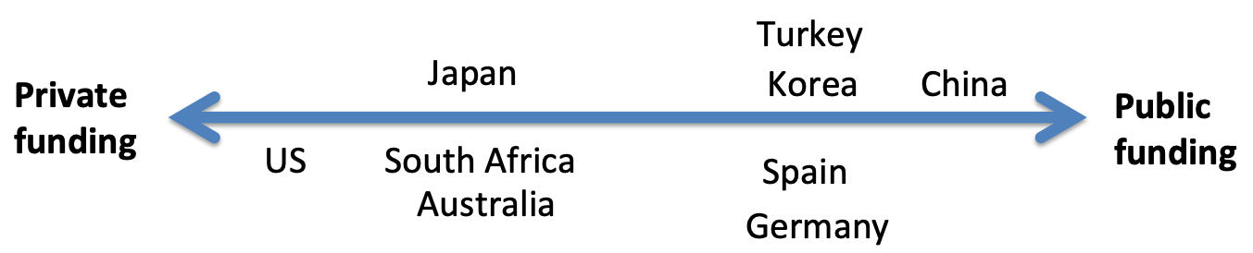

Crucially, private foundations have been an important source for funding (O)ER initiatives in the US. In particular, the Hewlett Foundation[6] has contributed over $70 million to open education initiatives and continues to provide strong support. Other foundations include are the Gates Foundation and the Open Society Foundation. However, individuals starting companies (like TeacherTube) and organizations (like Khan Academy) have also initiated what some might consider open education.

The growth and development of these initiatives calls into debate what counts as open education. Figure 6 indicates a possible spectrum of open education in the United States.

Figure 6

Spectrum of Open Education in the US.

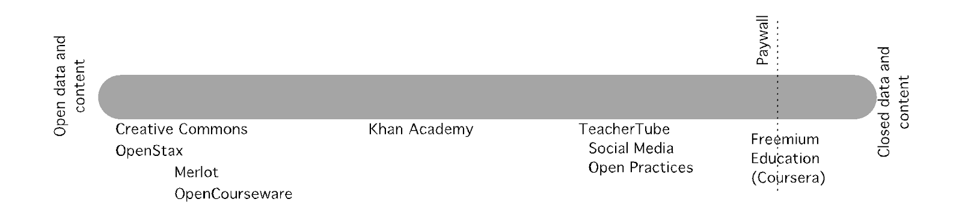

At the left end of the spectrum is the definition of open from the Open Knowledge Foundation, which involves the ability to use, reuse and redistribute content freely. Next are practices and resources where the data or content can be used at no immediate financial cost, but the user is knowingly or unknowingly giving the organization or company personal user data. The adage for this approach is: “If the product is free, the product is you”. The visible product -educational content – is free. But behind the scenes, the real product is user data, which providers can then sell for commercial purposes. At the far end of the spectrum, the product is initially financially free, but the user has to eventually pay for premium services (e.g. credentials for MOOCs). There may even be user data collected that is shared for commercial purposes.

Google and Microsoft have been particularly interested in South African education. In addition, it is remarked that even though guidelines and a vision have been put forward in the Open Learning Policy in South Africa, change in terms of driving an open philosophy in education as foreseen by various policies and frameworks, has not yet materialized.

At the right end of the spectrum, for instance in South Korea, policy and funding for venture entrepreneurship efforts of HEIs is to be currently highlighted.

In the case of Spain, companies such as Vodafone or foundations like the one from the BBVA bank have been offering private funding for projects related to digital transformation at the universities (though not specifically on (O)ER). Academic networks and organizations have also been offering modest funds for one-year projects, prizes or awards for the creation of (O)ER (in the past, OCW; and now MOOCs).

Additionally to public and private funding initiatives in Spain, the creation (and teaching) of (O)ERs/MOOCs is regarded as a complementary merit for university teacher accreditations by the National Agency of Evaluation of the Quality and Accreditation (ANECA).

Honorable titles and funding in the form of online course subsidies are also available for the development of MOOCs in China (the so-called State-benchmarking Open Courses).

### Agents for change

Agents at this level are mostly national and provincial governments (their ministries in charge of funding and investment on digital infrastructure, especially in HEI) (e.g. Spain, South Korea, Germany, China), national funding agencies (e.g. Canada) and private organizations (e.g. US). However, other bodies could also be involved, depending on the country.

In Australia, the macro level agents for change are government, university and industry bodies. One major agent for change in Australia is Infrastructure Australia (IA), which is an independent statutory body that audits Australia’s infrastructure needs, developing 15 year rolling plans to identify state and national priorities. Another is Innovation and Science Australia, which is an advisory board to the Australian Government, providing recommendations on innovation, research and science. The Australian Digital Council was developed in 2018 to help foster across-government collaboration on data and digital transformation, and includes ministers from each province. The Australian Technology Network of Universities (ATN) is a consortium of four research-intensive universities (University of Technology Sydney, RMIT University, University of South Australia and Curtin University), which educates 20% of Australian university students. ATN has a particular focus on industry collaboration, with over 18,000 industry partnerships, and one of its prime objectives is to influence government policy formation. The Business Council of Australia is also heavily invested in improving post-secondary education and skills. The Australasian Open Access Strategy Group (AOASG) advocates for Open and Fair Australasian research and is supported by 19 Australian universities, alongside eight New Zealand institutions and two affiliate organizations.

In the case of British Columbia (Canada), the Open Learning Agency, Thompson Rivers Open University and Royal Roads University are leading digital transformation in HE in the last 30 years.

In the case of Germany, the Hochschulforum Digitalisierung (HFD) is an important think tank, advisory body and actor that promotes policy-practice-research dialogue. It provides impetus for change at the national level, along with national funding, although the execution of projects is through provinces and institutions. Two other community-platforms relevant for the promotion of change in the field of OER are [OERinfo](https://open-educational-resources.de/), which is focused on fostering broader visibility of OER and reaching out to new target groups, and the [OER World Map](https://oerworldmap.org/), which is aimed at providing the most complete and comprehensive picture of the global OER movement.

Although there are agents for change at the macro level, change has been reported to happen mostly at the other levels in the majority of countries. For instance, change especially occurs at the institutional level in South Africa, Japan, Australia, Turkey[7] and Spain; and at the micro level (led by individual faculty members) in the US and Japan, but also in Australia. In the case of Canada and Germany, agents for change are mostly located at the provincial level. In the case of Turkey, it seems that a "ceremonial change" is often happening, which means that there are general policies but then there is the individual vision and the institutional vision.

Exceptions include China[8] and South Korea, where change happens mainly at the national level, due to the political structure of those countries.

[1] A reduced version of this chapter has been published in the following reference: Marín, V. I., Bond, M., Zawacki-Richter, O., Aydin, C. H., Bedenlier, S., Bozkurt, A., Conrad, D., Jung, I., Kondakci, Y., Prinsloo, P., Qayyum, A., Roberts, J., Sangrà, A., Slagter van Tryon, P. J., Veletsianos, G., & Xiao, J. (2020). A Comparative Study of National Infrastructures for Digital (Open) Educational Resources in Higher Education. Open Praxis, 12(2), 241–256. [https://edtechbooks.org/-tMNo](https://doi.org/10.5944/openpraxis.12.2.1071)

[2] Although we describe here the level of centralization of HEIs, we are referring to the political structure of the countries, which influences the structure of the HE systems.

[3] Universia is a higher education network supported by the Santander Bank formed by 1,341 universities of 23 Iberoamerican countries (79 universities in Spain).

[4] A joint research and development project undertaken by Swinburne University of Technology and the University of Tasmania in 2015/16.

[5] Japan rarely provides funding for HEI digital transformation related to (O)ER.

[6] Philanthropic arm of the early computer and information technology William Hewlett.

[7] Although Turkey has a highly centralized system, the change, or initiatives regarding OER come from public institutions that have a long history of open education, such as Anadolu, Ataturk and METU.

[8] Change in China also happens at the meso and micro levels in China, although compared to the Government, the other forces are far less significant.

Read this online at <https://edtechbooks.org/oer_around_the_world/macro_level_the_situ>