# Vocabulario: Saludos, despedidas y cortesías

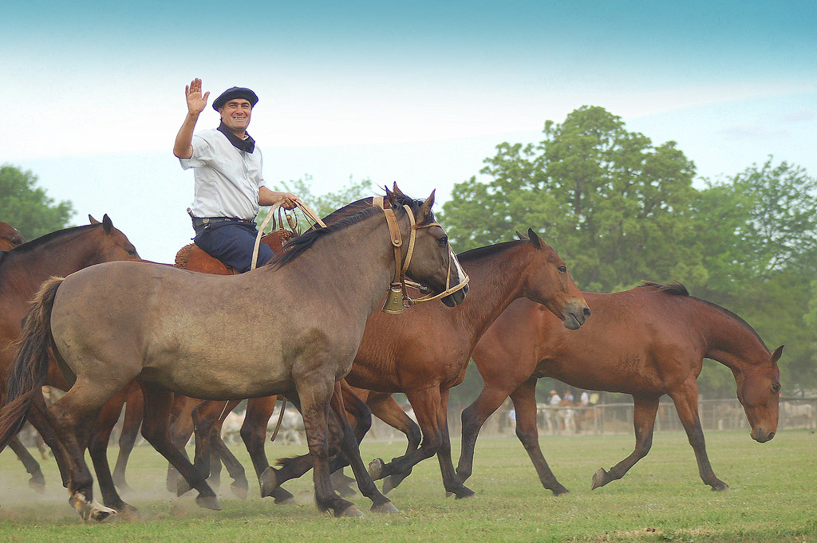

|  |
| --- |
| Para saludarse – To greet one another |
| Hola, ¿qué tal?  -Bastante bien. | Hello, how's it going?  -Quite well. |
| ¿Cómo estás? (tú)  - (Estoy) bien, gracias.  -Bien, ¿y tú?  -Mal, pero gracias por preguntar. | How are you? (singular informal)  - (I am) fine, thank you.  -Well, and you?  -Bad, but thank you for asking. |
| ¿Cómo está usted?  - (Estoy) bien, ¿y usted? | How are you? (singular formal)  -(I am) well, and you? |
| ¿Cómo están ustedes?  -(Estamos) muy bien. | How are you? (plural)  -(We are) very well. |
| ¿Cómo te va?  ¿Cómo le va a usted?  ¿Cómo les va?  -Más o menos.  -Regular (Así así).  -No muy bien. ¡Fatal! ¡Terrible! | How’s it going (for you)? (singular informal)  How’s it going (for you)? (singular formal)  How’s it going (for you all)? (plural)  -More or less.  -So-so.  -Not very well. Awful! Terrible! |
| ¿Qué hay de nuevo?  -No mucho.  - Nada.  OJO:  Nadie dice "Nada mucho." | What’s new?  -Not much.  -Nothing.  NOTE:  No one says "Nada mucho." in Spanish. |
| Buenos días. | Good morning. |
| Buenas tardes. | Good afternoon. / Good evening. |
| Buenas noches. | Good night. |

|  |
| --- |
| Para despedirse – To say goodbye |
| Adiós. | Goodbye. |
| Te veo. | I’ll see you. |
| Nos vemos. | We’ll see each other. |
| Tengo que irme. | I have to go. |
| Hasta luego. | See you later. |
| Hasta mañana. | See you tomorrow. |
| Hasta pronto. | See you soon. |
| Chau.    (también escrito como Chao / Ciao) | Bye. |

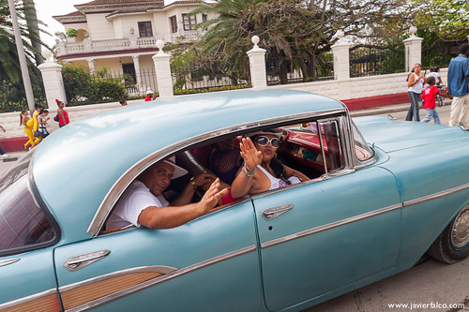

|  |
| --- |
| Cortesías |
| Gracias. | Thank you. |
| Muchas gracias. | Thank you very much. |
| De nada. | You're welcome. |
| No hay de qué. | It's nothing, don't mention it. (Responding to thanks.) |
| Por favor. | Please. |
| Bienvenido/a/os/as. | Welcome. |
| Perdón. | Sorry, excuse me, pardon me. |
| Con permiso. | Excuse me, pardon me. |
| Lo siento. | I'm sorry. |

### Saludos y despedidas en países hispanohablantes

In Spanish speaking countries, men and woman greet each other with “besitos” meaning they touch cheek to cheek and make a kissing sound with their lips. It doesn’t matter if they are good friends or if they are meeting for the first time, the cheek kissing is a universal form of greeting. It is also not uncommon for two men to hug and shake hands as a greeting.

Greetings like “good morning” or “good afternoon” are incredibly important in Spanish. The tradition of greeting another person is an important way of showing respect. In fact, in some parts of Latin America, you are expected to greet every person individually, even if they are in a group. That means that if you are walking along and pass a group of five people, you have to say, “Good morning,” to each person!

The following videos show some general conventions for greeting others in Mexico: [Greetings and Goodbyes in Spanish](https://www.youtube.com/watch?v=h5R2qyp9NYM) (Spanish and Go, Youtube).

|  |
| --- |
| Actividades de conversación |

##### **Actividad 1.** Saludos.

Practica los saludos con tu compañero:

1. Greeting: It is evening and you want to know how your friend is feeling.   
   Response: Your friend is feeling quite well!
2. Greeting: It is morning and you see your roommate after class. You want to know what’s new.  
   Response: Not much has happened since you last saw each other.
3. Greeting: It is afternoon and you go to see your professor in their office. You greet your professor and inquire as to how they are doing today.  
   Response: Your professor is feeling so-so, and wonders how you are doing also.

##### **Actividad 2.** A conversar.

Talk with three different classmates and exchange greetings and questions about how they are doing. You should use a different greeting for each classmate. Make sure you give logical responses to the different greetings and questions that your classmates ask you!

The information found on this page, when not created by us, is adapted from:

* Farmer, Zamostny, Hill, and Henderson Hollenbeck,[Bienvenidos](https://alg.manifoldapp.org/projects/bienvenidos) ([CC BY](https://creativecommons.org/licenses/by/4.0/)).
* Morawski and Alcocer, El Español por el Mundo ([CC BY](https://creativecommons.org/licenses/by/4.0/)).

Read this online at <https://edtechbooks.org/ventanas/los_saludos>