# Vocabulario: Los colores

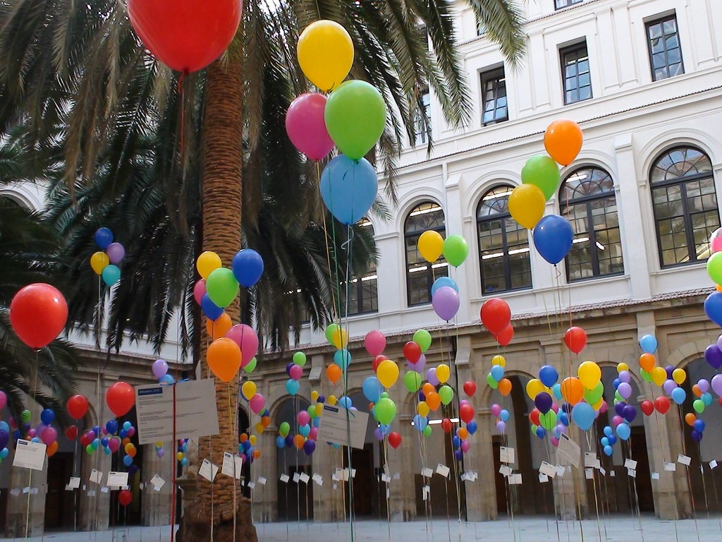

|  |  |
| --- | --- |
| Colores | Colors |
|  | amarillo | yellow |
|  | naranja**, anaranjado | orange |
|  | azul | blue |
|  | blanco | white |
|  | gris | gray |
|  | marrón, pardo, castaño, café* | brown |
|  | morado | purple |
|  | negro | black |
|  | rojo | red |
|  | rosa**, rosado | pink |
|  | verde | green |
|  | violeta | violet, purple |
| *Reference the following link to read about the different shades of brown and when to use them:  [Wordreference - Brown](https://www.wordreference.com/es/translation.asp?tranword=brown)  There are also many variations between dialects of Spanish in different countries. Generally, brown hair is pelo castaño (chestnut colored hair), brown eyes could be ojos de color café (coffee-colored eyes), ojos marrones, or ojos castaños. Pardo is often used for animals like the brown bear (oso pardo). |

#### Agreement

When colors are used as adjectives, they are placed after the nouns they modify. Remember to change those that end in -o in number and gender to reflect the words they modify. Those that end in -e or a consonant change only in number.

* blanco, blancos, blanca, blancas
* rojo, rojos, roja, rojas
* verde, verdes
* azul, azules

Ejemplos:

* La casa es blanca. VS El coche es blanco.
* Las casas son blancas. VS Los coches son blancos.
* El lápiz es azul. VS Los lápices son azules.

**There are also colors that reference a fruit (naranja) or a flower (rosa, violeta) which have just one form that ends in -a for all masculine, feminine, singular and plural, although it is also correct to use the ending -as for both masculine and feminine plurals.

* Las faldas violeta o las faldas violetas
* Los coches rosa o los coches rosas

##### **¡Qué raro tener un coche rosa!**

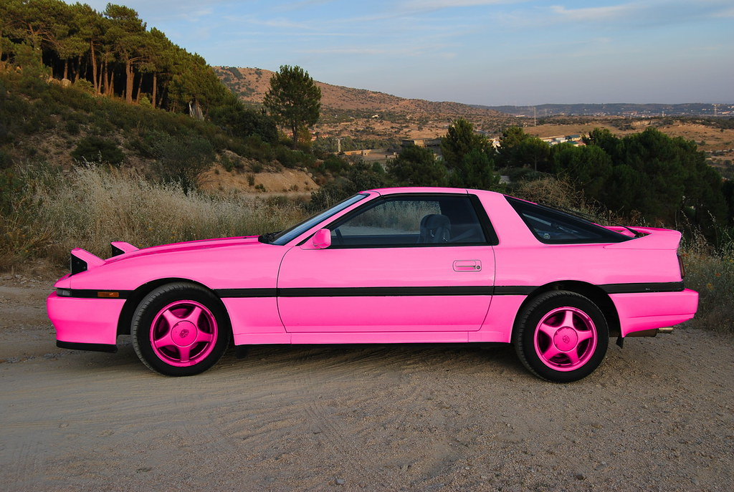

|  |
| --- |
| Listening |

Visit the following link to see and hear more examples:

* [Kwiziq - Colours in Spanish](https://spanish.kwiziq.com/revision/grammar/colours-gender-and-number)

Watch the following video of the colors of houses in Colombia. (Música de Carlos Vivés en el fondo.)

[Los colores de las casas colombianas](https://www.youtube.com/watch?v=nmAHhvlrbek) (MisCositasTV, YouTube)

|  |
| --- |
| Actividades de conversación |

##### **Actividad 1.** Los colores.

With your partner, describe the image below, associating different objects in the classroom with their colors. (Note: for some objects you may need to use more than one color!)

* Modelo: La pared es blanca.

Suggested vocabulary: las sillas, la computadora, el mapa, los pósters, las mesas, el arcoiris (rainbow)

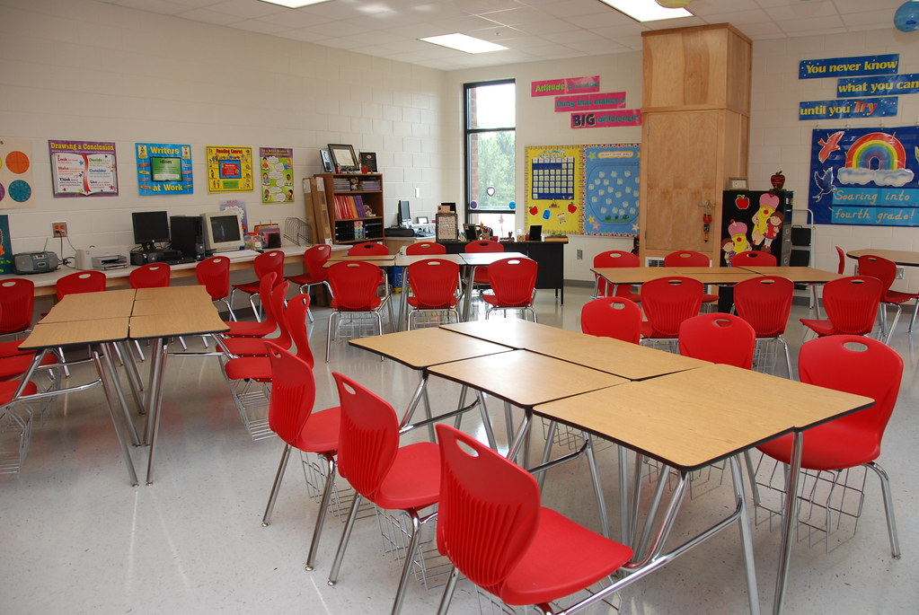

The information found on this page, when not created by us, is adapted from:

* Farmer, Zamostny, Hill, and Henderson Hollenbeck, [Bienvenidos](https://alg.manifoldapp.org/projects/bienvenidos) ([CC BY](https://creativecommons.org/licenses/by/4.0/)).

Read this online at <https://edtechbooks.org/ventanas/vocabulario_colores>