# Pronunciación 2: Las tildes

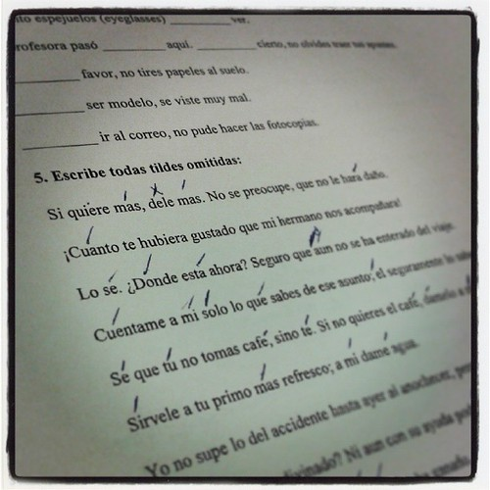

#### Pronunciación: Written accents, stress

|  |
| --- |
| Tildes  Written accent marks, or tildes, serve multiple purposes in Spanish. They are part of a word’s spelling they are not at the discretion of the speaker or writer. They can distinguish between two words that are pronounced the same but have different meanings, such as with si (if) and sí (yes) or el (the) and él (he). They also show where the stress falls if a word’s pronunciation breaks with typical stress patterns, such as with música and también. Tildes will never be placed on a consonant or unstressed syllable, and words cannot have more than one.  The stress is the emphasis given to certain syllables. As in English, stress is occasionally used to differentiate between words. All words have a stressed syllable. In Spanish, we have only two degrees of stress: strong or weak. The stress always goes on a vowel of the syllable.  La sílaba tónica (the stressed syllable) in Spanish words is the one that is pronounced the loudest. How do you know which syllable is pronounced the loudest? In other words, what is the tonic syllable? Remember, el español es fonético, Spanish words are spelled just like they sound. We have these simple four rules to help show you the stressed syllable. |
| **REGLA #1:**  Words ending in vowel, n, or s are stressed on the next to the last (penultimate) syllable:   * CA - ma * Li - mo - NA - da * LI - bro * PLU - ma * COM - pro * ES - tas |
| **REGLA #2:**  Words ending in any consonant except n, or s are stressed in the last syllable:   * doc - TOR * a - MOR * ciu - DAD * can - TAR * le - ER * ca - mi - NAR * pa - PEL * be – BER |
| **REGLA #3:**  When there are exceptions to the above rules, a written accent, the ORTHOGRAPHIC ACCENT = ACENTO ORTOGRÁFICO, is applied. The written accent (la tilde) is always on the vowels and looks like this: á, é, í, ó, ú.   * a - VIÓN * be - BÉ * ja - BÓN * na - CIÓN * e-du-ca-CIÓN - (All -ción or -sión words follow regla 3.) |
| **REGLA #4:**  Written accents are also used to differentiate between words that are pronounced the same but have different meanings:   * Si vs. Sí - (If vs. Yes) * Mi vs. Mí - (My vs. Me) * El vs. Él - (The vs. He) * Tu vs. Tú - (Your vs. You) |

Make sure you configure your keyboard to allow for the Spanish alphabet and diacritical marks. There are several ways you can do this. There are documents in Moodle to help you learn how to make diacritical marks on your PC or MAC. If you need help with this, please contact GTECH for assistance.

|  |
| --- |
| Listening |

(MaestroKaplan, YouTube)

The information in this chapter, when not created by us, is adapted from:

* Ceciliano, Notman, Beginning Spanish ¡Empecemos por aquí! ([CC BY-NC](https://creativecommons.org/licenses/by-nc/4.0/)).
* Silvaggio-Adams, Vallejo-Alegre, Yo puedo: para empezar ().

Read this online at <https://edtechbooks.org/ventanas/pronunciacion2>