# Gramática: Verbos en -ar

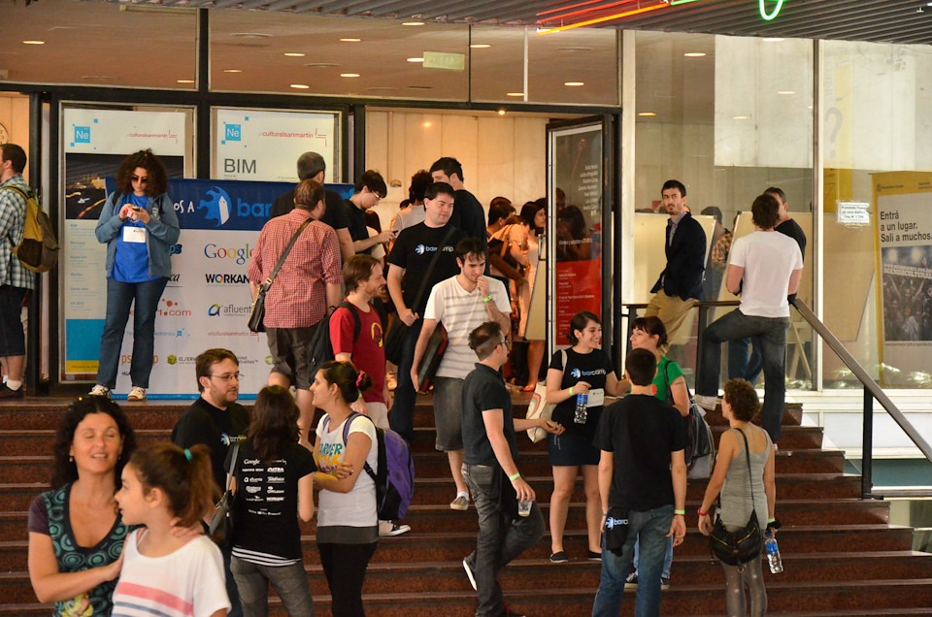

|  |
| --- |
| Describing what you do: the present indicative of -ar verbs |
| You have already learned the present indicative forms of the verbs ser and tener. Now you will learn the present indicative forms of -ar verbs. We use the present indicative to express the following: |
| * To describe routine actions: | **Estudias**  español en la universidad. /  **You study** Spanish at the university. |
| * To say what you are doing right now: | Ahora  **estudias**  matemáticas. /  Now **you’re studying** math. |
| * To ask questions about present events: | ¿  **Estudias**  en la biblioteca después de clase? /  **Do you study** in the library after class? |
| * To describe plans for the immediate future: | Mañana  **estudias**  con tus compañeros de clase. /  Tomorrow **you’re going to study** with your classmates. |

|  |
| --- |
| Conjugating -ar verbs in the present indicative |
| An infinitive verb is a verb before it has been conjugated to reflect the subject of the verb.  **Estudiar**  (  to study  ) is an infinitive. In Spanish, infinitives end in -  **ar**  , -  **er**  , or -  **ir**  . For now, you will learn to conjugate only -  **ar**  verbs. |
| A verb stem is what is left after you remove the -  **ar**  , -  **er**  , or -  **ir**  ending from the infinitive.  **Estudi**  - is the stem of  **estudiar**  . |
| A conjugated verb is a verb whose endings reflect person (I, you, he/she, we, you, they) and time (in this case, the present). |
| To conjugate an -  **ar**  verb in the present indicative, simply remove the -ar from the verb and attach the following endings to the stem, depending on the subject. |

|  |
| --- |
| **Estudiar** – to study |
| Yo estudi**o** | nosotros estudi**amos** |
| tú estudi**as** | vosotros estudi**áis** |
| él / ella / usted estudi**a** | ellos / ellas/ ustedes estudi**an** |

|  |
| --- |
| Forming sentences |
| To form a complete sentence using the present indicative of -ar verbs, remember to follow basic Spanish sentence structure: |
| * Subject + verb + when / where / what / with whom, etc. | * Yo + miro + televisión los fines de semana. / I + watch + tv on the weekends. |
| * Remember that in Spanish, subject pronouns are only necessary to emphasize or clarify. | * Yo miro televisión, pero mi amiga habla por teléfono. (emphasis)   + Vs. Miro televisión. * Usted camina en el parque. (Clarifies that the subject is usted, not él or élla)   + Vs. Camina en el parque. (There must be a previous context that provides the meaning of camina so that we do not need to write it.) |
| To say what you do not do, place  **no**  before the conjugated verb. If the subject is used, put the “  **no**  ” between the subject and the conjugated verb. | * **No** trabajo los fines de semana. / I do not work on the weekends. * Luis **no** trabaja los fines de semana. / Louis does not work on the weekends. |
| Certain present tense conjugations can be followed by infinitives. However, we cannot use two conjugated verbs together unless they are separated by a comma or y  (  and  ), pero (  but  ), or o (  or  ). | * Necesitamos estudiar el vocabulario. / We need to study vocabulary. * Los viernes, trabajo, ceno con amigos y descanso. / On Fridays, I work, eat dinner with friends, and rest. |
| To form a yes or no question, add question marks to a present tense sentence. If the subject is used, it usually follows the verb or is placed at the end of the sentence.  (Note: Certain dialects of Spanish simply take the statement and use intonation to create the question rather than changing word order.) | * ¿Trabajas los fines de semana? / Do you work on weekends? * ¿Trabaja Marta los fines de semana? / Does Martha work on the weekends? OR * ¿Trabaja los fines de semana Marta? / Does Martha work on the weekends? |

|  |
| --- |
| Vocabulario útil  Here are some regular -ar verbs referring to pastimes and activities: |
| alquilar (películas, coches) | to rent (movies, cars) | mirar (televisión) | to watch (television) |
| bailar | to dance | navegar por internet | to surf the web |
| caminar | to walk | patinar | to skate |
| cantar | to sing | pintar | to paint |
| cocinar | to cook | practicar deportes | to practice/play sports |
| descansar | to rest | sacar/tomar fotos | to take photos |
| escuchar (música) | to listen to (music) | tocar un instrumento musical | to play a musical instrument* |
| esquiar** | to ski | tomar un refresco | to drink a soft drink |
| estudiar (en la biblioteca, en casa) | to study (in the library, at home) | tomar el sol | to sunbathe |
| hablar (por teléfono) | to talk (on the phone) | viajar | to travel |
| levantar pesas | to lift weights | visitar a amigos | to visit friends |
| *instrumentos musicales: la guitarra – the guitar, el piano – the piano, la trompeta – the trumpet, el violín – the violin  **esquiar – the forms add an accent: esquío, esquías, esquía, esquiamos, esquiáis, esquían. We will talk about why the accent is added when we study diphthongs. |

|  |
| --- |
| Here are some additional regular -ar verbs not necessarily related to pastimes or activities, but commonly used: |
| acabar (+infinitivo) | to have just (done something) | limpiar | to clean |
| apagar | to turn off | llamar | to call |
| aparcar | to park | llegar | to arrive |
| ayudar | to help | necesitar (+infinitivo) | to need (to do something) |
| buscar | to look for | pasar | to pass |
| cenar | to eat dinner | preparar | to prepare |
| comprar | to buy | trabajar | to work |
| desear (+infinitivo) | to desire, to want (to) | usar | to use |
| enseñar | to show |  |  |
| Ejemplos:   * Acabo de llamar a mi mamá por teléfono. * Deseamos estudiar español. * Ramón necesita limpiar el escritorio. * Busca el libro, pero no lo puede encontrar. (cannot find it). |



|  |
| --- |
| Actividades de conversación |

##### **Actividad 1.** ¿Qué hacen?

|  |  |
| --- | --- |
| Say what the following people do on the indicated days and times. Follow the model. Use different verbs for each sentence.   * Modelo:   + You see: tus amigos y tú: los viernes por la tarde   + You say or write: Tus amigos y tú practican (o practicáis en España) deportes los viernes por la tarde.  1. Yo: los domingos por la tarde 2. Mi compañero(a) de cuarto: los viernes por la noche 3. Mis padres: los sábados por la mañana 4. Mis amigos y yo: los sábados por la noche | Vocabulario útil:     * viernes – Friday * sábado – Saturday * domingo – Sunday * la mañana – morning * la tarde – afternoon * la noche – night |
|

##### **Actividad 2.** Habilidades. (Abilities)

In groups, say what you do very well, and what you do not do well.

* Modelo: Cocino muy bien, pero pinto muy mal.

Then, summarize your group’s abilities for the class using the third person.

* Modelo: Elena y David cocinan muy bien, pero Marta cocina muy mal.

##### **Actividad 3.** Encuesta. (Survey)

Ask your classmates if they do the following activities. Keep a count of how many classmates answer affirmatively and how many answer negatively. Then, write complete sentences saying what your classmates do.

* Modelo:
  + You see: tocar un instrumento
  + You ask: ¿Tocas un instrumento?
  + Your partners respond: Sí, toco un instrumento. OR No, no toco un instrumento.
  + You write: Cinco estudiantes tocan un instrumento.

1. tocar un instrumento Sí: ______ No: ______
2. estudiar en la biblioteca Sí: ______ No: ______
3. escuchar música mientras (while) estudiar Sí: ______ No: ______
4. bailar con amigos los fines de semana Sí: ______ No: ______
5. viajar en el verano (summer) Sí: ______ No: ______
6. caminar a las clases Sí: ______ No: ______
7. cocinar con frecuencia Sí: ______ No: ______

The information found on this page, when not created by us, is adapted from:

* Farmer, Zamostny, Hill, and Henderson Hollenbeck, [Bienvenidos](https://alg.manifoldapp.org/projects/bienvenidos) ([CC BY](https://creativecommons.org/licenses/by/4.0/)).

Read this online at <https://edtechbooks.org/ventanas/verbos_ar>