Gramática: El verbo gustar I
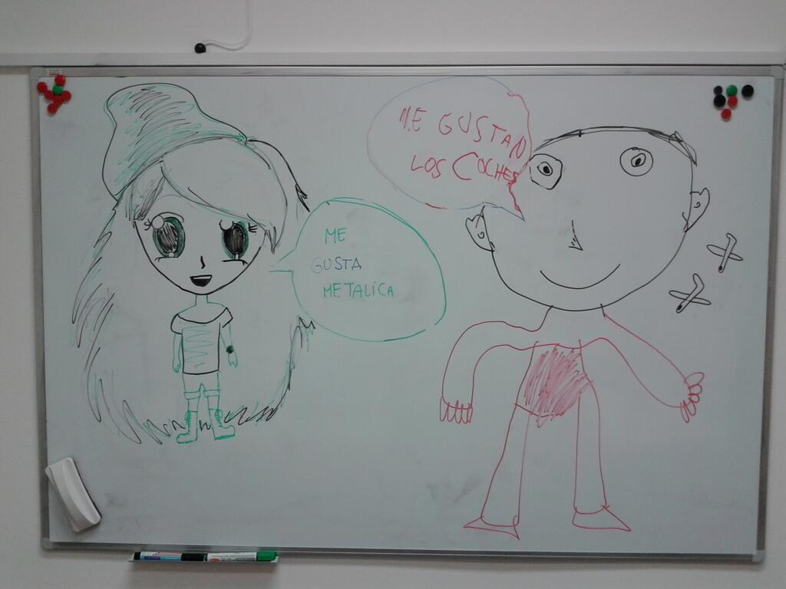

Identifying likes and dislikes: Gustar and similar verbs
Gusta, Gustan, and Other Forms
Gustar is roughly the equivalent of to like in English, but it is actually closer to to be pleasing to.
- A mí me gusta tocar el piano. / Playing the piano is pleasing to me. = I like to play the piano.
- A ti te gustan las películas. / Movies are pleasing to you. = You like movies.
Gustar  is a regular -ar verb and may be conjugated in all of the forms you learned earlier in this chapter: | gusto gustamos  gustas gustáis  gusta gustan
However, some of the forms are uncommon and are used primarily in romantic contexts. For example:
- A mí me gustas. / You are pleasing to me. = I like you. (romantically or as a friend)
- ¿Le gusto a Marta? / Am I pleasing to Marta? = Does Marta like me? (romantically or as a friend)
For this reason, we will be focusing for now on only two forms of gustar: gusta and gustan. These forms will allow us to talk about things people like and activities people like to do.

Forming Sentences with Gusta and Gustan
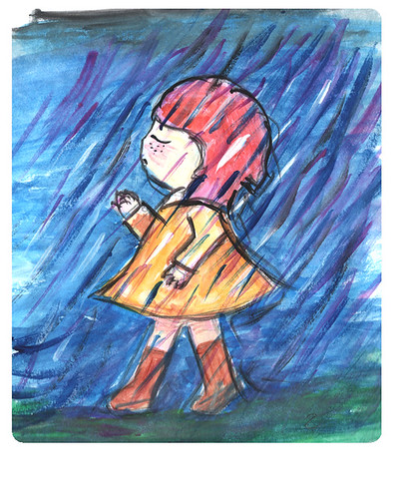
Take another look at the second example above:
- Te gustan las películas. / You like movies.
Notice the grammatical structure used in English:
- You + like + movies.
- Subject + verb + direct object.
This is also the structure that you learned earlier with most -ar verbs in Spanish, as in (Yo) miro películas / I watch movies.
- (Yo) + miro + películas.
- Subject + verb + direct object.
However—and this is an important difference—gustar and similar verbs require a different structure. So, to say You like movies, you say something like:
- Te + gustan + las películas.
- To you + are pleasing + movies.
- Indirect object + verb + subject.
Notice that the subject from the English sentence You like movies has become an indirect object (te/to you) in Spanish, and the direct object has become the subject, which remains at the end of the sentence.
This can be confusing at first, so it will help to remember the following formula for gustar and similar verbs:
- (No) + indirect object + gusta OR gustan + subject
Here are some examples. Each example provides a literal translation followed by a translation in standard English:
- Me gusta tocar el piano. / To me it is pleasing to play the piano. = I like to play the piano.
- No me gusta cantar y bailar. / Not to me is it pleasing to sing and dance . = I don’t like to sing and dance.
- Te gusta el perro. / To you is pleasing the dog. = You like the dog.
- No te gustan los gatos. / Not to you are pleasing cats. = You don’t like cats.
Notice that to negate a sentence with gustar, you must add no directly before the indirect object pronoun.
- No nos gusta escuchar música. / We don’t like to listen to music.
- No les gusta escribir con lápiz. / They don’t like writing in pencil.

Gusta versus gustan
Use the singular form gusta when gustar is followed by one or more infinitives or a singular noun.
- Me gusta alquilar películas. / I like to rent movies. (a single infinitive)
- Nos gusta cantar y bailar. / We like to sing and dance. (multiple infinitives)
- Te gusta la clase de español. / You like Spanish class. (a singular noun)
Use the plural form gustan when gustar is followed by multiple singular nouns or one or more plural nouns.
- Me gustan el perro y el gato. / I like the dog and the cat. (multiple singular nouns)
- Nos gustan los perros. / We like dogs. (one plural noun)
- Te gustan los perros y los gatos. / You like dogs and cats. (multiple plural nouns)
Remember, you must decide between gusta and gustan based on what comes after the verb, not based on the pronoun before it.

Questions with gustar
To ask about someone’s likes, use the questions:
- ¿Qué te / le / les gusta? / What do you (all) like?
- ¿Qué te / le / les gusta hacer? / What do you (all) like to do?
You can transform other sentences with gustar into questions by adding question marks and varying your intonation.
- Te gusta la clase de español. / You like Spanish class.
- ¿Te gusta la clase de español? / Do you like Spanish class?
- Les gustan los estudiantes. / They like the students.
- ¿Les gustan los estudiantes? / Do they like the students?

Vídeo
Me gusta y no me gusta en español - I like and I don't like in Spanish (ProfeDeEle, YouTube)

Actividades de conversación

Actividad 1. ¿Cuál es correcto?
Choose the correct Spanish translation for each of the following sentences. Can you explain why the other options are incorrect?
1. I like to dance.
- Yo gusto bailar.
- Me gusta bailar.
- Me gustan bailar.
2. You like patient people.
- Te gusta las personas pacientes.
- Te gustan las personas pacientes.
- Tú gustas las personas pacientes.
3. She doesn’t like lazy people.
- Le no gustan personas perezosas.
- No le gustan personas perezosas.
- Ella no gusta personas perezosas.
4. We don’t like to cook or clean (limpiar).
- Nosotros no gustamos cocinar o limpiar
- No nos gustan cocinar o limpiar.
- No nos gusta cocinar o limpiar.

Actividad 2. ¡______ gustan los perros!
Everybody in the class is a dog lover! Use the cues to complete the blanks with the correct indirect object pronoun. Choose between me, te, le, nos, os,and les. Follow the model.
- Modelo:
  - You see: yo
  - You write: Me gustan los perros pequeños.

- tú: _________ gustan los perros simpáticos y activos.
- nosotros: _________ gustan los perros cómicos y perezosos.
- Eduardo: _________ gustan los perros bajos y gordos.
- María e Isabel: _________ gustan los perros altos y delgados.
- ustedes: _________ gustan los perros inteligentes.
- Jorge y yo: _________ gustan los perros tontos.
- Marta y tú: No ________ gustan los perros, sino (but rather) los gatos.

Now, explain why the plural form gustan was used in all of the above sentences.

The information in this chapter, when not created by us, is adapted from:
- Farmer, Zamostny, Hill, and Henderson Hollenbeck, Bienvenidos (CC BY).

Read this online at https://edtechbooks.org/ventanas/gustar

