DocsTeach
DocsTeach is an educational website created by the National Archives education division to promote learning with and about the Archive's collection of documents (including text, videos, and photographs). It is a knowledge-centered website that allows users to explore all the available primary sources from the National Archives and share activities with students and peers. Educators can use pre-created activities or create their own activities. There are 253 activities (1,872 if you are a member) and 12,529 primary sources available for teachers and students.
Students can also perform their own research on documents and then select and download which ones are most relevant for their research. This research tool can promote critical thinking by allowing students to analyze primary sources and act like historians.
The website also provides free professional development webinars for elementary and secondary educators. All the features on this website are free of charge.

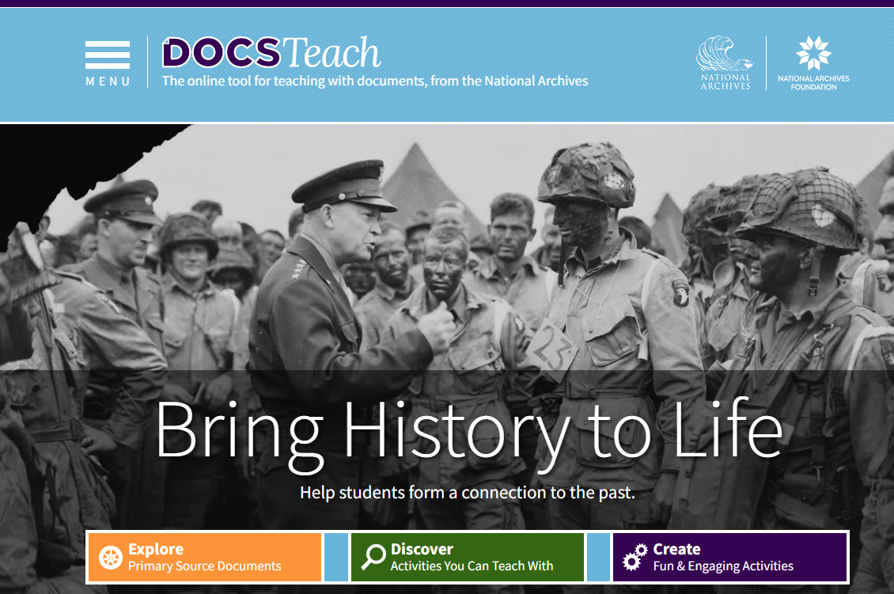

Tool Snapshot
Price | Free
Learning | Constructivism
Privacy | Privacy Policy
Accessibility | Accessibility Statement
Class Size | Unlimited
Login | No login needed for viewing primary sources and some activities; Login needed to use/create activities.
ISTE*S | Empowered Learner & Knowledge Constructor.
COPPA/FERPA Compliant | No  FERPA  /  COPPA  policy found. Check with your school IT  administrator.

Price
This website belongs to the National Archives, and it is government-funded. Therefore, all the features on this website are free of charge and are under a Creative Commons license. Educators and learners can search, view, and analyze all the documents without paying for them since most of the documents are public domain. Moreover, the professional development webinars are also free.
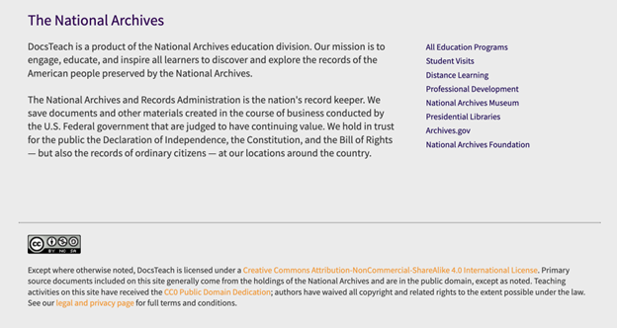

Type of Learning
Constructivism: Learners can use the tool to analyze primary sources and create their own interpretation of the information. Also, they can use the search tools to find documents that they find relevant for their learning process.

Ease of Use
I gave 5 stars to this website because it is very easy to use. The search tools for documents and activities are clear and uncomplicated. Users do not need a login to search and share activities with others nor do they need to log in to work on an activity as well.

Privacy
I gave 4 stars to this website because it does not collect personally identifiable information other than what is submitted when registering for an account (e.g., email, name) from its users according to its privacy policy. It is also possible to search, analyze and share documents without any login. If the educator wants to save shared activities or access more activities, they can log in with their name, email, and password. However, the website does not sell or share its users' information with third parties.
There is no information regarding whether the tool is COPPA/FERPA compliant. However, it does not collect any data from students. Furthermore, students do not have to identify themselves; it is possible to use a pseudonym given by the teacher when submitting their answers.
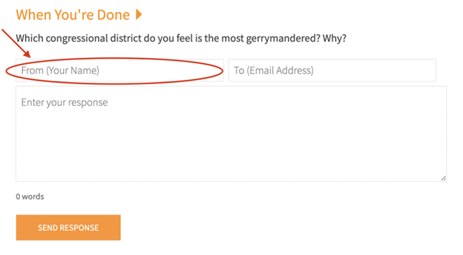

Accessibility
I gave 3 stars for the accessibility (DocsTeach's accessibility statement is a section in the website's privacy policy) of this website because the voice control works very well with the tools available and the site can be navigated without a mouse. However, I found the navigation throughout the website very confusing without a mouse. Moreover, documents do not seem to have alt text or a way to describe what’s in the document to a screen reader.

Class Size
Since the user is the one sharing the activities through a link, there is no limit to how many people can access the assignments simultaneously. Therefore, there are no limitations on the size of the class.

Login
A login is not required to access the website's features. Teachers can use this tool without logging in by sharing a link to the activities with their students. However, if educators want to save previous assignments or create their own, they need to log in with their name, email, and password. Students do not need to log in to use the website; they'll receive a link to the activities and, after they are done, their answers go directly to the teacher's email.

ISTE Standards
Empowered Learner: Students can choose how they will learn by selecting the documents they will analyze and sharing them with other students.
Knowledge Constructor: Students can use this tool to research and curate primary sources related to a given subject and select the documents that are more relevant to their own learning experience.

DocsTeach Overview

Transcript

DocsTeach & the SAMR Model
Here is an example of how DocsTeach might fit within the SAMR model:
- Substitution: Students analyze a digital document shared by the teacher and send their answers to the educator's email. Unlike analyzing a primary source from a textbook, students can explore thousands of documents on the website and learn independently.
- Augmentation: Students can quickly and easily search for primary sources related to a given topic and select the most relevant ones for their research.
- Modification: Students can work on activities that support critical and higher-order thinking and complete them at school or home, anytime and anywhere.
- Redefinition: Students from all around the globe can research and analyze primary sources from the National Archives without the financial burden of visiting this institution in Washington, DC.

Learning Activities

History
There are 12,529 primary sources available to be analyzed by students. For example, when learning about Abolitionism, students can research letters and biographies of abolitionists, anti-slavery petitions, court documents, laws, etc... Also, it is possible to filter the search so that students can access specific types of documents. For instance, they can research videos related to the historical period they are studying.
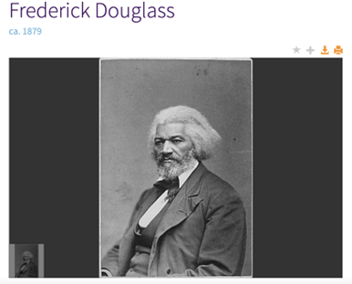

United States Government and Politics
Students can analyze different primary sources related to the U.S. government's three branches and organize them according to each branch's responsibilities.

Sociology
Students can research primary sources related to social and political groups, such as the Civil Rights movement or the LGBTQ+ movement. For example, it is possible to analyze laws, videos, photographs, letters, etc…, which would help learners understand the goals, tactics, and obstacles people had to overcome to obtain civil rights.

Mathematics
Students can analyze the Journal of Charles Mason and Jeremiah Dixon to identify how the authors utilized mathematics in it.
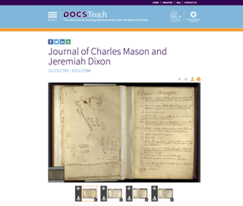

Science
Students can research scientific patent documents to analyze original innovations. For example, learners can study Eli Whitney's Cotton Gin Patent Drawing to understand the science behind it.
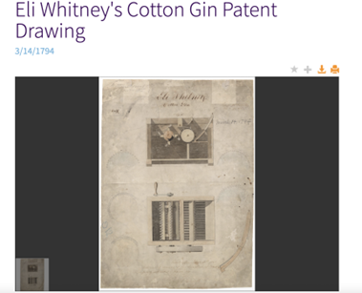

Language
Students can read documents such as the Constitution or the Bill of Rights to analyze the language used at the time. They can also rewrite the laws using their own words.

Resources
- Getting Started with DocsTeach: Finding and Sharing Activities.
- Getting Started with DocsTeac: Creating Your Own Activity.
- DocsTeach for Virtual Learning: How to Analyze Primary Sources Online with DocsTeach.
- DocsTeach for Virtual Learning: How to Pair and Share DocsTeach Activity Sets.
- 15 New Primary Source Activities from DocsTeach
- Education Week: Eight Ways to Teach With Primary Sources
- DocsTeach An Online Tool for Teaching with National Archives Documents
- DocsTeach Twitter account
- DocsTeach: Resources Related to Native Communities at the National Archives.
- Late-19th-Century Business Maps of San Francisco’s Chinatown, Used to Determine Immigration Status

How to Use DocsTeach
Users can use DocsTeach in three ways: Explore, Discover, and Create. Here are the steps to use each one of them:
- Go to https://www.docsteach.org/.
- Explore:
  - Click "Explore" to research the National Archive's documents.
  - Use the searching tool to find an activity related to a primary source.
  - Use filters to refine your search (Historical Era and Document Type).
  - Select the files that you want to explore.
  - Read and analyze the documents.
  - It is also possible to download documents.
- Discover:
  - Click "Discover" to research pre-created activities.
  - Use the searching tool to find a pre-created activity.
  - Use filters to refine your search (Historical Era, Thinking Skill, Activity Type, or Grade Level).
  - Select the files that you want to explore.
  - Read and analyze the activity.
  - Click on "Start Activity."
  - Send the activity's link to students.
  - They will work through the activity answering questions.
  - When they finish the activity, they can click on "When You're Done."
  - Students fill out the spaces with their names (or pseudonyms), the teacher's email, and answers;
  - The teacher will receive an email with a link to the student's activity.
Obs.: If you register on the website, you can access more documents.
- Create:
  - Click "Create" to create your activities.
  - Register on the website.
  - Activate your account through your email account.
  - Click on the link on the email DocsTeach sent you.
  - Log in.
  - Go to "Menu," click on "Home," and click on "Create."
  - Click on "Create a New Activity."
  - Choose activity type.
  - Choose the activity's title for students and teachers.
  - Click on "Save."
  - Go to 'Menu", click on "Home."
  - Select "Explore."
  - Use the searching tool to find a primary source related to your activity.
  - Use filters to refine your search (Historical Era and Document Type).
  - Select the files that you want to explore.
  - Read and analyze the documents.
  - In the right upper corner of the document, click on the "+" icon.
  - Select the activity that you previously created and click on "Add."
  - On the main menu, click on "My Account" and then on "My Activities."
  - Select the activity and click on "Edit and Manage Activity."
  - You can add elements by clicking on "Add Elements" and then on "Add activity Element."
  - Create the activity that students will have to work on by clicking on the tab "For Students."
  - Create a summary for other teachers.
  - Save and publish your activity.

Video: "Getting Started with DocsTeac: Creating Your Own Activity"

Research
Braun, Jolie (2017) "Resources for Teaching with Primary Source Materials," MAC Newsletter: Vol. 45: No. 1, Article 9. Available at: Iowa State University Digital Repository
Hussey, M. (2011). Teaching with online primary sources: documents from the national archives: DocsTeach.gov from the national archives. Teaching History: A Journal of Methods, 36(1), 34+. Available at: Gale Academic
Rinder, J. A.(2020). Helping Future Teachers Do History: The Effectiveness of the National Archives Docsteach Program on the Historical Thinking and Perception of History of Preservice Teachers. (Doctoral dissertation). Retrieved from "Helping Future Teachers Do History: The Effectiveness of the National " by Jeremy Alan Rinder

Author
This page was created by Ana Schantz.

Read this online at https://edtechbooks.org/onlinetools/docsteachH

