# Soundtrap

[Soundtrap](https://www.soundtrap.com/edu/?scrlybrkr=a5fd7f95) is a community-based creative sound production tool that allows users to collaborate with classmates, teachers, and other users worldwide. Sountrap can be accessed directly by the user's browser. As a cloud-based tool, users can access Soundtrap on a variety of devices, such as smartphones, laptops, and tablets. Students can use the tool to design music for presentations and projects, collaborate with classmates to create a song, and record podcasts to share knowledge on various subjects and topics. Soundtrap has an integrated **LMS (learning management system)**, which allows classroom features such as lesson plans and assignments to be uploaded by instructors for the students to access. The platform offers over 20,000 high-quality beats and presets (e.g. basslines), making songs even easier to create for students! **If you are struggling with getting students to develop their** [**creative thinking**](https://www.iste.org/explore/5_Reasons_Why_It_Is_More_Important_Than_Ever%20_Teach_Creativity#:~:text=Creativity%20motivates%20kids%20to%20learn,they%20need%20to%20accomplish%20it.) **and** [**communication skills**](https://wiki.ubc.ca/MET:Main_Page)**,** you might consider giving Soundtrap for education a try.

## Tool Snapshot

|  |  |
| --- | --- |
| **Price** | 30-day free trial for educators. $4.98 per student, 50 students minimum, purchased by school. |
| **Learning** | [Constructionism](http://edutechwiki.unige.ch/en/Constructionism)  &  [Social Learning](https://www.learning-theories.com/social-learning-theory-bandura.html) |
| **Ease of Use** | ★★★★★ |
| **Privacy** | ★★★★★ |
| **Accessibility** | ★✩✩✩✩ |
| **Class Size** | Unlimited |
| **Login** | Yes |
| **ISTE*S** | Digital Citizen, Creative Communicator, Global Collaborator |
| **COPPA/FERPA** | Yes |

### **Price**

Sounds and districts looking at implementing the use of Soundtrap for creative and educational learning can expect to pay $4.98 per student, with the minimum amount of students being 50. This gives students unlimited projects, 4,750 loops, 430 instruments to incorporate, and over 150,000 sound effects (Soundtrap).

### **Type of Learning**

Soundtrap is a tool that supports social learning and constructivism. As a cloud-based service, all projects can be shared and collaborated on with other users. Allowing students to work with their peers while observing their behaviors and thought processes gives them the opportunity to learn from each other which embraces a social learning style. From a Constructionist perspective, Soundtrap has a wide variety of tools that allows users to create, manipulate, and customize their sound recordings and projects, which follows the notion that building knowledge best occurs through building things that are tangible and shareable.

### **Ease of Use**

The education version of Soundtrap offers so many tools to get started, especially if the user has no prior experience in sound recording and using sound effects. Whether the users want to engage in music production or podcasts, Soundtrap is a good tool for anyone new to the idea. For example, the user can use electronic instruments like pianos, keyboards, synthesizers, and drum machines. There are also tutorials on how to use each of these. Collaboration is made easy with the “Collaborate” option right on the user's home screen. This way, the user can easily share, comment, and view others' projects. Soundtrap can be used not only to teach the basics of using audio to students but to also increase their creativity.

### **Privacy**

We rated privacy ★★★★★ because not only does Soundtrap not collect much data on their users, but they also do not share it for any arbitrary reasons. In order to create an account, users will need to provide their email and name. Other than that, the only data being collected is platform data usage (e.g. which sounds are being used - which the company will use for platform improvement). Soundtrap is both COPPA and FERPA compliant. The [privacy policy](https://www.soundtrap.com/legal/privacy/edu) states the platform “will not collect, maintain, use or share student personal information beyond that needed for Students to use our Education Services.” The information that Soundtrap does collect will not be disclosed unless it is required by law or to protect the security of Education Services or others. Students' information is never sold, rented, or traded.

### **Accessibility**

When running the page through an [online accessibility checker](https://wave.webaim.org/), there were many issues, such as missing alt text and labels, which makes using the tool with voice control or a screen reader very difficult. The website was found essentially unusable when conducting the no-mouse challenge. The company also has no official Accessibility Statement, which is why Soundtrap earned 1 star in accessibility.

### **Class Size**

While there are no restrictions on class size, in order to purchase access for students, the school must buy at least 50 subscriptions.

### **Login**

Students and teachers must create an account to use Soundtrap. Accounts can be made with an email address, Facebook, Google, or Microsoft account.

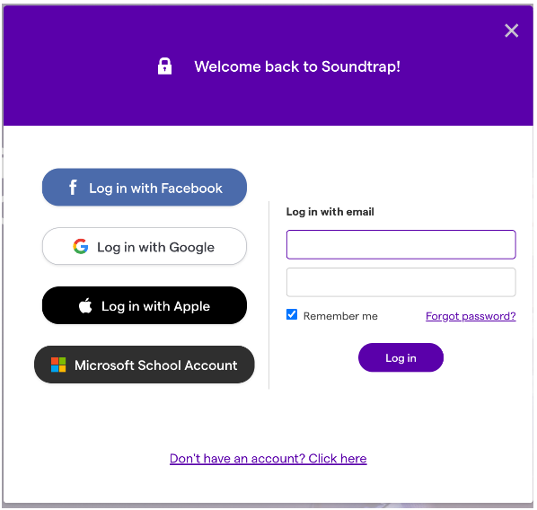

### **ISTE Standards**

Soundtrap, when used as a tool for educational purposes, follows the following ISTE standards for students: Digital Citizen, Creative Communicator, and Global Collaborator. As digital citizens, students learn to work in an interconnected world, in safe, legal, and ethical ways. Not only does Soundtrap encourage students to use media, such as audio files, legally and ethically, it also helps them gain experience using technology and the skills that come with it.  As creative communicator, students can creatively express themselves through audio. As Soundtrap is inherently creative, it allows students to express themselves in a creative way through various mediums such as songs or podcasts. As global collaborators, students use digital tools to expand their perspectives and knowledge by collaborating with others and working as a team. Due to Soundtrap offering collaboration between all users, students using this tool will be able to work with their peers and improve their team-working skills.

## Soundtrap in 120 seconds video

[Transcript](https://docs.google.com/document/d/16riJlfMAdCURn01iNyDTll0VbK5T5ROYEA1xDgxnMKw/edit?usp=sharing)

## Soundtrap & the [SAMR Model](https://www.powerschool.com/blog/samr-model-a-practical-guide-for-k-12-classroom-technology-integration/#:~:text=The%20SAMR%20Model%20is%20a,Augmentation%2C%20Modification%2C%20and%20Redefinition.)

Here is an example of how Soundtrap might fit within the SAMR model:

**Original Assignment:** Memorize a poem to perform for the class

* **Substitution:** Students can use Soundtrap to record themselves reading a poem rather than reciting the poem for the class.
* **Augmentation:** Students can comment on peers’ Soundtrap projects, even on direct timestamps, and offer suggestions.
* **Modification:** Students can use Soundtrap to explore adding audio effects to the reading of poems. For example, one of the features of Soundtrap is remixing. Students can either remix the lyrics from other songs into a new song on Soundtrap, or even add sounds that alter the meaning of the original poem.
* **Redefinition:** Students can collaborate on projects with a class from another part of the country to get diverse viewpoints.

## Learning Activities

### Math

Students can record themselves thinking aloud as they solve a math problem. Then, they can invite group members to listen to their recordings and offer feedback.

### Science

Students can record themselves talking about their observations and then add appropriate soundtracks to accompany their findings. Once compiled, students can post their Soundtrap project for others to learn from and teachers to grade, essentially making an audiobook-style lab report.

### Writing

Students record a piece of their writing by reading it aloud. Then, classmates pair up and listen to each other’s recordings, offering feedback. Students will then edit their projects, adding intro/outro music, sound effects, etc, to create a finished product.

### Topic Review

As a class, create a list of past topics/concepts they need to review. Then, have students choose one they are familiar with, which they will have to teach to their classmates. Use Soundtrap to record an informational podcast to be shared with the class to be listened to as a study tool.

### History/Social Studies

Record an interview with a relative about their life. Edit the interview, adding background music and sound effects. Another option is to have students find public domain recordings from historical events and speakers, such as the ones found [here](https://archive.org/details/Greatest_Speeches_of_the_20th_Century), and then remix them with new audio.

## Resources

* [Soundtrap Review for Teachers](https://www.commonsense.org/education/website/soundtrap)
* [Soundtrap Songwriting Teacher Guide](http://www.musicalfuturesinternational.org/uploads/1/2/0/1/12012511/soundtrap_songwriting_teacher_guide.pdf)
* [Create Assignments in Soundtrap for Education](https://www.youtube.com/watch?v=As2wQUy3G00)
* [Lesson Plans](https://edu.soundtrap.com/teacher-resources/lesson-plans/) (detailed lesson plans to inspire activities)
* [How to Make Beats (Google Classroom Activity)](https://www.youtube.com/watch?v=aU0c7AbJwuc)
* [A Music Teacher's Guide to Soundtrap](https://fflat-books.com/a-music-teachers-guide-to-soundtrap/)
* [Enhanced FAQ - Assignment VS Invite](https://www.youtube.com/watch?v=xfU3W_n9JM4&amp;list=PLto3DQIYibDgWLZTtM3bzpK4EbHjqt7Mw)
* [Audio Effects](https://www.youtube.com/watch?v=YhBbAwvgrvA)
* [Top 4 Recording Tips & Terms](https://www.youtube.com/watch?v=vKTFw9sGOc0)
* [How to Start a Student Podcast with Soundtrap](https://newedtechclassroom.com/student-podcast-soundtrap/)

## How to Use Soundtrap

1. Go to [www.soundtrap.com](http://www.twitter.com).
2. Click “Sign Up” under the option of “Educational Use.”
3. Use your email address to register for an account.
4. Add students by clicking “Add Students.”
   1. Copy the invite link and share it with students (this contains the group code).
      1. These codes must be activated (60 minutes - 30 days).
   2. The students will be able to create their account with their email address.
5. Organize and create groups.
   1. All users must be in the same group to collaborate.
6. Create assignments and share using the link.

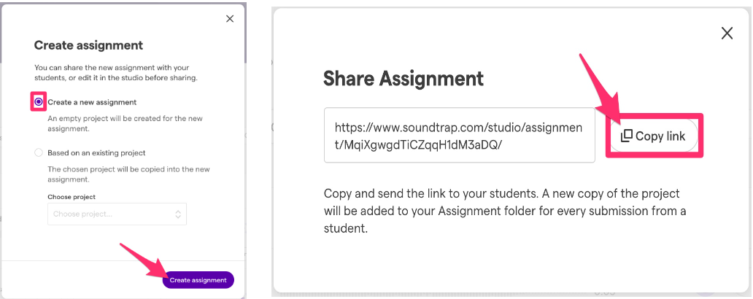

## Soundtrap for Education - Getting Started

## Research

Hicks, J., Winnick, L., & Gonchar, M. (2018, April 19). Project audio: Teaching students how to produce their own podcasts. The New York Times. Retrieved April 29, 2022, from <https://www.nytimes.com/2018/04/19/learning/lesson-plans/project-audio-teaching-students-how-to-produce-their-own-podcasts.html>

Hani Morgan (2015) Focus on Technology: Creating and Using Podcasts Promotes Student Engagement and Learning, Childhood Education, 91:1, 71-73. [https://www.tandfonline.com/doi/full/10.1080/00094056.2015.1001680?scroll=top&needAccess=true](https://www.tandfonline.com/doi/full/10.1080/00094056.2015.1001680?scroll=top&amp;needAccess=true)

## Authors

This page was created by Blaine Wiley and Krista DiCunzolo.

Read this online at <https://edtechbooks.org/onlinetools/soundtrap>