# TalkingPoints

[TalkingPoints](https://talkingpts.org/) is a messenger tool that allows teachers to **connect** and **communicate** with parents and families across **any language**. Teachers can communicate with parents via text messaging (via a phone or internet-connected device) in their native language [(About us, 2021)](https://talkingpts.org/about-us/). TalkingPoints is used by more than 50,000 schools across the U.S. and **translates into more than 100 different languages**. By using this digital platform, teachers can communicate with any parent, family member, or guardian of a student with ease. For example, a teacher can send a message in English saying “Hi how are you” to a parent whose native language is Spanish. The parent will then receive that message translated into Spanish “¿Hola! Cómo estás?” and can also reply in Spanish. They may say something like “[Estoy bien. ¿Cómo estás?](https://www.spanishdict.com/translate/Estoy%20bien.%20%C2%BFC%C3%B3mo%20est%C3%A1s%3F)”. Lastly, the teacher will receive the response translated into English "I am fine. how are you?” This can help **eliminate barriers** including time and language to encourage **family engagement** in supporting **student success**[(Edwards, 2021)](https://www.techlearning.com/how-to/what-is-talkingpoints-and-how-does-it-work-for-education). This is especially important because “family engagement is two times as effective in predicting a student's success than the family’s socioeconomic status” ([Taking Points, 2021](https://talkingpts.org/what-we-do/), para. 5). If you are struggling to inform families about student progress or to get families to engage in conversation due to language barriers, you may consider using TalkingPoints.

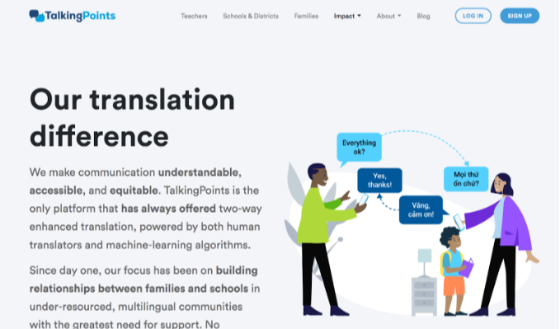

## Tool Snapshot

|  |  |
| --- | --- |
| **Price** | Free for individual teacher and parent accounts.  [Schools and districts can request a quote](https://talkingpts.org/pricing/)  . |
| **Learning** | [Social Learning](https://www.learning-theories.com/social-learning-theory-bandura.html) |
| **Ease of Use** | ★★✩✩✩ |
| [**Privacy**](https://talkingpts.org/privacy-policy/#:~:text=We%20will%20never%20sell%20or,revenue%20through%20selling%20data%20ever.) | ★★★★★ |
| **Accessibility** | ★★★✩✩ |
| **Class Size** | Limitations based on pricing plans. |
| **Login** | Yes |
| **ISTE*S** | None |
| **COPPA/FERPA Compliant** | Yes |

### Price

TalkingPoints is free for individual teacher and parent accounts, however, if a school or district would like to integrate TalkingPoints throughout the entire school or district, they would need to get a quote. As of now, TalkingPoints for high-need schools and districts is free through the end of the 2023 school year if schools and districts sign up before April 30th. For more information on TalkingPoints for schools and districts, visit the [pricing plan page](https://talkingpts.org/pricing/).

### Type of Learning

We believe that the social learning theory is most closely aligned with the way TalkingPoints is designed because this theory highlights the importance of learning from one another. TalkingPoints is designed to keep families engaged in their student's learning and to help families support student success. As children spend most of their time outside of school, their families have a big impact and influence on their learning. Similar to the key ideas of the social learning theory, students learn from their families through observation, imitation, conversations, and modeling.

### Ease of Use

We gave the tool two stars for ease of use because you are unable to use TalkingPoints unless you are a teacher or a parent with an account and class code. This can make it difficult for people who are interested in learning how to use the tool if they are not a teacher or parents with a class code. However, there are [step-by-step instructions and links to video tutorials](https://talkingpts.org/resources/) provided on the website for teachers and parents to view in order to learn how to use the tool. However, these features are somewhat hard to find, as the website has a cluttered layout.

### Privacy

We gave the tool five stars for privacy based on the extensive privacy policy detailed on [their website](https://talkingpts.org/privacy-and-security/). The privacy policy clearly states that a user’s data will never be shared with third parties and that a user’s data is not used for any type or form of advertising. TalkingPoints also guarantees that a user’s data will be deleted per a user’s request and provides a link that the user can use to request that their data be deleted. The data that is provided by the user is completely owned by the user, as stated in the privacy policy, and users will be notified if there are any changes in the TalkingPoints privacy policy. In addition, TalkingPoints is compliant with both [FERPA and COPPA](https://talkingpts.org/security-overview/). They meet the legislative requirements for COPPA, and help schools comply with FERPA regulations.

### Accessibility

We gave the tool 3 stars for accessibility because TalkingPoints does not have a specific accessibility statement on their website, although they do have some new accessible features and some that are coming in the future. [AccessiBe](https://www.youtube.com/watch?v=YRto1QedAE4) is a plugin that is installed on the TalkingPoints website, teacher web app, and school and district products, that allow users to adjust settings to support individuals with disabilities, such as blindness and ADHD. In addition, the tool allows users to choose various font sizes and has a speech-to-text function that allows the spoken text to be translated into over 100 different languages. Additionally, TalkingPoints has a text-to-speech function so users can listen to the messages that are being sent and received. Both speech-to-text and text-to-speech are so important and helpful for users with limited literacy. TalkingPoints also alerts educators with a “Readability Flag” when a message they are writing to a user is written above the reading level of a 5th-grader, and also helps the educator make the message simpler to assure that the user will be able to fully understand the message. Although TalkingPoints has these great accessibility features, there are a few things that could be added for optimal accessibility such as being able to use the tool without the use of one’s hands. We [researched the accessibility statement](https://intercom.help/talkingpoints/en/articles/5371115-ada-compliance-expanded-equity-features) in order to find details about how accessible TalkingPoints is for its users.

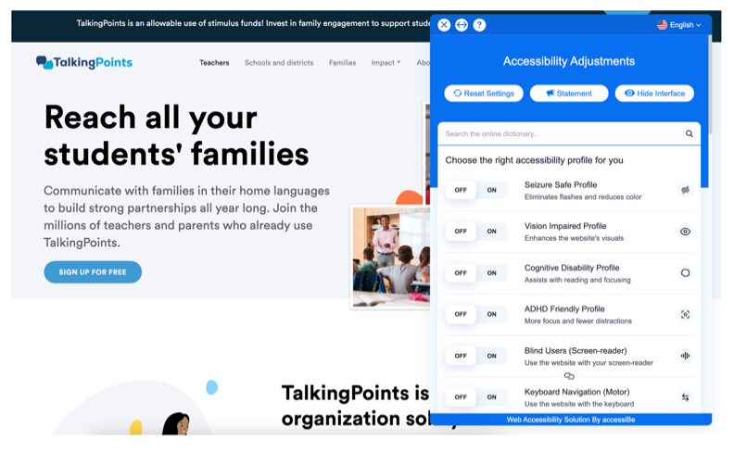

### Class Size

For free individual teacher accounts, there is a limit of 200 students and five classes, which limits class size. However, for school and district accounts that are based on a quote price system, there is no limit on the number of students or class sizes [(Edwards, 2021)](https://www.techlearning.com/how-to/what-is-talkingpoints-and-how-does-it-work-for-education).

### Login

TalkingPoints requires teachers, schools, and districts to register for an account using the web app or mobile app. A name, email address, password, or a Google account is needed to register. However, if you choose to sign up with a Google account, you will need to [provide additional information](https://intercom.help/talkingpoints/en/articles/1289712-talkingpoints-getting-started-guide) about the grade you teach and what type of teacher you are. Parents are also required to register for an account using the web or mobile app and are asked to provide their language, phone number, and email address (optional). Parents are then able to join using a 6-digit class code which is provided by the teacher to join their class. Once parents register for an account, they can either opt to receive SMS texts or download the TalkingPoints for Parents mobile app, where they will have to log in to use the tool. Once teachers are registered for an account, they are also required to log in using the web or mobile teacher app.

### ISTE Standards

We believe that TalkingPoints does not closely align with any of the ISTE standards. Because this tool is made specifically for parents, and not students, it does not meet any of the ISTE standards for students.

## TalkingPoints Overview Video

[Transcript](https://docs.google.com/document/d/1gpSuHvf8kwfDbIqrtuzRq3NR-g-hHk4lJmNwGuZBaoc/edit)

## TalkingPoints & the SAMR Model

Dr. Ruben Puentedura’s [SAMR model](https://www.emergingedtech.com/2015/04/examples-of-transforming-lessons-through-samr/) offers a detailed framework to help teachers integrate technology into the classroom in more meaningful and productive ways. As a result, we encourage teachers to use this model to facilitate the effective use of technology in the classroom.

Here is an example of how TalkingPoints might fit within the SAMR model:

* **Substitution:** Teachers use TalkingPoints to message parents about student progress, rather than email or phone-based text messages.
* **Augmentation:** Teachers can send multimodal messages that parents can access on a phone or website. Using the website means that messages won't take up cell data on parents' phones.
* **Modification:** Teachers can have their messages checked for readability so they're easy to understand for parents.
* **Redefinition:** Teachers and parents can communicate with one another in their language through the translation of over 100 different languages, overcoming language barriers that may have otherwise been a problem.

TalkingPoints is not just a substitute for text messaging. While substitution does have benefits, this tool provides newly accessible technology that supports student success by building connections between schools, teachers, and families that may have otherwise been avoided due to language barriers.

## Learning Activities

### Math

Text the link to different math resources; videos, websites, or virtual manipulatives to parents to try out with their kids outside of school.

### Science

Send parents the directions to an at-home science experiment that their child was assigned, so they may help their child if desired.

### English/Language Arts

Send parents a virtual copy of a book or a passage from a book that was assigned in class to students, and ask parents to read a chapter of the book aloud with their child.

### Backchanneling

Send parents reminders for their children’s upcoming assignments and class events.

### Parent-Teacher Community

Message parents about their children's progress in school. Send pictures of students on a school field trip or during a school event.

## Resources

* [TalkingPoints receives transformational gift from MacKenzie Scott to advance meaningful, equitable, family engagement for students](https://www.ewa.org/press-release/talkingpoints-receives-transformational-gift-mackenzie-scott-advance-meaningful)
* [Building connections between schools and families will boost student achievement](https://hechingerreport.org/opinion-more-federal-money-is-coming-to-schools-we-should-use-it-to-support-families/)
* [Translation App Engages Families in Student Learning](https://northfieldpromise.org/2021/12/translation-app-engages-families-in-student-learning/)
* [How TalkingPoints is helping teachers and parents stay connected to enhance student success and well-being](https://blogs.cisco.com/csr/how-talkingpoints-is-helping-teachers-and-parents-stay-connected-to-enhance-student-success-and-well-being)
* [How I Use Apps to Improve Family Engagement](https://theeducatorsroom.com/how-i-use-apps-to-improve-family-engagement-and-parent-engagement/)
* [TalkingPoints for Parent App Tutorial](https://www.youtube.com/watch?v=y-YEkYYozzs)
* [TalkingPoints Getting Started Guide](https://intercom.help/talkingpoints/en/articles/1289712-talkingpoints-getting-started-guide)
* [Elevating Family Voices in the Classroom](https://talkingpts.org/blog/elevating-family-voices-in-the-classroom/8082/)
* <https://twitter.com/MusicMrBrox/status/1514055946472939526?s=20>
* [Family Engagement in Action: TalkingPoints](https://www.carnegie.org/our-work/article/family-engagement-action-talkingpoints-overcoming-language-barriers/)

## How to Use TalkingPoints

Below is a step-by-step tutorial by TalkingPoints that shows teachers how to both set up and use TalkingPoints. The video provides accurate closed captions.

## Research

Crook, A., Cannonier, C., & Simmons, C. (2018, April 13). There's an app for that: The impact of reminder apps on student learning and anxiety. Taylor & Francis. Retrieved April 22, 2022, from <https://www.tandfonline.com/doi/abs/10.1080/08832323.2018.1441120>

Dyer, T. D., Aroz, J., & Larson, E. (2017, March 29). Now you see me: Using reminds to achieve proximity online. Digital Commons@Georgia Southern. Retrieved April 22, 2022, from <https://digitalcommons.georgiasouthern.edu/sotlcommons/SoTL/2017/58/>

McCoy, K. (2016, March 21). What is remind & why should I care? the advantages of utilizing a one-directional text message application to support student learning in Academia. What is Remind & Why Should I Care? The Advantages of Utilizing a One-directional Text Message Application to Support Student Learning in Academia - Learning & Technology Library (LearnTechLib). Retrieved April 22, 2022, from <https://www.learntechlib.org/p/171645/>

Nisbet, K., & Opp, A. (n.d.). Effects of the remind app on parent-teacher communication at a mixed-income middle school. SOPHIA. Retrieved April 22, 2022, from <https://sophia.stkate.edu/maed/227/>

## Authors

This page was created by Jillian Reilly and Sarah Pingeton.

Read this online at <https://edtechbooks.org/onlinetools/talkingpoints>