Mentimeter
Mentimeter is an online presentation-building tool that facilitates audience engagement. The tool allows presenters to include polls, multiple-choice and open-ended questions, quizzes, and scales that audience members can interact with live. Mentimeter was founded in Sweden in 2014 and by the end of 2021 had over 270 million users worldwide (Investor Information - Mentimeter). If you are struggling with getting students to share their thoughts, Mentimeter is a tool that should definitely be considered. It allows students to remain anonymous while still being able to express their thinking and view others' thoughts. For example, if a teacher or presenter wants to ask an open-ended question, an ongoing post-board will appear on the screen and students can add responses to the question as they please. The post-board can be seen in the screenshot below.
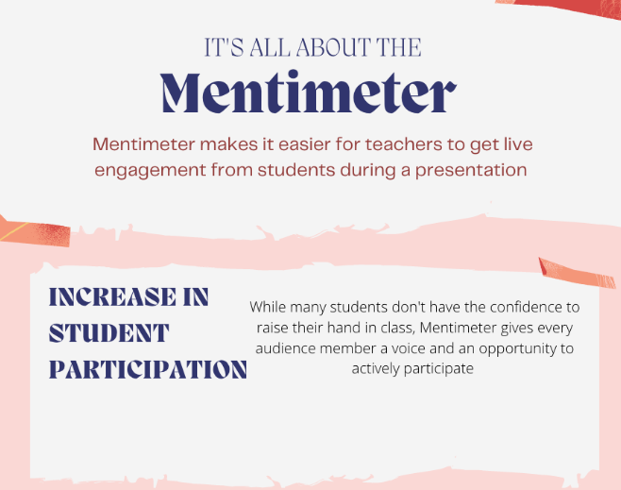

Tool Snapshot
Price | Pricing Plan
Type of learning | Behaviorism  Social Learning
Privacy | Privacy Policy
Accessibility | Accessibility Statement
Class Size | Unlimited
Login Required | Yes for presenters. No for audience members.
ISTE Standards for Students | Empowered Learner Creative Communicator
COPPA/FERPA Compliant | No FERPA/COPPA policy found. Check with your school IT administrator.

Price
Mentimeter has four different options for membership. The free option provides users with unlimited presentations and unlimited audience members. However, it limits presenters to two questions and five quizzes per presentation. Then there is the Basic option which is $11.99 a month. This option has unlimited questions and quizzes per presentation. Mentimeter also has a Pro membership that is $24.99 a month and allows presenters to build a team. Finally, there is the Custom option that allows teams of 10+ presenters to collaborate while having access to team management services. The price for this option is not listed on their pricing plan.

Type of Learning
I selected Behaviorism learning theory because Mentimeter follows the “skill and drill” teaching technique that is described in that theory. Teachers are able to present information to students and then directly quiz them on it through Mentimeter. I then selected Social Learning because students are able to see their peers' responses. Mentimeter leads to group discussions which is a major part of social learning.

Ease of Use
I gave Mentimeter’s ease of use four stars because I had never used it before as a presenter and within five minutes I had created a presentation and interacted with it successfully from another device. Mentimeter has pop-up notifications that show users which buttons do what function as well as providing previews of what each question type, heading, and quiz will look like on the slide by just gliding the mouse over each option. The website Menti that is used by audience members is also extremely easy to use and audience members can smoothly interact with the presentation without being familiar with Mentimeter at all.

Privacy
I rated Mentimeter’s Privacy Policy two stars because users have to share names and email addresses to be a presenter. Mentimeter collects this information as well as IP addresses and time stamps of interactions on the site. Mentimeter also interacts with third-party companies to gain information on users for marketing purposes. The only reason why I didn’t give them one star is because Mentimeter included that users can completely delete their account at any time as well as restrict the processing of their data. This tool also uses google ReCAPTCHA, which monitors users' every click and other characteristics to determine whether the user is a human or an automated program.

Accessibility
I gave Mentimeter's accessibility a one star because their accessibility statement only addresses the accessibility of their audience website Menti.com. They have an entire accessibility conformance report that only applies to the audience site menti.com and do not have one for their presenter site. The presenter platform appears to be nearly impossible to navigate for people needing screen readers. However, the audience site has more accessibility and is able to function with screen readers.

Class Size
All plans allow presenters to interact with an unlimited number of audience members which is a great feature that college professors can use in any size lecture they might have. Mentimeter is not just limited to teachers with classes under 50 people like many edtech tools are.

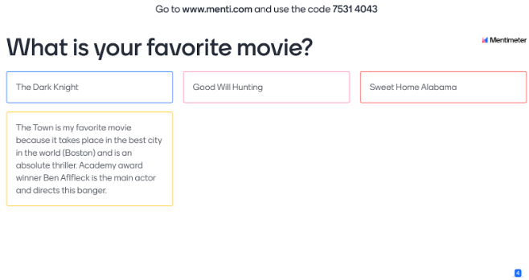

Login
Students and audience members do not need to log in with any personal information, all they need is the code from the teacher or presenter and they will be able to directly interact with the presentation. However, teachers and presenters do need to log in either through Facebook or with a Google account.

ISTE Standards
I selected Empowered Learner because Mentimeter gives students immediate feedback on their responses and allows students to ask more questions if they are not correctly understanding a concept. For example, if the teacher is presenting and asks students to respond to a multiple-choice question, students will be able to immediately see if they properly understand the material that has been taught. Mentimeter allows students to directly display their learning. I also selected a Creative Communicator because students can also use Mentimeter to create their creative presentations.

Mentimeter in 120 seconds video

Video transcript

Mentimeter & the SAMR Model
- Substitution: Students use Mentimeter to respond to teacher questions instead of having to answer out loud.
- Augmentation: All students get to respond to teacher questions instead of just a few.
- Modification: Students can see all of their peers' responses instead of only hearing from a few.
- Redefinition: Students can create their own polls or questions that people around the world can respond to.
Far too often, technology is used as a direct substitute for other low-tech tools (e.g., pencil and paper). While substitution has some benefits (e.g., students develop their technology skills and knowledge), we encourage you to think about how you might use Mentimeter to modify or redefine learning.

Learning Activities

Icebreakers
Ask students if they wrote a book what the title would be. Then display the answers and see if anyone wants to share them aloud.
Using an open-ended question, teachers can do word association activities. For example, before starting a new topic teachers can ask students what words they associate with specific topics (e.g., What words do you associate with the solar system?).

Science
Show students a picture of two different phases of the moon, and ask them which one is a waxing crescent. Students will be able to respond via the multiple-choice question format.

English
Provide students with a long quote from reading and ask them to summarize the quote in as few words as possible. This will be able to show how thoroughly they understand a quote.

Other
After a presentation, ask students what they learned from the presentation, the responses will be displayed on the next slide of the presentation for all to see.
Instead of having students brainstorm on a piece of paper, have students brainstorm on Mentimeter so that the entire class can see everyone’s responses. Take a screenshot and print out a copy for each student so that they can have those ideas as they move further into the assignment.

Resources
Make sure that the title of the resources you add below matches the exact title on the website/video that you are linking to.
- Best Classroom Icebreakers in 2022 - Mentimeter
- Polls, Surveys & Quizzes for School & University - Mentimeter
- 10 Ways to Keep Students Engaged in 2022 - Mentimeter
- Tips and tricks for teaching with Mentimeter
- What is Mentimeter and How Can It Be Used for Teaching? Tips and Tricks | Tech & Learning
- Interactive Quizzes & Games for the Classroom - Mentimeter
- MENTIMETER for Teachers: A Beginners Guide 2022

How to Use Mentimeter
How to present with Mentimeter:
- Go to https://www.mentimeter.com.
- Click ‘sign up and enter your email address and name.
- Then click present.
- In the top left corner there will be options for different types of questions and quizzes.
- Glide your mouse over each question type to get a preview of how it will look on the screen.
- Create your questions in a text box on the right of the screen.
- When ready to present click the "present" button.
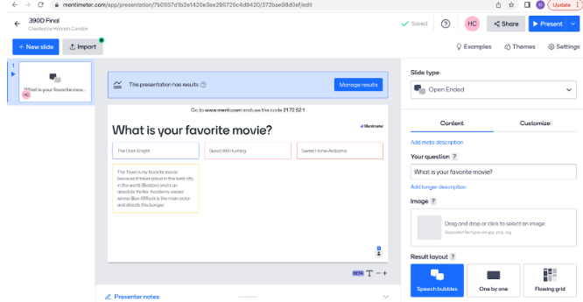
How to use Mentimeter as a student:
- Go to https://www.menti.com.
- Type the number that is at the top of your teacher's screen into the text box and hit submit.
- The next screen will show your teacher's question and will instruct you on how to select your answer.
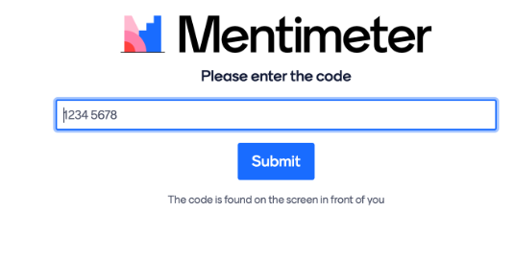

Research
Gokbulut, B. (2020). The effect of Mentimeter and Kahoot applications on university students' E-learning. World Journal on Educational Technology: Current Issues, 12(2), 107-116. Retrieved from http://silk.library.umass.edu/login?url=https://www.proquest.com/scholarly-journals/effect-mentimeter-kahoot-applications-on/docview/2488223693/se-2?accountid=14572
Ahshan, R. (2021). A framework for implementing strategies for active student engagement in Remote/Online teaching and learning during the COVID-19 pandemic. Education Sciences, 11 Retrieved from http://silk.library.umass.edu/login?url=https://www.proquest.com/scholarly-journals/framework-implementing-strategies-active-student/docview/2608772093/se-2?accountid=14572

Author
This page was created by Hannah Condon.

Read this online at https://edtechbooks.org/onlinetools/mentimeter

