# Coggle

[Coggle](https://coggle.it) is an online mind mapping tool that can be utilized in any grade level or subject. **Users have the creative freedom to work individually, or with others, to make visually appealing and well-organized mind maps**. This can be done with the variety of different shapes, colors, sizes, and formats offered, as well as with the unlimited image upload feature. The many functions made available through Coggle make it a community-, knowledge-, and learner-centered tool. Users can work with multiple people on one diagram, allowing them to learn with, and from one another; users apply their current knowledge to effectively create and organize cohesive mind maps; and lastly, users can construct their diagrams in a way that will best fit their needs, and therefore empower their learning.

**Coggle can be a beneficial tool for teachers to promote critical thinking about the course material**. Coggle allows its users to be creative with the diagrams they assemble and personalize them to best suit the user's needs and preferred method of organization. This can encourage students to be more engaged in learning new material, and the process of creating a mind map requires in-depth thinking and planning of concepts, which would naturally inspire critical thinking and a greater understanding of the material.

## Tool Snapshot

|  |  |
| --- | --- |
| [Price](https://coggle.it/plans) | Coggle starter: Free limited version; Coggle Awesome: $5/month; Coggle Organization: $8/ Month |
| Learning | [Cognitivism](https://edtechbooks.org/studentguide/cognitivism)  ,  [Constructionism](http://edutechwiki.unige.ch/en/Constructionism)  ,  [Social](http://gsi.berkeley.edu/gsi-guide-contents/learning-theory-research/social-constructivism/) |
| Ease of Use | ★★★✩✩ |
| [Privacy](https://coggle.it/privacy) | ★★★★✩ |
| [Accessibility](https://coggle.it/accessibility) | ★★★✩✩ |
| Class Size | Unlimited |
| Login Required | Yes |
| [ISTE*S](http://www.iste.org/standards/standards/for-students-2016) | Global Collaborator, Innovative Designer, Creative Communicator |
| COPPA/FERPA Compliant | No FERPA/COPPA policy found. Check with your school IT administrator. |

### Price

Coggle has three different types of plans for its users. The starter plan is free, the Awesome plan is [$5/month](https://coggle.it/awesome), and the Organization plan is [$8/month](https://coggle.it/organisations). Each plan allows for additional features, such as more creative freedom when making diagrams (Awesome), and user and data management (Organizer).

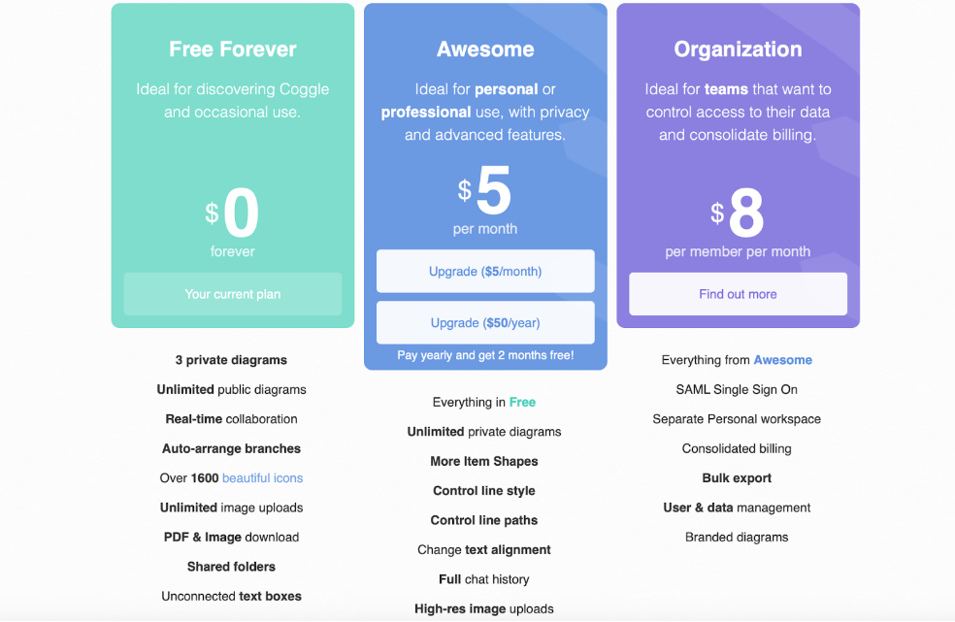

### Type of Learning

#### Cognitivism

Students who use Coggle are learning new information through cognitive processes by organizing and assigning meaning to each concept.

#### Constructionism

Students learn by building mind maps and diagrams on topics they are introduced to, allowing them to process new ideas as they work on their creations.

#### Social Constructivism

Students can work collaboratively with their peers on mind maps in real-time, enabling them to share their knowledge, and learn with, and from one another.

### Ease of Use

We gave Coggle 3 stars for ease of use because the user interface is clear to navigate, and there are multiple instructional videos on the site ([Video Tutorial Introduction](https://coggle.help/article/104-video-tutorial-introduction), [Keyboard Shortcuts](https://bloggle.coggle.it/post/144405061272/a-video-guide-to-the-keyboard-shortcuts-in-coggle)). When using different features, a pop-up box with an explanation of each button appears when your mouse hovers over it, this makes it easy to create mind maps, even if you have never used Coggle before.

### Privacy

We gave Coggle’s [privacy policy](https://coggle.it/privacy) 4 out of 5 stars because it is clear about what happens to its users' data, however, there isn’t any information about whether it is COPPA and FERPA compliant. The privacy policy states that none of its users' data is shared with or sold to third-party sites without consent, however, a third-party site is required to create an account and login. It is stated in the policy that the only information they take is your name, email address, avatar, gender, and preferred language, all of which are permanently deleted once closing your account. Mind maps made privately with Coggle can not be accessed by anyone other than the creator, although this is not entirely true for people with the “Organization” plan. The privacy policy says that any diagrams made through the Organization plan are visible to Organization administrators, “even if you do not invite them.” For example, teachers should be aware that if you are on the organization plan, the school may or may not have access to your student's work without their permission (Coggle, [privacy policy](https://coggle.it/privacy), 2022).

### Accessibility

Coggle does have an accessibility statement that states the application includes [hotkeys](https://coggle.help/article/24-keyboard-shortcuts), a screen reader, and color changes for users with disabilities. There are still several limitations. According to Coggle, “text does not wrap onto the screen, but may scroll off the edge for large diagrams … The visual structure of Coggle diagrams may not be well represented by screen readers, and while the PDF exports of diagrams include text in an accessible format, the visual structure of the diagram in the PDF file will be ignored by screen readers, which will normally read the diagram from top to bottom” (Coggle, [accessibility policy](https://coggle.it/accessibility), 2022, para. 4-6).

### Class

There is no limitation on the number of students who can work on mind maps at once, as long as they have their own devices, users are allowed to add people to their mind maps by sending out an email invitation, however, the shareable links are only available for paid plans.

### Login

Educators and students need to log in to use Coggle, which can only be done with a third-party account such as Apple, Microsoft, or Google.

### ISTE Standards

#### Innovative Designer

Students use this online tool to plan and design their mind maps using the provided colors, shapes, and formats.

#### Creative Communicator

Students can creatively present their visual representations of the content they learn in class.

#### Global Collaborator

Students can work with their peers in real-time to create mind maps on new material and concepts learned in class.

## Coggle Overview Video

[Video Transcripts](https://docs.google.com/document/d/1Y_J2BmH82NT3DKNV7L9fyuK_hkhBARIH4npkmY71-K0/edit?usp=sharing)

## Coggle & the SAMR Model

Dr. Ruben Puentedura’s [SAMR model](http://www.emergingedtech.com/2015/04/examples-of-transforming-lessons-through-samr/) offers a lens for examining how technology is adopted in a classroom. As you strive to incorporate online tools into your classroom, we encourage you to use this model as an analytic tool.

Here is an example of how **Coggle** might fit within the SAMR model:

* **Substitution:** Students can create mind maps in Coggle rather than on a whiteboard in class.
* **Augmentation:** Students can add videos, images, and links to their mind maps and even access the public diagrams to use as a template for their creation.
* **Modification:** Students can create mind maps about course material, and can revisit them, make edits, and add new information they learn later on.
* **Redefinition:** Students can work on projects, in real-time, with people outside of their community to expand their learning network.

## Learning Activities

### Math

Younger students who are starting to learn geometry can use the [Shapes in the Coggle template](https://static.coggle.it/diagram/YhNivcZnKihmRyEK/t/shapes-in-coggle) to create a diagram with the names of different shapes and how they are classified. As a way to practice this, they can identify shapes they see in their own lives and edit their diagram over seven days.

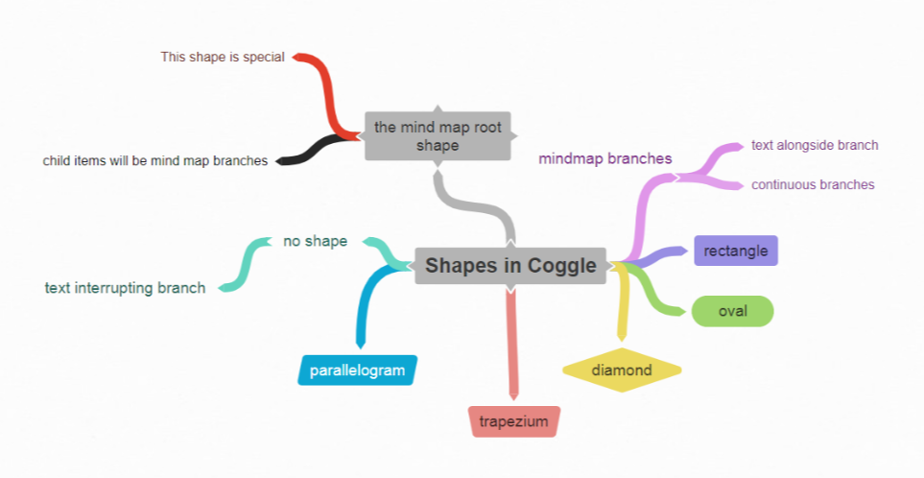

### Science

To explain a challenging concept, students could create a diagram that goes into depth on the key components of that concept. For example, in biology, a mind map that lays out you learn the structure and function of cells, which involves many components that can be difficult to understand and remember. Using a mind map that incorporates images can help students to visualize each step and how they relate to one another.

### English

Students can use Coggle to create a diagram as an outline for an essay. Creating a mind map can be an effective way of categorizing thoughts, themes, and main points in a cohesive and visually appealing way.

### History

Students can use Coggle to create a [timeline of important historical events](https://static.coggle.it/diagram/XM7GQseK2T22388V/t/roman-history-timeline), as a way to remember when they occurred, as well as their significance in world history. Image of a public diagram on Coggle of a timeline of Roman historical events.

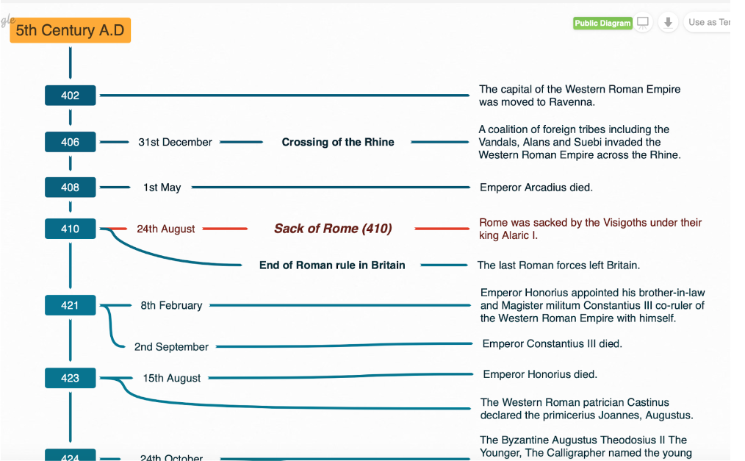

### Foreign Language

Coggle can easily change the language of the user interface, so students can create mind maps in the foreign language they are learning in school to memorize the meaning of words and phrases.

## Resources

* [Coggle Software Review for 2022](https://project-management.com/coggle-software-review/)
* [Coggle Introduction](https://www.youtube.com/watch?v=iL40u0uNYa8)
* [eTools: Using Coggle in the Classroom](https://www.natcom.org/sites/default/files/pages/eTools_%20Coggle_September_2018.pdf)
* [Collaborative Idea Generation and Organization Using Coggle](https://ecampusontario.pressbooks.pub/techtoolsforteaching/chapter/collaborative-idea-generation-and-organisation-using-coggle/)
* [Bloggle](https://bloggle.coggle.it)
* [How to use Coggle Teachers](https://www.youtube.com/watch?v=lFmsa7j5FtE)
* [Coggle Tutorial: Do More with Coggles](https://www.youtube.com/watch?v=99VswRkMyW4)
* [5 Mind Map Apps to Capture and Share Your Ideas](https://www.maketecheasier.com/best-mind-map-apps/)
* [Coggle Keyboard Shortcut](https://www.youtube.com/watch?v=Y5bApW0aUo0)
* [Coggle Brainstorming - How To Use Coggle.it Mind Maps](https://www.youtube.com/watch?v=iHOO6wq5lM0)

## How to Use Coggle

1. Go to <https://coggle.it>.
2. Click “Sign Up Now” to create an account using your existing Google, Microsoft, or Apple account.
   1. If you do not already have one of these accounts you must create one to get started.
3. From the pop-up window that asks to select which category best describes you as a user, hover over the “Education” option, then select “Teacher”.
4. To start using the free version of the tool, click on the green button on the top left-hand side that says “Create Diagram.”
   1. To invite other people to collaborate on your Coggle, click the gray add symbol (+) in the upper right-hand corner.
   2. To chat with the people you are collaborating with, click the gray quotation symbol (“) in the upper right-hand corner, and a chat box will appear on the right side.
5. Once you have started making diagrams, you can access them easily from the sidebar on the left side of the home screen.
   1. Under “Created By You” you can find all the diagrams you have made.
   2. Under the “Shared With Me” you can find all the diagrams people have allowed you access to work on.
   3. Under “Gallery” you can find popular diagrams and use them as templates when creating your own.
   4. There is also a “Create Folder” button so you can organize your diagrams into categories.
6. To upgrade to either the “Awesome” subscription or the “Organization” subscription, click the orange button on the top left-hand side that says “Upgrade Now”.

## Research

Arulchelvan, P., Veramuthu, P., Singh, P. K. P., & Yunus, M. M. (2019). iGen Digital Learners: Let’s Collaborate via Coggle. Creative Education, 10, 178-189. <https://doi.org/10.4236/ce.2019.101014>

Debbag, M., Cukurbasi, B., & Fidan, M. (2021). Use of digital mind maps in technology education: A pilot study with pre-service science teachers.Informatics in Education, 20(1), 47-68.  <https://files.eric.ed.gov/fulltext/EJ1289388.pdf>

## Authors

This page was created by Anna Hellyar & Tom Yuan.

Read this online at <https://edtechbooks.org/onlinetools/coggle>