# Bloom's Taxonomy

Benjamin Bloom and his associates developed a taxonomy of different kinds of thinking and learning. The taxonomy is divided into three parts: the cognitive, affective, and the psychomotor domains. In this chapter, we will address how the taxonomy was developed, how it evolved, and how educators use it for teaching purposes.

Is the mental effort required to recall a definition the same as the mental effort needed to write an essay—what about recalling multiplication tables versus solving an equation? In both cases the latter will involve greater mental processing than the former, right? Benjamin Bloom and his associates recognized this and developed a taxonomy of different kinds of thinking and learning, which is popularly known as Bloom’s taxonomy. In this chapter, we will address how the taxonomy was developed, how it evolved, and how educators use it for teaching purposes.

## Evolution of the Taxonomy

The Taxonomy of Educational Objectives handbook (Bloom et al., 1956) is a book that explains how students learn and details the cognitive domain. It was published in 1956 (a first volume focused on cognitive objectives) after a series of conferences from 1949 to 1953 in which Benjamin S. Bloom was ably assisted by his colleagues, Max D. Engelhart, Edward J. Furst, Walker H. Hill, and David R. Krathwohl. The conferences sought to improve communication between educators about the design of curricula and educational examinations. In 1964, the second volume in the series (Krathwohl et al., 1964), focusing on affective outcomes, was published. Around eight years later in1972, Elizabeth Simpson built the taxonomy of the psychomotor domain based on the work of Bloom and others (Simpson, 1966). A revised version of the taxonomy for the cognitive domain was later created in 2001 (Krathwohl, 2002).

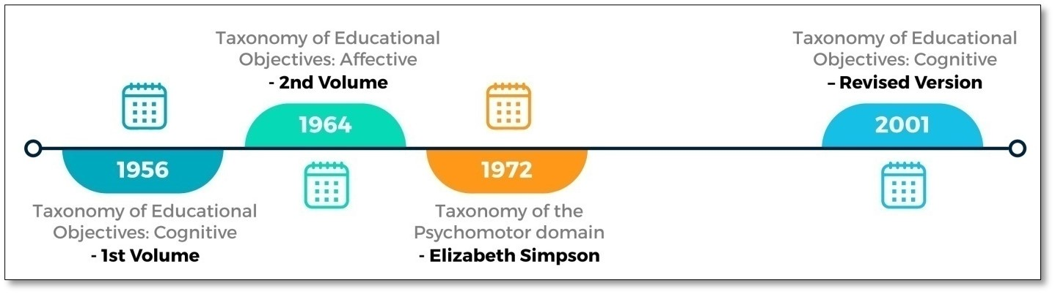

## Purpose of the Taxonomy

Why was the taxonomy developed? In the handbooks, the authors explained that the taxonomy was created to

* ensure precise communication when educators, administrators, and research workers communicate about educational goals;
* create a common ground between schools for exchanging information about curriculum and evaluation devices;
* provide teachers with a framework to identify whether the educational goals that they have identified are lower or higher-order thinking goals, and
* help teachers define objectives in such a manner that it becomes easy to plan learning experiences and develop evaluation devices (Bloom et al.,1956).

The team had been previously concerned about the presence of “nebulous” terms and a lack of common understanding amongst educators regarding educational objectives. As they stated in the handbook: “For example, some teachers believe their students should “really understand,” others want their students to internalize knowledge; still others want their students to “grasp the core or essence,” or “comprehend.” Do they all mean the same thing?” (p. 1).

## Things to Consider

Bloom’s taxonomy is an excellent framework that differentiates between lower-order thinking skills and higher-order thinking skills. However, the following points must be kept in mind when we use Bloom’s taxonomy.

Bloom’s taxonomy was developed after going through many educational outcomes that existed across various schools in America (Bloom et al., 1956). In that sense, the group worked backwards, identifying existing educational outcomes and then the taxonomy based on these outcomes.

Though referred to as a taxonomy, the framework is more of a classification of student behaviors that represent the intended educational outcomes (Kompa, n.d.). A taxonomy is evidence-based, while classification is a method to communicate ideas in a way that is useful and suggests potential actions.

## The Taxonomy

The taxonomy is divided into three parts: the cognitive, affective, and the psychomotor domains. The handbook published in 1956 described the three domains but detailed only the cognitive domain.

* The cognitive domain refers to knowledge attainment, and mental or intellectual processes, such as the ability to solve a mathematical problem or write an essay. Let’s consider this example from mathematics: “Students will be able to understand that perimeter and area have a relationship and recognize and apply their new knowledge in real-life situations.” To achieve this learning outcome, a student must recall the definitions of perimeter and area, understand how the two differ, recall the formula to calculate these, and use this information to find out the perimeter and area of something in real life (e.g. a playground).These are mental processes that take place in the brain; hence, they fall within the ambit of the cognitive domain.
* The affective domain addresses emotional aspects reflected via learners' beliefs, values, and interests, such as the ability to appreciate and/or empathize. An example of the learning outcome in this domain for the mathematics topic on area and perimeter could be the following: “Students will value the need for learning about area and perimeter. They will demonstrate this by listening to the teacher, responding to their questions, and clarifying doubts.”
* The psychomotor domain addresses skills that are cultivated through neuromuscular motor activities, such as the ability to write, or wield a scalpel with precision. In our mathematics example, the learning outcome on the topic of area and perimeter may be, “Students will be able to draw a rectangle for a given area and perimeter using geometry tools.” This task requires motor coordination and will fall in the purview of the psychomotor domain.

## Cognitive Domain

In the cognitive domain, Bloom and his collaborators (Bloom et al., 1956) identified and defined six levels of cognitive complexity: knowledge, comprehension, application, analysis, synthesis, and evaluation.  These levels were arranged hierarchically on a continuum ranging from simple to complex and from concrete to abstract. Each category also had sub-categories, as displayed in the following table, recreated from their original work (Bloom et al., 1956):

|  |  |
| --- | --- |
| **Levels** | **Categories as sub-categories** |
| Knowledge | * Knowledge of specifics   + Knowledge of terminology   + Knowledge of specific facts * Knowledge of ways and means of dealing with specifics   + Knowledge of conventions   + Knowledge of trends and sequences   + Knowledge of classifications and categories   + Knowledge of criteria   + Knowledge of methodology * Knowledge of universals and abstractions in a field   + Knowledge of principles and generalizations   + Knowledge of theories and structures |
| Comprehension | * Translation * Interpretation * Extrapolation |
| Application | Note: The original taxonomy had no sub-categories under Application |
| Analysis | * Analysis of elements * Analysis of relationships * Analysis of organizational principles |
| Synthesis | * Production of a unique communication * Production of a plan or a proposed set of operations * Derivation of a set of abstract relations |
| Evaluation | * Evaluation in terms of internal evidence * Judgements in terms of external criteria |

Since the categories are arranged hierarchically, the taxonomy implies that higher levels of cognition are built upon the lower levels. Intellectual operations increase in complexity from the first level, that is “Knowledge”, to the last level, which is “Evaluation”. There’s often a misunderstanding that lower levels are less desirable than higher levels. This is not true because unless you master the lower levels, you cannot achieve the higher levels. As is stated in the handbook: “While it is recognized that knowledge is involved in the more complex major categories of the taxonomy (2.00 to 6.00), the knowledge category differs from the others in that remembering 'is the major psychological process involved here, while in the other categories the remembering is only one part of a much more complex process of relating, judging, and reorganizing” (Bloom et al., 1956, p. 62).

The higher-level thinking skills involve utilizing knowledge and understanding in new situations, or in a form that is very different from how it was learned initially. In short, the taxonomy was divided into two parts: (a) the simple behavior of remembering or recalling knowledge, and (b) the more complex behaviors of the abilities and skills.

### Learning Check

A student recites the poem, "Stopping by Woods on a Snowy Evening" by Robert Frost. What is the cognitive level of this task?

Remember

Analyze

Understand

A teacher gives her Grade 2 class a worksheet of multiplication tables to complete. Which domains will be involved in completing this task?

Affective

Cognitive

Psychomotor

Kindergarten students practice writing the English alphabet using stencils. Which domain does this task address?

Cognitive

Affective

Psychomotor

A Grade 10 class is tasked with discussing the historical importance of the novel Pride and Prejudice and its importance to the development of English literature. Which cognitive level does this address?

Evaluate

Create

Apply

A student is working on a presentation using presentation software. The topic of the presentation is "Sustainable Living and Reducing Carbon Footprints." Which domains will be addressed through this task?

Cognitive

Affective

Psychomotor

## Criticism Of the Taxonomy

The taxonomy was designed to help educators state educational objectives, develop evaluation devices, and identify instructional strategies (Bloom et al., 1956). Thus, the taxonomy was meant to be used as a cognitive tool or job-aid for educators. However, a problem with cognitive tools is that they are representations of thought, and that is inherently problematic. While the creators of such tools may take into consideration how users will comprehend and use the tool, it is not possible to anticipate all the ways in which they will understand and use the tool. A common refrain of educators was that the taxonomy was mired in ambiguity, and a consensus on the levels was difficult to achieve (Soozandehfar & Adeli, 2016, p. 3). For example, an educational objective may be classified into either of the two lowest levels (knowledge or comprehension) or into any of the four highest levels (application, analysis, synthesis, or evaluation) by different educators (Soozandehfar & Adeli, 2016, p. 5). In addition, critics argued that the taxonomy was not based on research and evidence (Kompa, n.d.).  The taxonomy is also criticized for the creation of a hierarchy (lower-order thinking to higher-order thinking), which according to some educationists is not how the human brain works (Kompa, n.d.). For instance, we may analyze content in order to understand it. Lastly, there have been a number of articles, which propagate the view that the lowest level, “remember” is not important, and educators must strive to achieve the higher-order learning outcomes (Soozandehfar & Adeli, 2016, p. 5). In other words, lower-order skills (i.e., knowledge and comprehension) are considered less critical and invaluable, which is not true.

## Revised Taxonomy

Because of some of the criticism of the taxonomy, the framework was revised 45 years later by David R. Krathwohl, professor at the Syracuse University. This work is published in the journal, Theory into Practice, Volume 41, Number 4, Autumn 2002. The main revisions included the following: (a) change in terminology and in structure, (b) emphasis on subcategories, and (c) one-dimensional to two-dimensional.

### Change in Terminology and in Structure

Verbs are now used to refer to all the levels: “Remember” (in place of “Knowledge”), “Understand” (in place of “Comprehension”), “Apply,” “Analyze,” “Evaluate” and “Create.” The levels “Synthesis” and “Evaluate” have been interchanged, with “Evaluate” at level five, while “Synthesis” (Create) is at level six.

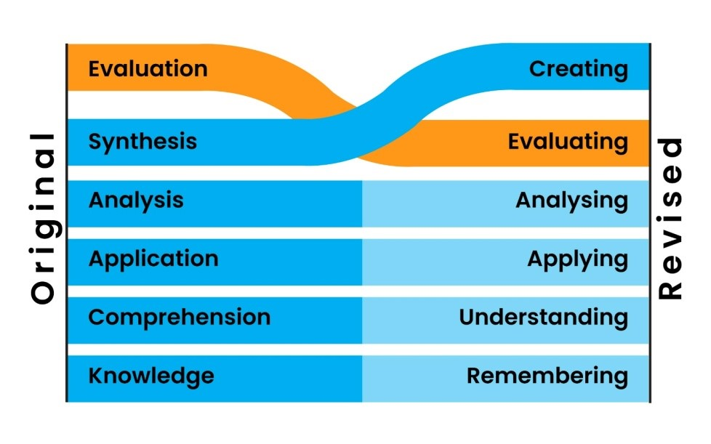

### Emphasis on Subcategories

While the earlier taxonomy placed emphasis on the main categories, that is the levels, the revised taxonomy is placed on the sub-categories.

|  |  |
| --- | --- |
| **Level** | **Sub-categories** |
| Level 1: Remember | Recognizing    Recalling |
| Level 2: Understand | Interpreting    Exemplifying    Classifying    Summarizing    Inferring    Comparing    Explaining |
| Level 3: Apply | Executing    Implementing |
| Level 4: Analyze | Differentiating    Organizing    Attributing |
| Level 5: Evaluate | Checking    Critiquing |
| Level 6: Create | Generating    Planning    Producing |

### One-Dimensional and Two-Dimensional

This is a major structural change that was introduced in the revised taxonomy. The new “Knowledge” dimension was reorganized, and the number of sub-categories under this was increased to four. The increase in sub-categories was a result of a better understanding of cognitive psychology. Metacognition, a fourth category, was added to the Knowledge category. The table below depicts the Knowledge dimension and the sub-categories.

|  |  |  |
| --- | --- | --- |
| **Category (Knowledge)** | **Sub-categories** | **Description** |
| Knowledge Dimension | Factual Knowledge | Factual knowledge refers to knowing isolated bits of information in the form of discrete facts. Some examples are knowing the capital of countries, significant historical dates, components of the food pyramid, names of American Presidents, major battles of WWII, etc. |
| Conceptual knowledge | Conceptual knowledge involves understanding relationships between various elements within a larger structure, such as classification and categories. For example, species of animals, different kinds of arguments, geological eras, Newton's laws of motion, principles of democracy, the theory of evolution, and so on. |
| Procedural knowledge | The knowledge of a specific methodology, or sequence of steps required to complete a task, is known as procedural knowledge. Some examples are knowing how to solve equations, how to create and save a document using Microsoft Word, or the procedure to perform chemical experiments in a lab. |
| Metacognitive knowledge | Metacognition refers to the learner's ability to be aware of their own thinking processes. Knowing how to memorize facts quickly and easily or adopt strategies for comprehending new and complex material are examples of metacognitive knowledge. |

### Read and Reflect

In a literature class, when teaching the poem, "The Daffodils", by William Wordsworth, the following tasks are set:

After reading the poem together as a class, students are asked to recite the first stanza of the poem followed by a question prompt such as, "What is the poet comparing the daffodils with and what resemblance does he find?" This is then followed by a task where students are told to describe the scene in the poem in their own words. Next, the students are asked to analyze the mood of the poem and poet. Finally, the students are tasked with writing a poem on nature, similar to the theme of "The Daffodils."

1. Which levels of Bloom's taxonomy in the cognitive domain can you identify?
2. Is the psychomotor domain being addressed in any way in this example? If yes, how?

## Applying Bloom's Taxonomy

Though it was developed in 1956, Bloom’s taxonomy is still relevant to educators. In current times, curriculum developers, teachers, and instructional designers apply the revised version of the taxonomy in the following ways:

1. **Content Structuring:** As per Bloom’s taxonomy, learners must complete the initial levels of thinking before moving to the higher ones. When designers plan to teach a concept, this framework can help them present learning materials in a simple to complex sequence. Basically, the designer will introduce simple facts, then move on to concepts, before addressing more complex thinking tasks such as application, analysis, evaluation, and synthesis. For instance, if the person using the taxonomy were a teacher, they would first introduce the components of a story (plot, characters, conflict, and resolution) before asking their students to write a story. Typically, in lower grades within K-12, information recall is the focus; in the middle grades, understanding and application of concepts is emphasized; and in the higher grades, students work on analyzing, evaluating, and synthesizing concepts and principles.
2. **Teaching and reinforcing:** An understanding of the different levels in Bloom’s taxonomy helps instructors decide whether a previously taught concept needs to be reinforced. To continue with our example, if learners can recall the components of a story but are struggling to write one, the teacher may select examples from different stories to highlight each component so that the students develop an understanding of the components. In addition, the teacher may also ask students to read a story and identify these components on their own, and then provide feedback.
3. **Assessing:** A very good application of Bloom’s taxonomy is the mapping of questions to the level at which the learning outcomes are set. If the learning outcome is set at a recall level, then teachers must create questions that test learners for recall to ensure that the assessment is valid (a valid test is one that measures what it claims to measure). For example, if the learning outcome is to recall and understand the components of a story, the test should not assess students’ abilities to write a story. This would be inappropriate and a misalignment between the learning objective, the teaching, and the assessment; this may cause students to feel frustrated. But, if the learning outcome is to develop the ability to write a story, and the instruction focused on developing skills for this learning outcome, then the assessment must test if learners can write a story.

**Note:** It’s important to remember that it may not be possible in certain disciplines to map all the levels because different disciplines require different types of thinking. For instance, a pilot being trained is not typically expected to be “creative”; rather they are expected to follow standard operating procedures. On the other hand, the discipline of “art” will require high levels of creativity. In short, the value and priority of the levels will differ across disciplines. Further, the interpretation of levels changes across grades. For example, writing a story will be “synthesis” in the primary grades, but for a college-going student, pursuing a creative-writing course, synthesis may involve coming up with a new genre of story.

## Applying the Taxonomy: Case Study

### LIDT in the World: "Using Teaching Cases for Achieving Bloom's High-Order Cognitive Levels: An Application in Technically Oriented Information Systems Course" (Tan, 2017)

This research demonstrates how case studies were used to connect theory with real-world examples in teaching a computing course. This course is taken by students pursuing the undergraduate degree program in Information Systems at the Singapore Management University. As part of this initiative, three types of case studies were used to teach how to design an Enterprise Web Portal. These case studies were used to accomplish different learning outcomes mapped to the various cognitive levels in the revised Bloom’s taxonomy. This initiative was tracked over two academic years through surveys. The outcome revealed that teaching in this way helped students achieve higher-order cognitive levels, such as evaluating and creating.

In this research initiative, the three types of case studies, which were introduced by the researchers, were: a storytelling case, a design-and-problem-solving case, and a create-design-implement case as part of the course. This is how the researchers described the three cases:

1. Cases where problems and solutions (or options) are described within the case and do not involve technical tasks are storytelling cases. This type of case study addresses the remembering, understanding, and applying cognitive levels.
2. Cases where students analyze scenarios in order to design a solution to address the stated needs are problem-solving cases. These scenarios are not real, but mimic conditions in the real world. This type of case aims to address the analysis level along with remembering, understanding, and applying.
3. Cases in which students are provided with real-world situations and are expected to create a scenario and identify needs in order to design a solution by configuring the features of packaged software, and customizing it are create-design-implement cases. This type of case addressed the applying, analyzing, evaluating, and creating cognitive levels.

Through this study, the researchers gathered empirical evidence that proved how, by using case studies, students achieved outcomes at higher cognitive levels of the revised Bloom’s taxonomy. The initiative gave students an opportunity to see their solutions in action, and the implications of their design decisions. In addition, it helped to prepare students for a career in the real world.

Reflect: What role did an understanding of Bloom’s taxonomy play in helping this case-based learning to be successful?

## Robert Mager

A chapter on learning outcomes is not complete without mentioning Robert Mager and his seminal work in this area. Mager came up with a format for writing learning outcomes. He referred to learning outcomes as behavioral objectives and proposed that a well-written behavioral objective has three parts (Mager, 1962, p. 41):

* **Terminal Behavior:** what the learner will be able to do after the instruction
* **Condition:** the situation under which the performance will be assessed
* **Criteria:** the standards for measuring the performance

Here is an example of a learning outcome written using Mager’s format with a breakup of the three components:

### Example

**Learning outcome:** Write an original, compelling, and engaging story in the fantasy genre.

**Terminal Behavior:** Write a story

**Condition:** Fantasy genre

**Criteria:** Original, compelling, and engaging

Writing learning outcomes using this format makes the outcomes verbose and complex. Hence, most educators apply the performance part and drop the condition and criteria. The condition is stated if there are multiple ways to complete a task and only one of these is being taught and assessed. In our example above, there are many genres of story-writing, so it is important to specify which one is being taught and assessed—hence, it is useful to describe the condition. Criteria are stated as part of the learning outcome for subjective content, where a rubric is to be used to evaluate. If the learners are being assessed through objective questions, then the passing score becomes the criteria and does not need to be specifically stated in the learning outcome statement (Tucker, 2023).

Of the three components, Mager emphasized terminal behavior, which he stated must be written using specific and measurable verbs. The emphasis on verbs was placed because Mager considered that they helped to measure the success or failure of the learner in completing a learning task. He advised that the use of ambiguous verbs, such as “know” and “understand” be avoided when writing behavioral objectives (Mager, 1962, p. 11).

## Summary

Similar to other teaching-learning frameworks, Bloom’s taxonomy has advantages and disadvantages. The strength in the taxonomy lies in how it structures the thinking process and connects it with learning. Educators who use the taxonomy thoughtfully can make informed decisions while teaching and ensure that they plan and design learning events that will help develop different thinking skills. However, there is also the possibility that teachers may select learning outcomes that they think are desirable without much thinking or planning. This will do more harm than good. To summarize, it is important to understand that Bloom’s taxonomy is a descriptive framework that illustrates the complex nature of the thinking process and provides a structure for understanding it. It must not be used as a prescriptive framework (a template) where designers pick verbs from a readily available list without giving much thought to whether the learning outcome is applicable in the given context or not.

### Learning Check Explanations

1. A student recites the poem, “Stopping by Woods on a Snowy Evening” by Robert Frost. What is the cognitive level of this task?  
   This task is at the Remember level, since the student is recalling the poem from memory.
2. A teacher gives her Grade 2 class a worksheet of multiplication tables to complete. Which domains will be involved in completing this task?  
   Cognitive and psychomotor, since the students will recall the times tables (cognitive) and use a pencil to complete the activity (psychomotor).
3. Students practice writing the English alphabet using stencils. Which domain does this task address?  
   This task will address the psychomotor domain because the focus is on motor skills.
4. A Grade 10 class is tasked with discussing the historical importance of the novel Pride and Prejudice and its importance to the development of English literature. Which cognitive level does this address?  
   This task will involve evaluating the novel on certain parameters (historical importance and importance in the development of English literature) and is thus at the Evaluate level.
5. A student is working on a presentation using presentation software. The topic of the presentation is “Sustainable Living and Reducing Carbon Footprints”.  Which domains will be addressed through this task?  
   Cognitive, Affective & Psychomotor domains will be involved. Knowing, understanding, analyzing and applying information on sustainable living (Cognitive); knowing how to use software (cognitive); appreciating the need to live sustainably (Affective) and using computer peripherals, such as mouse or touchpad and keyboard (Psychomotor).

## References

Bloom, B. S. (Ed.), Engelhart, M. D., Furst, E. J., Hill, W. H., & Krathwohl, D. R. (1956). Taxonomy of educational objectives: The classification of educational goals, Handbook I: Cognitive domain. Longmans. <https://eclass.uoa.gr/modules/document/file.php/PPP242/Benjamin%20S.%20Bloom%20-%20Taxonomy%20of%20Educational%20Objectives%2C%20Handbook%201_%20Cognitive%20Domain-Addison%20Wesley%20Publishing%20Company%20%281956%29.pdf>

Tucker, C. (2023). Should we list learning objectives? Experiencing Learning. <https://www.christytuckerlearning.com/should-we-list-the-learning-objectives/>

Krathwohl, D. R. (2002, Autumn). A revision of Bloom’s taxonomy: An overview. Theory Into Practice, 41(4), 212–218. <https://doi.org/10.1207/s15430421tip4104_2>

Krathwohl, D. R., Bloom, B. S., & Masia, B. B. (1964). Taxonomy of educational objectives: The classification of educational goals, Handbook II: Affective domain. Longmans. <http://daneshnamehicsa.ir/userfiles/file/Resources/10)%20History/Intro-Taxonomy%20of%20Educational%20Objectives,%20Handbook%202,%20Affective%20Domain.pdf>

Kompa, J. S. (n.d.). Why it is time to retire Bloom’s taxonomy. Lifelong Education & Change Blog. <https://joanakompa.com/2017/02/07/why-it-is-time-to-retire-blooms-taxonomy/>

Mager, R. F. (1962). Preparing instructional objectives. Fearon Publishers. [https://babel.hathitrust.org/cgi/pt?id=mdp.39015016282587&view=1up&seq=3](https://babel.hathitrust.org/cgi/pt?id=mdp.39015016282587&amp;view=1up&amp;seq=3)

Simpson, E. J. (1966). The classification of educational objectives, psychomotor domain [Project, University of Illinois]. U.S. Department of Health, Education and Welfare, Office of Education. <https://eric.ed.gov/?id=ED010368>

Soozandehfar, S. M. A., & Adeli, M. R. (2016). A critical appraisal of Bloom’s taxonomy. American Research Journal of English and Literature, 2. <https://doi.org/10.21694/2378-9026.16014>

Tan K. W. (2017). Using teaching cases for achieving Bloom’s higher-order cognitive levels: An application in technically-oriented information systems course. Proceedings of the 2017 AIS SIGED International Conference on Information Systems Education and Research.10. Research Collection School Of Information Systems. <https://aisel.aisnet.org/siged2017/1>

## Suggested Readings

Agarwal, P. K. (2019). Retrieval practice & Bloom’s taxonomy: Do students need fact knowledge before higher order thinking? Journal of Educational Psychology, 111(2), 189–209. <https://doi.org/10.1037/edu0000282>

Clark, D. (2020, March 1). Bloom (1913–1999) – Mastery learning. Taxonomy of learning… not a hierarchy…. Donald Clark Plan B. <http://donaldclarkplanb.blogspot.com/2020/03/bloom-1913-1999-taxonomy-of-learning.html>

Gracey, L. (2021, December 9). Why it may be time to dump Bloom’s taxonomy. TechNotes. <https://blog.tcea.org/why-it-may-be-time-to-dump-blooms-taxonomy/>

Thalheimer, W. (2013, May 13). Rethinking instructional objectives. Work-Learning Research. <https://www.worklearning.com/2013/05/13/rethinking-instructional-objectives/>

Read this online at <https://edtechbooks.org/foundations_of_learn/blooms_taxonomy>