# TPACK

Warr, M., Mishra, P.

The Technological Pedagogical Content Knowledge (TPACK) Framework describes the types of knowledge required by teachers for the successful and effective integration of technology in teaching. The most current representation of the framework is in the form of a three-circle Venn diagram within a larger circle. At the center are three partially overlapping circles representing three key knowledge domains: Content Knowledge (CK), Pedagogical Knowledge (PK) and Technological Knowledge (TK). The fourth circle (typically shown as a dotted line) encompasses the three overlapping circles and represents Contextual Knowledge (XK). Most importantly, the TPACK framework proposes that effective integration of technology in teaching requires the integration of the four TPACK knowledge domains—a form of knowledge greater than the knowledge of each of these domains in isolation. It is, instead, a recognition and deep understanding that these knowledge domains exist in tension with each other and that effective technology integration requires finding the right balance that connects the affordances of the technology with the requirements of the content and the pedagogical approaches given a particular educational context.

The TPACK framework was first introduced by Mishra and Koelher (2006).  The framework builds on Shulman’s (1986, 1987) Pedagogical Content Knowledge (PCK)—the idea that teacher knowledge is more than mere knowledge of content and of general pedagogical principles. Shulman suggested that teachers possess a special form of knowledge that has to do with processes and techniques for transforming content in ways that are pedagogically viable. The TPACK framework extended PCK to include technological knowledge as being an important component of the kinds of knowledge teachers need to possess, and similar to PCK, TPACK is conceived as being more than individual pieces of knowledge.

Figure 1

The Technological Pedagogical Content Knowledge (TPACK) Framework (Mishra, 2019)

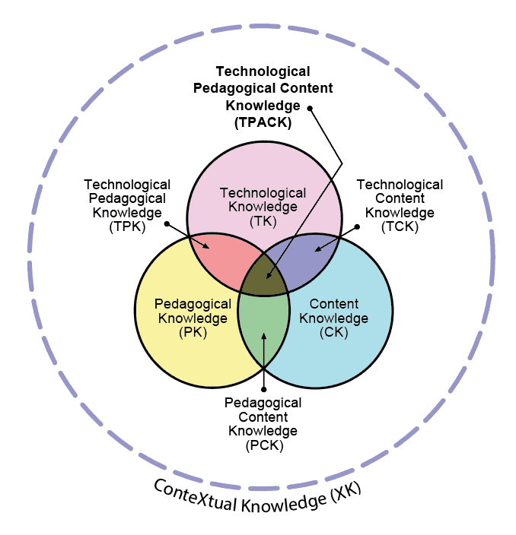

Content Knowledge (CK) refers to knowledge about the subject matter teachers are teaching, including the content specific to the curriculum that is being taught and a deeper understanding of disciplinary concepts and practices. Pedagogical Knowledge (PK) concerns teachers’ knowledge about methods and practices of teaching and learning, including the overall goals of education, how students learn, assessment practices, and classroom management. Technological Knowledge (TK) describes a type of fluid understanding of technologies and the ability to use them productively for various learning or organizational tasks. TK is fluid and evolving because technologies continually develop over time. Finally, Contextual Knowledge (XK) is the knowledge teachers possess of the broader context within which their teaching functions. These may include knowledge of state standards and policies as well as the broader culture of the school or the district.

Central to the TPACK framework is the interaction between its knowledge domains. Thus, TPACK includes understanding how to represent concepts through technology, how to use technology to teach content, common misconceptions in curricular areas and how technology can address them, how technologies affect students’ epistemologies, and how each of these factors play out in specific contexts. Teachers with effective TPACK can flexibly integrate content, pedagogy, and technology to address contextualized needs and challenges. They continually adapt to new technological tools, new concepts in content, and innovative pedagogical approaches utilizing the affordances and constraints of technologies to improve teaching and learning in their particular educational context.

## Historical Context

The most recognized version of the TPACK framework was conceptualized and first reported in 2005 by Matthew Koehler and Punya Mishra, who were both faculty at Michigan State University. This was not a completely original construct as scholars since 1998 had discussed how to better understand and explain how educators should conceptualize the role of technology in education. It was becoming clear that an emphasis on technology (and the educational possibilities it engendered) was not adequate to explain what was happening in actual educational settings; adding technology into an educational process did not lead to change. In particular, it was recognized that teachers needed to understand the relationships between users, technologies, and practices, including how technologies can support the teaching and learning of educational concepts (Koehler & Mishra, 2005). Later work added the importance of context to the mix.

As previously mentioned, Koehler and Mishra built the TPACK framework by extending Shulman’s (1986, 1987) Pedagogical Content Knowledge framework to include technology (Koehler & Mishra, 2005). Other scholars had proposed similar ideas (Hughes, 2005; Keating & Evans, 2001; Lundeberg et al., 2003; Margerum-Leys & Marx 2002), but it was Mishra and Koehler’s (2006) description and representation of TPACK, with minor tweaks over the next few years, that became widely adopted.

After its initial introduction, TPACK scholarship was expanded through two handbooks (AACTE Committee on Innovation and Technology, 2008; Herring et al., 2016), a monthly newsletter, journal articles, conference presentations, and other publications. The newsletter and a bibliography of TPACK scholarship can be found at [tpack.org](http://tpack.org). To illustrate the impact of TPACK, prior to 2021 there had been 1418 articles, 318 chapters in books, 28 books, and 438 dissertations that used it as a conceptual framework to guide their work (Harris, 2021). More important has been the impact of TPACK on practice, with schools and colleges of education across the world incorporating the TPACK framework in teacher professional development and teacher education.

## References

AACTE Committee on Innovation and Technology. (2008). Handbook of Technological Pedagogical Content Knowledge (TPCK) for Educators. Routledge.

Harris, J. (2021, March). TPACK newsletter update. TPACK Newsletter, 44. [https://edtechbooks.org/-VWMb](https://punyamishra.com/wp-content/uploads/2022/06/TPACKNewsletterIssue44.pdf)

Herring, M. C., Koehler, M. J., & Mishra, P. (2016). Handbook of technological pedagogical content knowledge (TPACK) for educators. C. Herring, M. J. Koehler, & P. Mishra (eds.); 2nd ed.). Routledge. [https://edtechbooks.org/-dGC](https://doi.org/10.4324/9781315771328)

Hughes, J. (2005). The role of teacher knowledge and learning experiences in forming technology-integrated pedagogy. Journal of technology and teacher education, 13(2), 277-302.

Keating, T., & Evans, E. (2001). Three computers in the back of the classroom: Preservice teachers conception of technology integration. In J. Price, D. Willis, N. Davis, & J. Willis (Eds.), Proceedings of SITE 2011--Society for Information Technology and Teacher Education International Conference (pp. 1671–1676). [https://edtechbooks.org/-dzsR](https://www.learntechlib.org/p/17023/)

Koehler, M. J., & Mishra, P. (2005). What happens when teachers design educational technology? The development of technological pedagogical content knowledge. Journal of Educational Computing, 32(2), 131–152. [https://edtechbooks.org/-RAo](https://doi.org/10.2190/0EW7-01WB-BKHL-QDYV)

Lundeberg, Bergland, Klyczek, & Hoffman. (2003). Using action research to develop preservice teachers’ beliefs, knowledge and confidence about technology. Journal of Interactive Online Learning, 1(4).

Margerum-Leys, J., & Mar, R. (2002). Teacher knowledge of educational Technology: A study of student teacher/mentor teacher pairs. Journal of Educational Computing Research, 26(4), 427–462.

Mishra, P., & Koehler, M. J. (2006). Technological pedagogical content knowledge: A framework for teacher knowledge. Teachers College Record, 108(6), 1017–1054.

Mishra, P. (2019). Considering Contextual Knowledge: The TPACK Diagram Gets an Upgrade. Journal of Digital Learning in Teacher Education. [https://edtechbooks.org/-oYzL](https://doi.org/10.1080/21532974.2019.1588611)

Shulman, L. (1987). Knowledge and teaching: Foundations of the new reform. Harvard Educational Review, 57(1), 1–23. [https://edtechbooks.org/-Jbm](https://doi.org/10.17763/haer.57.1.j463w79r56455411)

Shulman, L. S. (1986). Those who understand: Knowledge growth in teaching. Educational Researcher.[https://edtechbooks.org/-dVDK](https://journals.sagepub.com/doi/pdf/10.3102/0013189x015002004)

Read this online at <https://edtechbooks.org/encyclopedia/tpack>