Blended Teaching
Graham, C. R., Draper, D.
Blended teaching is the strategic combination of instruction in two different modalities: online and in-person (Graham, 2021). This article addresses the question of why instructors choose to teach in a blended modality. It also addresses seven common challenges to student engagement that intentional blended strategies can help to overcome. A few practical examples of strategic blends are provided. Finally, two research-based competency frameworks are shared to help blended instructors increase their awareness and self-evaluation of core pedagogical skills for effective blended teaching.
Effective blended teaching is almost always intentional and strategic. There are a wide variety of models and teaching strategies that can be designed into a blend. Figure 1 depicts a spectrum of possibilities from the modality perspective.
Figure 1
Spectrum of blended possibilities based on combining in-person and online modality
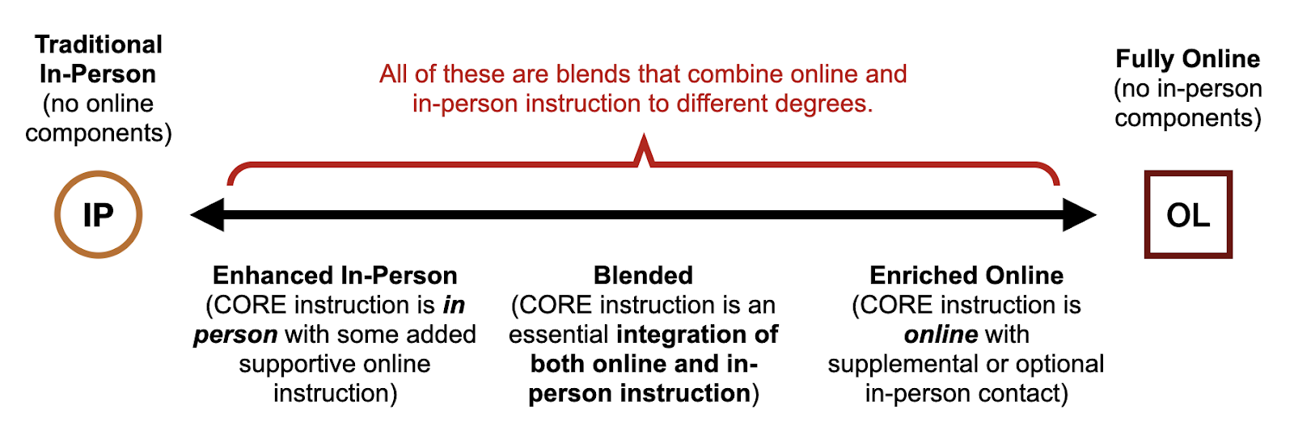
There are a number of blended models that fit within the spectrum described in Figure 1. Some of these models include rotation, flex, and flipped (Staker & Horn, 2012); hyflex (Beatty, 2019); inside out and outside in (Kohls et al., 2018); supplemental, emporium, replacement, and buffet (Twigg, 2003); and time-based blends (Norberg et al., 2011). Incorporating these models in traditional schools and universities demands new forms of school leadership (Scheninger, 2019) and a critical examination of strategic innovation, school structure, and cross-institutional partnerships (Thompson et al., 2019).

Why Blend?
There are many reasons why teachers and institutions choose blended approaches. The three most common reasons are shown in Table 1. It is important to note that teachers often work to achieve multiple purposes with a blend even though one purpose may have priority over the others. Furthermore, reasons for blending can have a strong influence on the blended approach that is chosen.
Table 1
Common reasons to adopt blended teaching and learning
Reason | Brief Explanation
Improved Student Learning | Whereas different learners maintain personal preferences for how they prefer to receive information (Pashler et al., 2008) and for how they actually learn (Willingham et al., 2015), teaching through multiple modalities can lead to improved student learning.
Increased Access and Flexibility | True blended approaches can facilitate purposeful anytime/anywhere learning experiences for students and anytime/anywhere teaching circumstances for instructors, removing the fixed limitations of time and place for education to occur (Joosten et al., 2021).
Increased Efficiency | Some curricula are more quickly and more easily taught when digital tools are used to enhance teaching and learning. Similarly, other concepts and contents benefit most from face to face instructional interaction. Blending can improve efficiency when teachers and students have access to both online and in-person options (Chigeza & Halbert, 2014).

Strategic Blending
Having a clear purpose for blending can help make blended course or lesson design more intentional and strategic. Blending with purpose allows teachers to align pedagogical objectives and activities with appropriate approaches and technologies, thus keeping improved student learning at the forefront (Picciano, 2009). In addition, teachers may adopt blended approaches to increase opportunities for social emotional learning and deep learning as described by the 6C’s: character, citizenship, collaboration, communication, creativity, and critical thinking (Fullan et al., 2018). Table 2 outlines seven common pedagogical challenges to student engagement (7P’s) that blended teaching strategies can help educators to overcome. Additionally, frameworks such as PICRAT or 4E’s (enable, engage, elevate, extend) can help teachers to strategically reflect on the relationship between their pedagogical purposes and the technologies used to support those purposes (Kimmons et al., 2022; Kolb, 2017; Borup et al., 2022).
Table 2
Seven pedagogical challenges to student engagement that blended approaches can help with (Stein & Graham, 2020; Graham et al., 2019)
Challenge | Blended Approaches Can Address Challenge
Participation | Intentionally combining in-person and online interactions can ensure that all students participate.
Pacing | While in-person instruction often revolves around synchronous whole class activities, online instruction can be individualized to meet unique pacing needs.
Personalization | This occurs when the learner is an active participant in making choices around the goals, time, place, pace, or path of learning experiences, (Graham et al., 2019; Bray & McClaskey, 2015). While personalization is possible in an entirely in-person learning environment, the flexibility and digital tools (like adaptive software) available online, can make it a more practical option for teachers in a blended teaching context.
Place | Whereas in-person instruction requires that all learners be physically present in the same location, online portions need not be limited to the same space. Furthermore, students can virtually visit authentic locations for learning that are outside the classroom.
Personal Interaction | Instead of the one-to-many model of interaction inherent to in-person teaching, online learning can facilitate flexible and meaningful one-to-one interactions between teachers and students, especially when instruction is asynchronous and intentionally planned.
Preparation | Blending allows students to look ahead at the curriculum, making deeper and more meaningful preparations for in-person learning experiences. It can also help teachers to know students’ level of preparation before class time.
Practice with Feedback | Through algorithmic and pre-programmed elements, online practice activities can facilitate a faster and more robust feedback experience than is otherwise available for analog, in-person learning.

Practical Examples
Consider how the following real-world examples of blended teaching and learning align with the common reasons for blending listed above, along with how they might help to overcome pedagogical challenges.
- Postsecondary - A college professor meets with her class in person on Tuesdays and Thursdays and has additional coursework and learning materials organized online as required elements of the course. Multiple online pathways are provided for students to progress through the curriculum, allowing for student choice as an integral part of the adult learning experience (Merriam & Bierema, 2013). In addition, students may select from a menu of options for demonstrating the knowledge they have acquired.
- Secondary - Instead of lecturing for the first 30 minutes of class, a math teacher shares a condensed video recording of the lecture for students to watch as homework the day before. She then begins class with a brief formative assessment to gauge which of yesterday’s concepts deserve highest priority for in-class discussion. Her purposeful planning allows her to embed important concepts into the online content that will prepare students for a richer in-person discussion.
- Elementary - An elementary teacher organizes students into small groups, based upon academic need. She then dedicates a portion of the day’s instructional time for “centers,” rotating students through online instructional activities strategically aligned with student needs, small group activities, and teacher directed instruction.

Blended Teaching Competencies
Several key issues are faced when designing blended environments: incorporating flexibility, stimulating interaction, facilitating student learning processes, and fostering an affective learning climate (Boelens et al., 2017). Important blended and online teaching competencies have been identified that can help address these and other significant issues (Pulham & Graham, 2018). Table 3 outlines two competency frameworks relevant to blended teaching that are grounded in research and focus primarily on pedagogical skills. The Blended Teaching Readiness Survey (https://bit.ly/blended-teaching-readiness) based on the BT Readiness Framework serves as a helpful tool for teachers to self-assess their understanding and skills for blended teaching.
Table 3
Competency frameworks relevant for blended and online teaching
Blended Teaching Readiness Framework  (Graham et al., 2019; Pulham & Graham, 2018) | Pillars of Online Pedagogy  (Archambault et al., 2022)
- Integrate Online and In-Person Instruction  - Use Digital Data to Inform Teaching Practices  - Enable Personalized Learning Experiences  - Facilitate Online Interaction with Instructors, Students, and Content | - Build Relationships and Community  - Incorporate Active Learning  - Leverage Learner Agency  - Embrace Mastery Learning  - Personalize the Learning Process

The ability to teach in a blended modality is becoming increasingly important for instructors in K-12, higher education, and corporate training contexts. Instructors can strategically identify blended approaches and models that can benefit students in their unique contexts. Blended teaching competencies can be learned, measured, and improved upon.

References
Archambault, L., Leary, H., & Rice, K. (2022). Pillars of online pedagogy: A framework for teaching in online learning environments. Educational Psychologist, 57(3), 178–191. https://doi.org/10.1080/00461520.2022.2051513
Beatty, B. J. (2019). Hybrid-flexible course design: Implementing student-directed hybrid classes. EdTechBooks.org. https://edtechbooks.org/hyflex
Boelens, R., De Wever, B., & Voet, M. (2017). Four key challenges to the design of blended learning: A systematic literature review. Educational Research Review, 22, 1–18.
Borup, J., Graham, C. R., Short, C. R., & Shin, J. K. (2022). Evaluating Blended Teaching with the 4Es and PICRAT. In C. R. Graham, J. Borup, M. Jensen, K. T. Arnesen, & C. R. Short (Eds.), K-12 Blended Teaching (Vol 2): A Guide to Practice Within the Disciplines, Vol. 2. EdTech Books. https://edtechbooks.org/k12blended2/evaluating_bt
Borup, J., Graham, C. R., Short, C., & Shin, J. K. (2022). Designing the new normal: Enable, engage, elevate, and extend student learning. EDUCAUSE Review. https://er.educause.edu/articles/2022/1/designing-the-new-normal-enable-engage-elevate-and-extend-student-learning
Bray, B., & McClaskey, K. (2015). Personalization vs Differentiation vs Individualization Report (PDI) v3. Viitattu, 16, 2015.
Chigeza, P., & Halbert, K. (2014). Navigating E-Learning and Blended Learning for Pre-Service Teachers: Redesigning for Engagement, Access and Efficiency. Australian Journal of Teacher Education, 39(11), 133–146.
Graham, C. R. (2021). Exploring definitions, models, frameworks, and theory for blended learning research. In A. G. Picciano, C. D. Dziuban, C. R. Graham, & P. D. Moskal (Eds.), Blended learning: Research perspectives, Volume 3 (pp. 10–30).
Graham, C. R., Borup, J., Short, C. R., & Archambault, L. (2019). K-12 blended teaching: A guide to personalized learning and online integration. Provo, UT: EdTechBooks.org. http://edtechbooks.org/k12blended_series
Fullan, M., Quinn, J., & McEachen, J. (2018). Deep learning: Engage the world change the world. Thousand Oaks, CA: Corwin.
Horn, M. B., & Staker, H. (2014). Blended: Using disruptive innovation to improve schools. San Francisco: Jossey-Bass.
Joosten, T., Weber, N., Baker, M., Schletzbaum, A., & McGuire, A. (2021). Planning for a blended future: A research-driven guide for educators. [Report] Every Learner Everywhere Network. https://www.everylearnereverywhere.org/wp-content/uploads/Planning-for-a-Blended-Future-FINAL-1.pdf
Kimmons, R., Draper, D., & Backman, J. (2022). PICRAT: The PICRAT Technology Integration Model. EdTechnica: The Open Encyclopedia of Educational Technology.
Kohls, C., Köppe, C., Dalsgaard, C., & Pedersen, A. Y. (2018). Outside in and inside out: New hybrid education patterns. In ACM International Conference Proceeding Series. https://doi.org/10.1145/3282308.3282330
Kolb, L. (2017). Learning first, technology second: The educator’s guide to designing authentic lessons. International Society for Technology in Education.
Merriam, S. B., & Bierema, L. L. (2013). Adult learning: Linking theory and practice. John Wiley & Sons.
Norberg, A., Dziuban, C. D., & Moskal, P. D. (2011). A time-based blended learning model. On the Horizon, 19(3), 207–216. https://doi.org/10.1108/10748121111163913
Pashler, H., McDaniel, M., Rohrer, D., & Bjork, R. A. (2008). Learning styles: concepts and evidence. Psychological Science in the Public Interest, 9(3): 105–119.
Picciano, A. G. (2009). Blending with purpose: The mutimodal model. Journal of Asynchronous Learning Networks, 13(1), 7–18.
Pulham, E., & Graham, C. R. (2018). Comparing K-12 online and blended teaching competencies: A literature review. Distance Education, 39(3), 411–432.
Sheninger, E. (2019). Digital leadership: Changing paradigms for changing times. Corwin Press.
Staker, H., & Horn, M. B. (2012). Classifying K-12 Blended learning. https://www.christenseninstitute.org/wp-content/uploads/2013/04/Classifying-K-12-blended-learning.pdf
Stein, J., & Graham, C. R. (2020). Essentials for blended learning: A standards-based guide (2nd ed.). New York, NY: Routledge.
Thompson, K., Jowallah, R., & Cavanagh, T. B. (2019). “Solve the Big Problems”: Leading Through Strategic Innovation in Blended Teaching and Learning. In Technology leadership for innovation in higher education (pp. 26–48). IGI Global.
Twigg, C. A. (2003). Improving learning and reducing costs: New models for online learning. Educause Review, 38(5), 28–38.
Willingham, D. T., Hughes, E. M., Dobolyi, D. G. (2015). The scientific status of learning styles theories. Teaching of Psychology, 42(3): 266–271.

Community Artifacts
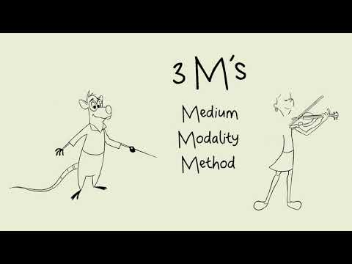
Watch on YouTube
Read this online at https://edtechbooks.org/encyclopedia/blended_teaching

